CUSSONS P8660 Computer Controlled Multi Cylinder ETB

Cussons P8660 Series Computer Controlled Multi-Cylinder Automotive Engine Test Beds have been developed to provide a self-contained advanced engine test facility for automotive and industrial light duty multi-cylinder engines having full **AUTOTEST IV** computer control and data management system purpose designed for engine performance, economy and energy balance measurements. With suitable ancillary equipment, as specified in subsequent items, the system can be used for data logging, exhaust emissions analysis work and high speed combustion data acquisition programmes.

**Experimental Capabilities and Measurements**

 Measurement of maximum torque and maximum power with plotting of full throttle/rack power against speed curve

 Determination of brake mean effective pressures

 Analysis of torque speed characteristics

 Determination of fuel consumption characteristics

 Calculation of brake specific fuel consumptions

 Analysis of load characteristics at constant speed

 Determination of volumetric efficiency

 Air consumption, fuel consumption, air/fuel ratios

 Brake thermal efficiencies

 Exhaust, water, oil and air temperatures

 Pressure/time, pressure/volume and crank angle diagrams(with P4600/P4605)

We are able to offer the following versions of this facility dependent on the end users dynamometer requirements:

**P8661 COMPUTER CONTROLLED MULTI-CYLINDERETB WITH  HYDROKINETIC DYNAMOMETER.**

**P8662 COMPUTER CONTROLLED MULTI-CYLINDERETB WITH EDDY CURRENT DYNAMOMETER.**

**P8663 COMPUTER CONTROLLED MULTI-CYLINDERETB WITH REGENERATIVE DYNAMOMETER**

**AUTOTEST IV SPECIFICATION**: the main configurations as standard are:-

 64 Analogue input channels

 16 Analogue output channels

 64 Digital input channels

 32 Digital (relay) output channels

 16 Frequency input channels

 A 2 channel hardware in-cell display and manual control unit

 Operator display via single screen PC

**Experimental Capabilities and Measurements EQUIPMENT Requirements**

**P8634 Dynamometer calibration equipment**

**P8635 Installation materials kit suitable for P8651, P8652 and P8653**

**P8613 Four Cylinder Water Cooled Spark Ignited Engine**

**P8621 Four Cylinder Water Cooled Compression Ignition Engine**

**P8263 Exhaust Gas Calorimeter**

**P4650 Electronic Engine Indicating Equipment**

**P4651 PC & Printer**

**P4652 Combustion Analysis Software**

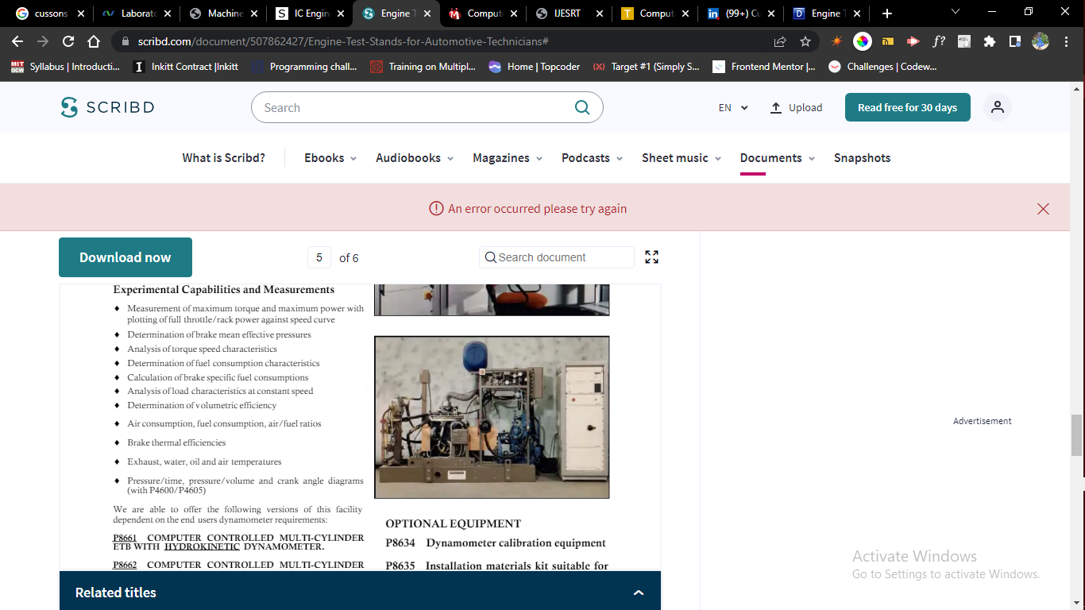

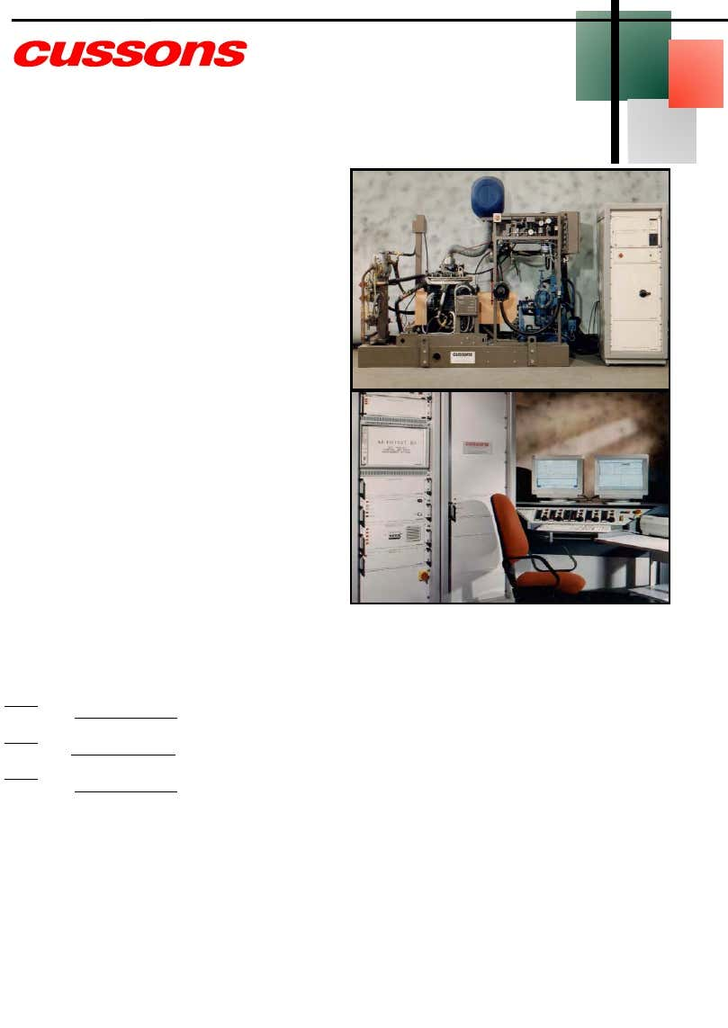

**P4650 Electronic Engine indicating Kit**

The recording and analysis of combustion related events within internal combustion engines has received considerable attention over the years with significant improvements in ease of use, in accuracy and in reliability. Now, Cussons Technology have introduced an intelligent, afford-able, digital multi-channel high speed engine data acquisition and analysis system. The P4650 operates as a powerful stand alone system for derivation and analysis of routine data which can also be used as a fast front end data acquisition system for more complex analysis in a PC or host computing configuration.

Electronic indicating Equipment for Above ETB’s

**P8390 Basic Emission Analyser for HC—CO—CO2—O2**

It combines micro processor simplicity of operation with infrared sensor accuracy. The system is designed to meet or exceed the OIML class 1 specification for automotive gas analysers, and is the latest development from a proven range of analysis equipment.

**Options :**

**P8391 Oil temperature and RPM inductive pickup**

**P8392 Self calibration module including 1 gas bottle**

**P8394 Analyser Stand**

**P8395 A4 Printer**

Emission Analyser for above ETB’s

**P4651 PC & Printer**

**P4652 Software for Combustion Analysis**

**Optional for Diesel Engines**

P4426 Strain Gauge Pressure Transducer & Adaptor

P4447 Strain Gauge Amplifier Channel

P4427 Standard Injector Needle Lift Transducer & Injector

P4444 Amplifier Channel for Injector Needle Lift

**Optional for Gasoline Engines**

Piezo Transducer Spark Plug Adaptor

**Injection Timing Module**

**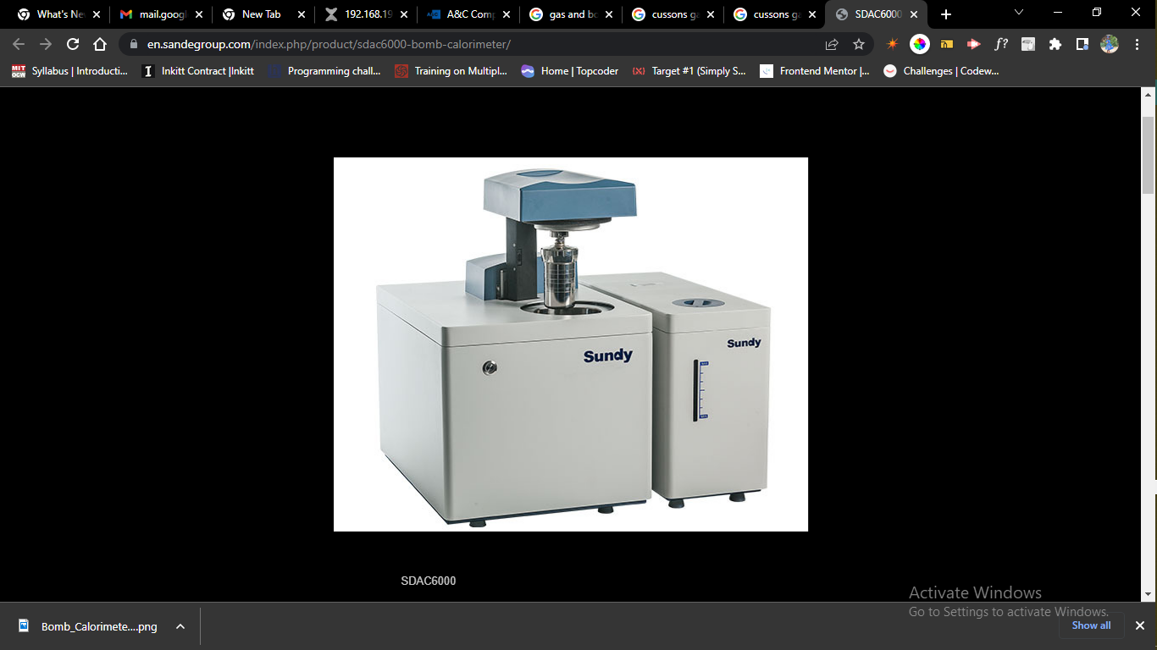**

[Skip to content](https://en.sandegroup.com/index.php/product/sdac6000-bomb-calorimeter/#content)

0086-731-88112150  [sales@sandegroup.com](mailto:sales@sandegroup.com)

Top of Form

SDAC6000 Bomb Calorimeter

**Application:**

SDAC6000 automatic isoperibol oxygen bomb calorimeter can be used to determine the calorific value in solid and liquid combustibles such as coal,coke,petroleum oil, cement black meal, biomass fuels as well as building material.

>Fully automatic oxygen filling and releasing, fully automatic bomb raising and lowering, full test …

>Optional support stand, customer can choose either benchtop or vertical type

|  |  |
| --- | --- |

Product description

**Highlights**：

**Optimized design, fully automatic oxygen filling & releasing, fully automatic bomb raising & lowering, full test process is less than 10 minutes.**  
①Unique bucket water circle system, which can determine water volume for each testing automatically. New stainless steel oxygen bomb can be easily assembled and disassembled. High stirring efficiency by propeller, faster heat transfer of oxygen bomb, testing time is greatly reduced.  
②Unique automatic press type oxygen filling & releasing design, no blockage, much more stable than traditional automatic calorimeter.  
③Built-in intelligent water tank with heating and cooling function, water temperature can keep constant, non-stop working available.  
④High automation: bomb raising & lowering, oxygen filling & releasing, determination of bucket water volume and control of water  
temperature and test can be finished automatically.

**Good environment adaptability, precise, accurate and reliable rest result**  
①Helix tube multipoint isothermal technology, create a controllable and stable internal environment (consists of jacket and jacket lid,  
temperature difference<0.1℃),stop the interference of external environment (such as air flow, temperature) to bucket, test result is  
reliable.  
②Independent jacket and bucket water system. After the test, bucket water automatically flow back into water tank, no affection  
between inlet and outlet of bucket water and jacket water. Jacket water temperature is stabilized.

**Accurate and reliable test result**

①Larger heat capacity make the testing result is more accurate and reliable.

**Reasonable structure, reliable operation, safe and environment friendly**  
①With self-diagnostic function, malfunction can be detected accurately, easy to maintain.  
②Unique crucible support design, convenient to use.

**Specification:**

|  |  |
| --- | --- |
| **Description** | **SDAC6000** |
| Analysis Time | Analysis Time: <8min Full Test Process: <10min |
| Temperature Resolution | 0.0001K |
| Precision(RSD) (1g Benzoic Acid) | ≤0.05% |
| Heat Capacity Stability | ≤0.2% within three months |
| System Structure | Benchtop / Vertical |
| Conformance with Standard | ISO 1928, ISO 9831,ISO18125,ASTM D5865, ASTM D240, ASTM D4809, ASTM E711, ASTM D5468,GB/T 213,GB/T 30727, AS 1038.5，BS EN 15400, BIS1350 |
| Test per Hour | 6 |
| Bomb volume | 250ml |
| Calorimeter Type | Isoperibol |
| Oxygen Filling | Fully automatic oxygen filling & releasing, fully automatic bomb raising & lowering |
| Bomb Washing | Manual |
| Max. Bomb pressure | 20Mp |
| Bomb Identity | Yes |
| Gas Requirement | 99.5% Oxygen |
| Water Requirement | Distilled  Water |
| Energy Measurement Range | 0~50000J |
| Bucket Filling | Automatic |
| Constant Volumetric Tank with Temp Control Device | Bucket determine water volume automatically |
| Independent Bucket and Jacket Water System | Yes |
| Stirring Method | Propeller |
| Power Inverter | No |
| Reproducibility based on analysis of 1g Benzoic Acid | 0.10% |
| Average Temperature Increase | 2℃ |
| Temperature Measurement | PT1000 |
| Working Temperatures | ≤32℃ |
| Cooling method | Refrigerating Device |
| Network | Yes |
| Power | AC 220V (-10% +10%)50/60Hz |
| Max.Power | 0.6KW |
| Dimension | Main body: 428\*565\*485 Water tank: 220\*565\*410 |
| Weight | 50kg |
| Advance Calculation | Yes |
| Analysis Report | Yes |
| Statistics Report | Yes |
| System Monitor | Yes |



**Oxygen Bomb Calorimeter – C 6000 Global Standards Package**

[[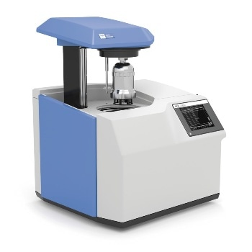](https://www.azom.com/images/equipments/EquipmentImage_5119.jpg)](https://www.azom.com/images/equipments/EquipmentImage_5119.jpg)

* [**View Supplier Profile**](https://www.azom.com/suppliers.aspx?SupplierID=8680)
* [**Visit Supplier Website**](https://www.ika.com/en)

The C 6000 global standards oxygen bomb calorimeter is a combination of modern technology, variability and automation (adiabatic, isoperibol; dynamic modes) in a single instrument. It operates based on all bomb calorimeter standards, such as, for example, the DIN, ASTM, GOST, ISO and GB. The operator can choose between three different starting temperatures (22 ºC, 30 ºC, 25 ºC) in each measuring mode: adiabatic, dynamic or isoperibol. Due to the spherically shaped decomposition vessel head, it was possible to reduce the wall thickness, allowing for faster heat transfer resulting in a shorter time measurement. Due to the wide range of interfaces (PC, Ethernet, balance, SD card, printer) this unit is effortlessly adaptable based on the customer's specific application requirements. Further adaption to LIMS and data management is possible with the calorimeter software C 6040 Calvin (Accessory).

* Automatic ignition
* Automatic water filling and draining
* Automatic oxygen filling, flushing and venting
* RFID technology for automatic decomposition vessel identification
* New design of the decomposition vessel allows for easier and faster sample preparation
* Can be operated with a chiller
* Convenient and easy touch screen operation
* Control chart view and correction calculation of globally used standards
* Ethernet interface for data management via FTP server or connection of a network printer
* Removable SD card allows for easier data measurement management, in addition to software updates

The C 6000 global standards Package 1/12 consists of:

* C 6000 global standards
* RC 2 basic Cooling water supply
* C 6012 Decomposition vessel, halogen resistant

**Specifications**

|  |  |
| --- | --- |
| **Technical Data** | |
| Measuring range max. [J] | 40000 |
| Measuring mode adiabatic 22 °C | yes |
| Measuring mode dynamic 22 °C | yes |
| Measuring mode isoperibol 22 °C | yes |
| Measuring mode adiabatic 25 °C | yes |
| Measuring mode dynamic 25 °C | yes |
| Measuring mode isoperibol 25 °C | yes |
| Measuring mode adiabatic 30 °C | yes |
| Measuring mode dynamic 30 °C | yes |
| Measuring mode isoperibol 30 °C | yes |
| Measurements/h adiabatic | 5 |
| Measurements/h dynamic | 6 |
| Measurements/h isoperibol | 4 |
| Reproducibility adiabatic (1 g benzoic acid NBS39i) [%RSD] | 0.05 |
| Reproducibility dynamic (1 g benzoic acid NBS39i) [%RSD] | 0.15 |
| Reproducibility isoperibol (1 g benzoic acid NBS39i) [%RSD] | 0.05 |
| Touchscreen | yes |
| Working temperature [°C] | 22 - 30 |
| Temperature measurement resolution [K] | 0.0001 |
| Cooling medium temperature [°C] | 12 - 27 |
| Cooling medium permissible operating pressure [bar] | 1.5 |
| Cooling medium | tap water |
| Type of cooling | flow |
| Chiller | KV600NR |
| Flow rate [l/h] | 60 - 70 |
| Rec. flow rate at 18 °C [l/h] | 60 |
| Oxygen operating pressure max. [bar] | 40 |
| Interface scale | RS232 |
| Interface printer | USB |
| Interface PC | RS232 |
| Interface test rack | yes |
| Interface ext. keyboard | yes |
| Oxygen filling | yes |
| Degasification | yes |
| Decomposition detection | yes |
| Decomposition vessel C 6012 | yes |
| Analysis according to DIN 51900 | yes |
| Analysis according to DIN EN ISO 1716 | yes |
| Analysis according to DIN EN ISO 9831 | yes |
| Analysis according to DIN EN 15170 | yes |
| Analysis according to DIN CEN TS 14918 | yes |
| Analysis according to ASTM D240 | yes |
| Analysis according to ASTM D4809 | yes |
| Analysis according to ASTM D5865 | yes |
| Analysis according to ASTM E711 | yes |
| Analysis according to ISO 1928 | yes |
| Analysis according to GB T213 | yes |
| Dimensions (W x H x D) [mm] | 500 x 425 x 450 |
| Weight [kg] | 29 |
| Permissible ambient temperature [°C] | 20 - 30 |
| Permissible relative humidity [%] | 80 |
| Protection class according to DIN EN 60529 | IP 20 |
| RS 232 interface | yes |
| USB interface | yes |
| Voltage [V] | 220 - 240 / 100 - 120 |
| Frequency [Hz] | 50/60 |
| Power input [W] | 1700 |
| **Ident. No.** | **0010000564** |

**Accessories**

C 6040 CalWin, C 6010 Decomposition vessel, standard, C 5041.10 Connection cable, C 6012 Decomposition vessel, halogen resistant, C 1.50 Dot matrix printer, C 6030 Venting station, C 60.1012 Organizer, C 6000.10 Set of spare parts, C 6000.12 Set of spare parts, C 1.103 Ignition wire, C 1.123 Ignition wire platinum, C 27 Calorimeter preparation set, C 29 Pressure gauge, oxygen, C 21 Pelleting press, C 5010.8 Crucible holder small, C 5010.5 Crucible holder big, C 25 Pressure regulating valve, C 5020 Sample rack, C 710.4 Cotton thread, cut to length, C 710.8 Cotton thread, C 4 Quartz dish, C 5 Set of VA combustion crucibles, C 6 Quartz crucible, big, C 710.2 Set of VA combustion crucibles, C 9 Gelatin capsules, C 10 Acetobutyrate capsules, C 12 Combustion bags 40 x 35 mm, C 12 A Combustion bags 70 x 35 mm, C 15 Paraffin strips, C 16 Parafilm, C 17 Paraffin, C 43 Benzoic acid NBS 39i, C 723 Benzoic acid, blister package, AOD 1.11 Control standard, AOD 1.12 Control standard, C 723 Benzoic acid BIG Package, C 6000.1 Water protect, 100 ml.

* [Request A Quote](https://www.azom.com/equipment-details.aspx?EquipID=5119)
* [Download PDF Copy](https://www.azom.com/equipment-details.aspx?EquipID=5119)
* [Download Brochure](https://www.azom.com/equipment-details.aspx?EquipID=5119)

**Other Equipment by this Supplier**

[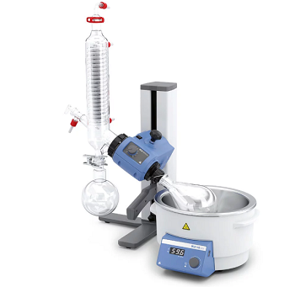](https://www.azom.com/equipment-details.aspx?EquipID=5116)

**[Beginner Rotary Evaporator – RV 3 V Evaporator](https://www.azom.com/equipment-details.aspx?EquipID=5116)**

[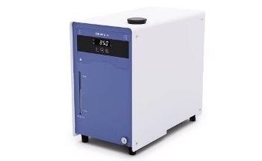](https://www.azom.com/equipment-details.aspx?EquipID=7835)

**[Compact Recirculating Chiller: RC 2 lite](https://www.azom.com/equipment-details.aspx?EquipID=7835)**

[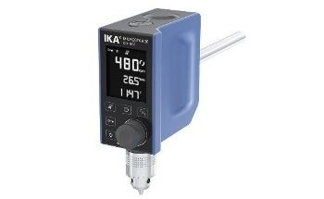](https://www.azom.com/equipment-details.aspx?EquipID=6809)

**[Control Overhead Stirrer - MICROSTAR 30 Control](https://www.azom.com/equipment-details.aspx?EquipID=6809)**

[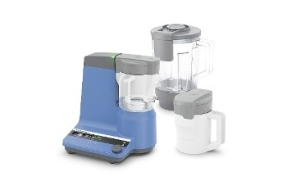](https://www.azom.com/equipment-details.aspx?EquipID=6784)

**[Crushing Tasks with Both Fine and Coarse Crushing - IKA MultiDrive](https://www.azom.com/equipment-details.aspx?EquipID=6784)**

[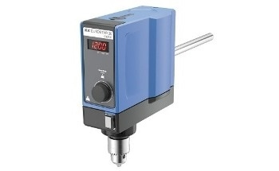](https://www.azom.com/equipment-details.aspx?EquipID=6808)

**[Digital Overhead Stirrer - EUROSTAR 20 Digital](https://www.azom.com/equipment-details.aspx?EquipID=6808)**

[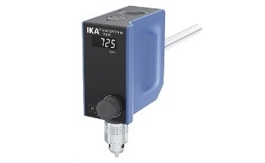](https://www.azom.com/equipment-details.aspx?EquipID=6811)

**[Digital Overhead Stirrer - MICROSTAR 15 Digital](https://www.azom.com/equipment-details.aspx?EquipID=6811)**

[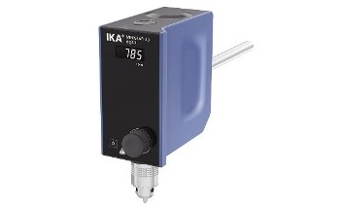](https://www.azom.com/equipment-details.aspx?EquipID=6810)

**[Digital Overheard Stirrer - MINISTAR 40 Digital](https://www.azom.com/equipment-details.aspx?EquipID=6810)**

[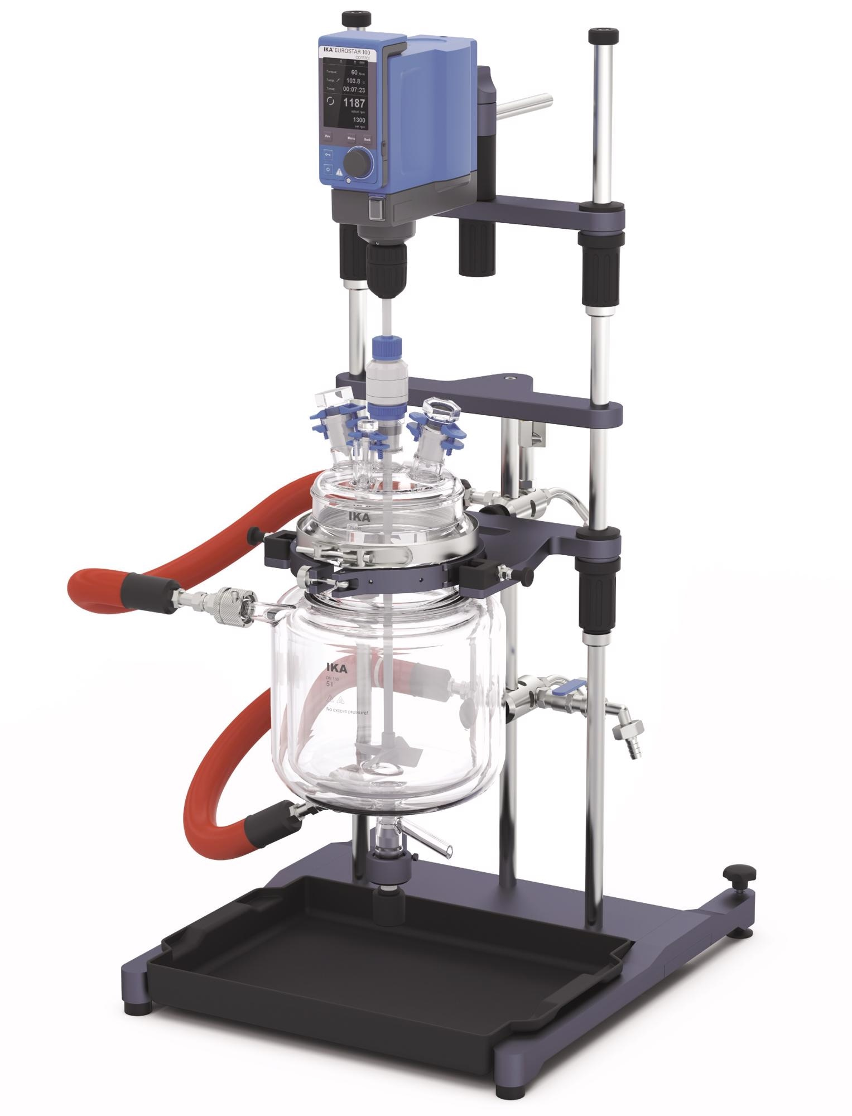](https://www.azom.com/equipment-details.aspx?EquipID=8183)

**[EasySyn Reactor System for Organic or Aqueous Synthesis](https://www.azom.com/equipment-details.aspx?EquipID=8183)**

[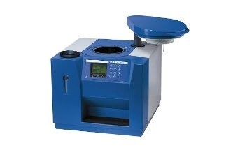](https://www.azom.com/equipment-details.aspx?EquipID=472)

**[GCV Determination - IKA C 200 Calorimeter System](https://www.azom.com/equipment-details.aspx?EquipID=472)**

[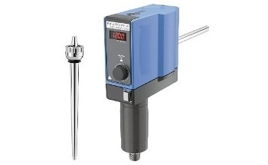](https://www.azom.com/equipment-details.aspx?EquipID=6807)

**[High Speed Digital Overhead Stirrer - EUROSTAR 20](https://www.azom.com/equipment-details.aspx?EquipID=6807)**

[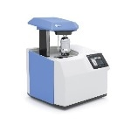](https://www.azom.com/equipment-details.aspx?EquipID=6748)

**[IKA Calorimeter C 6000 Global Standards Package 1/10](https://www.azom.com/equipment-details.aspx?EquipID=6748)**

[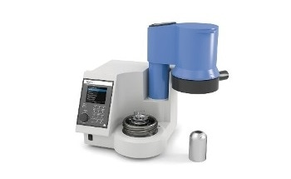](https://www.azom.com/equipment-details.aspx?EquipID=5829)

**[IKA Calorimeters C 1 Package 1/12](https://www.azom.com/equipment-details.aspx?EquipID=5829)**

[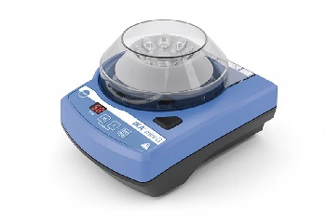](https://www.azom.com/equipment-details.aspx?EquipID=5802)

**[IKA Centrifuges - IKA Mini G](https://www.azom.com/equipment-details.aspx?EquipID=5802)**

[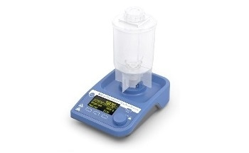](https://www.azom.com/equipment-details.aspx?EquipID=6751)

**[IKA Disperser ULTRA-TURRAX® Tube Drive P control](https://www.azom.com/equipment-details.aspx?EquipID=6751)**

[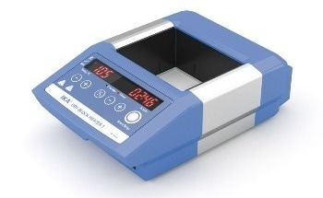](https://www.azom.com/equipment-details.aspx?EquipID=5827)

**[IKA Dry Block Heater Dry Block Heater 1](https://www.azom.com/equipment-details.aspx?EquipID=5827)**

[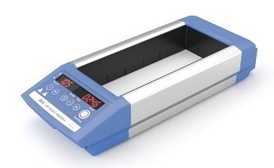](https://www.azom.com/equipment-details.aspx?EquipID=5801)

**[IKA Dry Block Heaters - Dry Block Heater 3](https://www.azom.com/equipment-details.aspx?EquipID=5801)**

[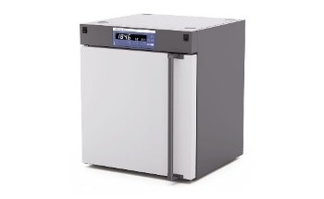](https://www.azom.com/equipment-details.aspx?EquipID=5804)

**[IKA Drying Ovens - IKA Oven 125 Basic Dry](https://www.azom.com/equipment-details.aspx?EquipID=5804)**

[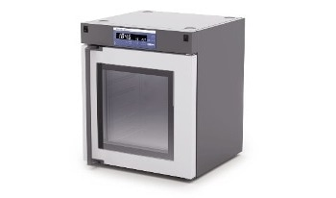](https://www.azom.com/equipment-details.aspx?EquipID=5831)

**[IKA Drying Ovens, IKA Oven 125 Basic Dry - Glass](https://www.azom.com/equipment-details.aspx?EquipID=5831)**

[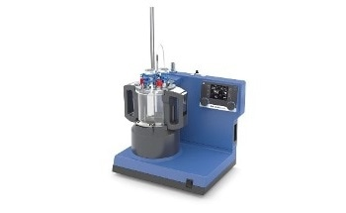](https://www.azom.com/equipment-details.aspx?EquipID=5797)

**[IKA Laboratory Reactors - LR 1000 Control Package](https://www.azom.com/equipment-details.aspx?EquipID=5797)**

[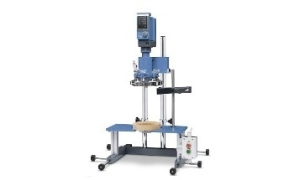](https://www.azom.com/equipment-details.aspx?EquipID=5833)

**[IKA Laboratory Reactors - LR-2.ST, the Compact Power](https://www.azom.com/equipment-details.aspx?EquipID=5833)**

[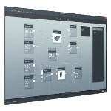](https://www.azom.com/equipment-details.aspx?EquipID=6744)

**[IKA Laboratory Software labworldsoft® 6 Pro](https://www.azom.com/equipment-details.aspx?EquipID=6744)**

[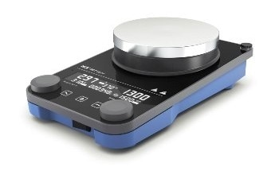](https://www.azom.com/equipment-details.aspx?EquipID=6743)

**[IKA Magnetic Stirrer Plate (RCT Digital)](https://www.azom.com/equipment-details.aspx?EquipID=6743)**

[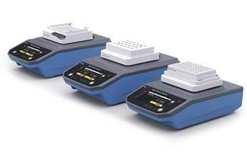](https://www.azom.com/equipment-details.aspx?EquipID=8009)

**[IKA MATRIX Thermoshakers](https://www.azom.com/equipment-details.aspx?EquipID=8009)**

[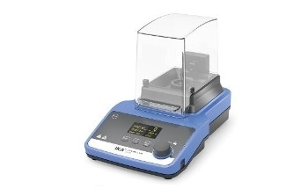](https://www.azom.com/equipment-details.aspx?EquipID=5799)

**[IKA Mills - Tube Mill 100 Control](https://www.azom.com/equipment-details.aspx?EquipID=5799)**

[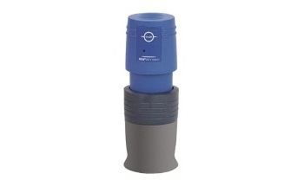](https://www.azom.com/equipment-details.aspx?EquipID=5826)

**[IKA Mills A 11 Basic Analytical Mill](https://www.azom.com/equipment-details.aspx?EquipID=5826)**

[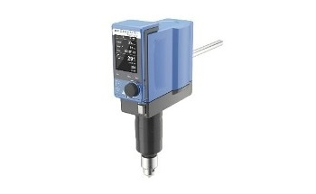](https://www.azom.com/equipment-details.aspx?EquipID=5795)

**[IKA Overhead Stirrers - EUROSTAR 100 Control P4](https://www.azom.com/equipment-details.aspx?EquipID=5795)**

[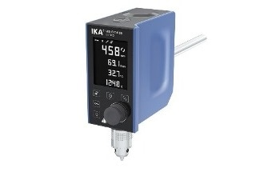](https://www.azom.com/equipment-details.aspx?EquipID=5823)

**[IKA Overhead Stirrers MINISTAR 80 Control](https://www.azom.com/equipment-details.aspx?EquipID=5823)**

[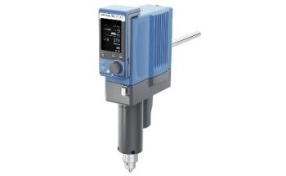](https://www.azom.com/equipment-details.aspx?EquipID=6103)

**[IKA Overhead Stirrers STARVISC 200-2.5 Control](https://www.azom.com/equipment-details.aspx?EquipID=6103)**

[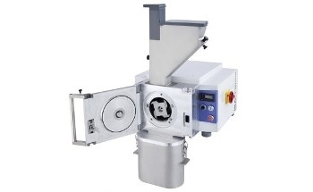](https://www.azom.com/equipment-details.aspx?EquipID=3992)

**[IKA Pilotina - Multipurpose Dry Milling System](https://www.azom.com/equipment-details.aspx?EquipID=3992)**

[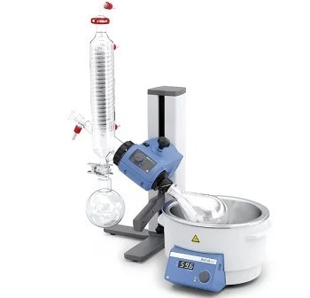](https://www.azom.com/equipment-details.aspx?EquipID=8377)

**[IKA Rotary Evaporators](https://www.azom.com/equipment-details.aspx?EquipID=8377)**

[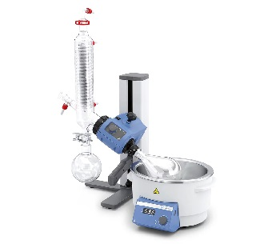](https://www.azom.com/equipment-details.aspx?EquipID=5800)

**[IKA Rotary Evaporators - RV 3 V-C](https://www.azom.com/equipment-details.aspx?EquipID=5800)**

[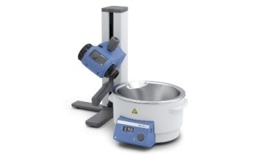](https://www.azom.com/equipment-details.aspx?EquipID=5832)

**[IKA Rotary Evaporators RV 3 FLEX](https://www.azom.com/equipment-details.aspx?EquipID=5832)**

[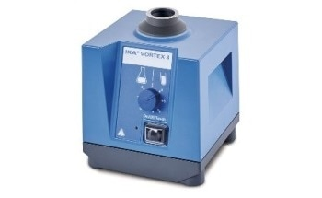](https://www.azom.com/equipment-details.aspx?EquipID=5796)

**[IKA Shakers - VORTEX 3](https://www.azom.com/equipment-details.aspx?EquipID=5796)**

[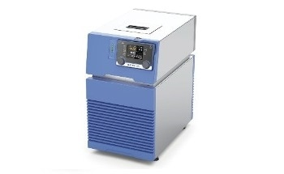](https://www.azom.com/equipment-details.aspx?EquipID=5806)

**[IKA Temperature Control - RC 5 Control](https://www.azom.com/equipment-details.aspx?EquipID=5806)**

[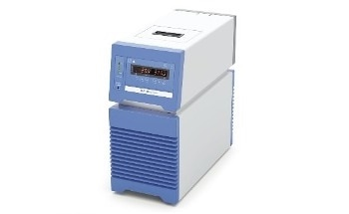](https://www.azom.com/equipment-details.aspx?EquipID=5834)

**[IKA Temperature Control HRC 2 Basic](https://www.azom.com/equipment-details.aspx?EquipID=5834)**

[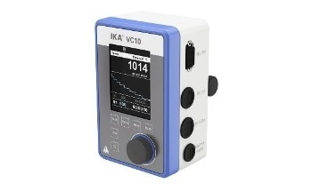](https://www.azom.com/equipment-details.aspx?EquipID=5794)

**[IKA Vacuum - VC 10 Vacuum Controller](https://www.azom.com/equipment-details.aspx?EquipID=5794)**

[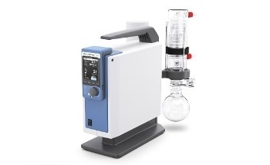](https://www.azom.com/equipment-details.aspx?EquipID=6105)

**[IKA Vacuum IKA Vacstar Control](https://www.azom.com/equipment-details.aspx?EquipID=6105)**

[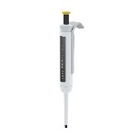](https://www.azom.com/equipment-details.aspx?EquipID=6750)

**[IKA Vario Pipette 2-20 μl](https://www.azom.com/equipment-details.aspx?EquipID=6750)**

[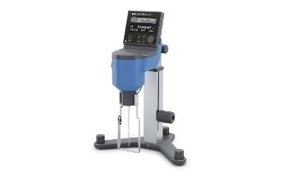](https://www.azom.com/equipment-details.aspx?EquipID=6104)

**[IKA Viscometer ROTAVISC hi-vi II Complete](https://www.azom.com/equipment-details.aspx?EquipID=6104)**

[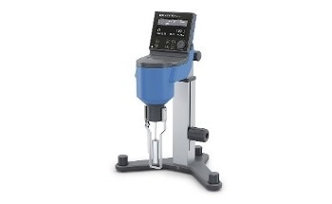](https://www.azom.com/equipment-details.aspx?EquipID=6746)

**[IKA Viscometer ROTAVISC lo-vi Complete](https://www.azom.com/equipment-details.aspx?EquipID=6746)**

[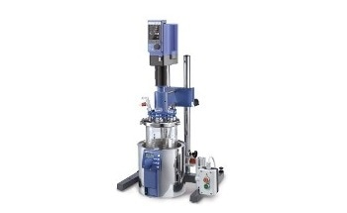](https://www.azom.com/equipment-details.aspx?EquipID=4000)

**[LR-2.ST - Modular Design Reactor for Chemical Reactions](https://www.azom.com/equipment-details.aspx?EquipID=4000)**

[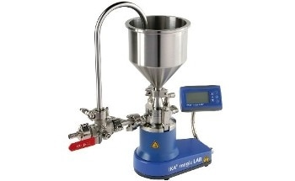](https://www.azom.com/equipment-details.aspx?EquipID=3997)

**[magic LAB – Multi-Functional ‘Lab’ for Mixing](https://www.azom.com/equipment-details.aspx?EquipID=3997)**

[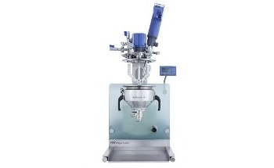](https://www.azom.com/equipment-details.aspx?EquipID=3991)

**[magic PLANT - Lab-Scale Process Plant for Emulsification](https://www.azom.com/equipment-details.aspx?EquipID=3991)**

[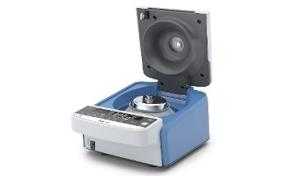](https://www.azom.com/equipment-details.aspx?EquipID=6785)

**[Midi Centrifuge for Separating Substances - IKA G-L Centrifuge](https://www.azom.com/equipment-details.aspx?EquipID=6785)**

[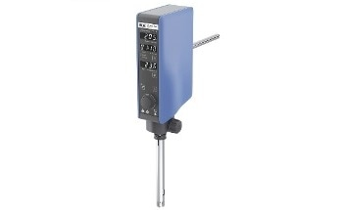](https://www.azom.com/equipment-details.aspx?EquipID=6786)

**[Operation Time Detection and Temperature Measurement - T 25 Easy Clean Control Disperser](https://www.azom.com/equipment-details.aspx?EquipID=6786)**

[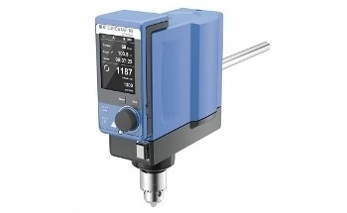](https://www.azom.com/equipment-details.aspx?EquipID=6806)

**[Overhead Stirrer - EUROSTAR 60 Control](https://www.azom.com/equipment-details.aspx?EquipID=6806)**

[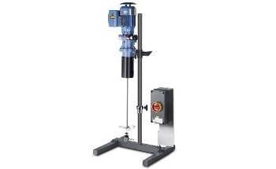](https://www.azom.com/equipment-details.aspx?EquipID=3996)

**[RKG-00-Bo - Mechanical Agitator of Free-Flowing Liquids](https://www.azom.com/equipment-details.aspx?EquipID=3996)**

Bottom of Form

**Other Sites from AZoNetwork**

[Skip to main content](https://www.hitachi-hightech.com/eu/product_detail/?pn=su7000&version=#body)

[](http://www.hitachi.com/)

[[](javascript:void(0);)Search](javascript:void(0);)

[[](javascript:void(0);) Europe](javascript:void(0);)

[Hitachi Group  
Products & Services](javascript:void(0);)

[Hitachi Group  
Corporate Information](javascript:void(0);)

[](https://www.hitachi-hightech.com/eu/)

* [Hitachi High-Tech Top](https://www.hitachi-hightech.com/global/)

* [Deutsch](https://www.hitachi-hightech.com/eu/index.html?version=de)

* [Global Network](https://map.hitachi-hightech.com/en?lang=en)

* [Sitemap](https://www.hitachi-hightech.com/eu/sitemap/)

# Ultra-High Resolution Analytical FESEM SU7000

Top of Form

Bottom of Form

* [Request Info](https://www.hitachi-hightech.com/eu/product_detail/?pn=su7000&version=)
* [Print](javascript:void(0))

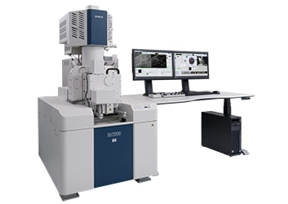

**SU7000: The Next-Generation FE-SEM**

The modern FE-SEM requires not only high performance but also a multitude of functionalities including wide-area observation, in-situ analysis, variable pressure, high-resolution imaging at low accelerating voltages, and simultaneous multi-signal collection.

The SU7000 is designed to address these aspects and more by delivering enhanced information for diversified needs in the field of electron microscopy.

Experience the nano-world with the SU7000!

\*

Images on monitors are inset.

\*

The device photograph shows configuration with optional items.

## [Features](https://www.hitachi-hightech.com/eu/product_detail/?pn=su7000&version=#productSub-0)

## [Specifications](https://www.hitachi-hightech.com/eu/product_detail/?pn=su7000&version=#productSub-1)

## [Installation Diagram](https://www.hitachi-hightech.com/eu/product_detail/?pn=su7000&version=#productSub-2)

### Key Concept

1. **Versatile Imaging Capability**  
   The SU7000 excels in fast acquisition of multiple signals to address expansive SEM needs, from imaging a wide field of view to visualizing sub-nanometer structures and everything in between.  
    The incorporation of newly designed electron optics and detection systems allows for efficient simultaneous acquisition of multiple secondary electron and back-scattered electron signals.
2. **Multi-Channel Imaging**  
   The number of the detectors mounted on the SEM is ever increasing, along with the need to display all collected information effectively.  
    The SU7000 is capable of processing, displaying, and saving up to 6 signals simultaneously to maximize information acquisition.
3. **Wide Variety of Observation Techniques**  
   The specimen chamber and the vacuum system are optimized for:  
   ・Large specimen size  
   ・Sample manipulation at various axes  
   ・Variable pressure conditions  
   ・Cryogenic conditions  
   ・Heating and cooling in-situ observation
4. **Microanalysis**  
   The electron gun is equipped with a Schottky emitter that provides up to 200 nA beam current to accommodate various microanalysis applications.  
    The specimen chamber and port layout are designed to incorporate multiple analytical options including EDX, WDX, EBSD, cathodoluminescence, and more.  
    The SU7000 with the combination of numerous analytical accessories unifies multi-discipline techniques in a single platform.

### Imaging Performance

#### Enhanced Information Acquisition

The advanced detection system of the SU7000 streamlines acquisition of structural, topographical, compositional, crystallographic, and other types of information by minimizing changes to microscope conditions, such as working distance or accelerating voltage.

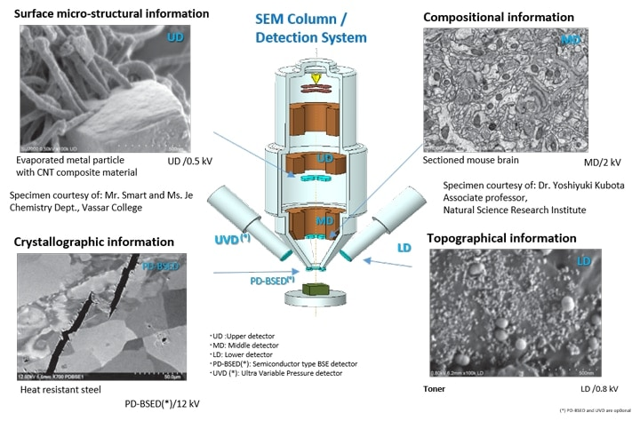

#### Single-Scan Multi-Signal Imaging

Specimen: Organic-coated gold rods

Specimen courtesy of: Mr. Smart and Ms. Je Chemistry Dept.,  
Vassar College

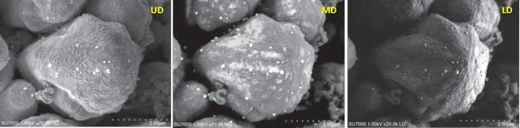

Simultaneous image acquisition for surface micro-structural information (UD), surface coating (MD), and overall topographic information (LD). Acceleration voltage: 1 kV

### Intuitive Graphical User Interface

#### Enhanced Signal Display

* Customizable display modes.
* Single and Dual-monitor configurations.
* Simultaneous image display up to 4-ch (single) and 6-ch (dual).
* Chamber Scope and SEM MAP for optical stage navigation.

#### Highly Flexible Screen Layout

The software is capable of display 1, 2, or 4 signals including the chamber scope or SEM MAP on a single monitor.  
Additionally, the operation panel can be customized to display submenus anywhere on the screen.

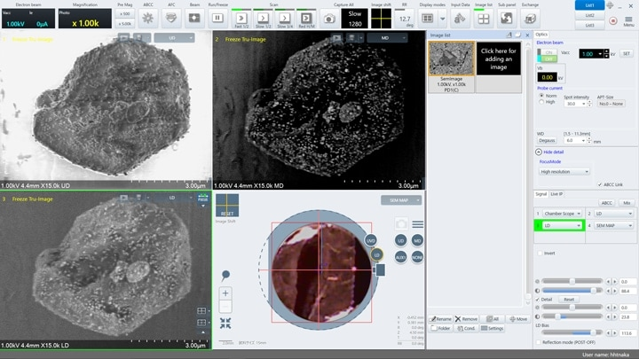

#### Dual Monitor

The first monitor can be used as a dedicated image display while the second monitor is utilized for operation.  
Five detector images (UD, LD, UVD, MD, and PD-BSED) and SEM MAP of non-metallic inclusions in a steel specimen are displayed (left).  
The screen shows the operation panel menu and the thumbnail image window on one screen (right).  
The dual-monitor configuration supports increased productivity with expanded workspace.

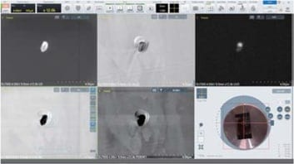

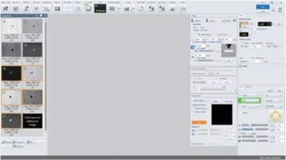

### Expandable Observation and Analysis

#### Large specimen chamber and large stage

The specimen chamber can accommodate a tall specimen of φ 200 mm or 80 mm in height and 18 accessory ports. The large stage travels 135 mm (X) x 100 mm (Y) and can accept up to 2 kg of specimen.(\*) Large specimen or variable type of sub-stages can be easily mounted on the front-opening large stage door.

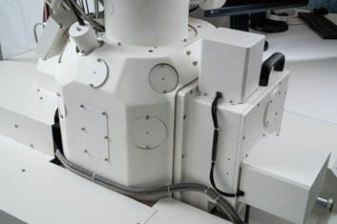  
external view of the specimen chamber featuring 18 accessories ports

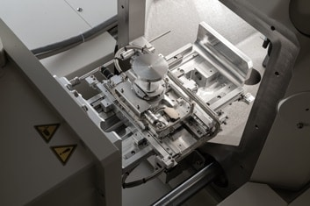  
external view of the stage. XY movable range: 135×100 mm

(\*)

at 0° tilt

#### Camera Navigation(\*)

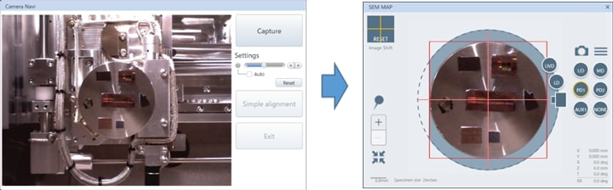  
Left: Picture of the sample captured by the camera equipped inside the chamber.  
Right: Camera image transferred to the SEM MAP screen for navigation.

The camera navigation feature correlates an optical image to the target observation area.  
The camera installed in the specimen chamber captures the specimen image at the time of specimen introduction. The image is transferred to the SEM MAP screen for a graphically driven navigation interface.  
Camera navigation supports a maximum of φ 100 mm specimen.

(\*)

Camera navigation function is optional

#### Detection System Enabling Dynamic Observation

The SU7000 supports observation under various environmental conditions. A variety of detectors (\*) such as UVD and MD are selectable in addition to the PD-BSED for observation under low-vacuum conditions.

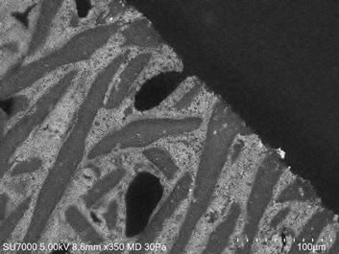

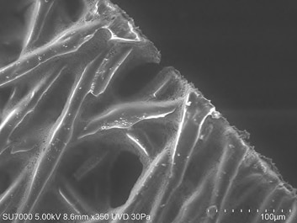

**Detector Selection Under Low-Vacuum Conditions**  
Specimen: Fiber with metallic oxide  
Left: MD (Backscattered electron) image  
Right: UVD (SE image)  
The oxide dispersion and fiber layering state are observed respectively.

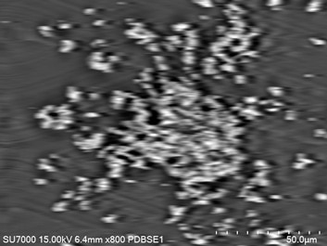

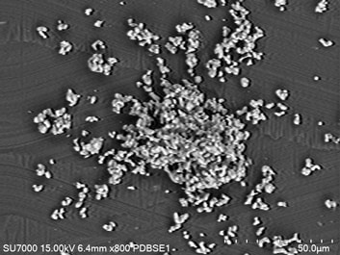

**Improved PD-BSED Response Speed**  
Left: Traditional PD-BSED response at the scan rate of 30 ms x 64 frames  
Right: SU7000 PD-BSED image demonstrating improved response and image quality to expand in-situ observation capability

## [Technical magazine "SI NEWS"](https://www.hitachi-hightech.com/global/sinews/)

This journal addresses a wide range variety of research papers and useful application data using Hitachi science instruments.

* [Return to the Top of Page](https://www.hitachi-hightech.com/eu/product_detail/?pn=su7000&version=#top)

## [Science & Medical Systems](https://www.hitachi-hightech.com/eu/products/science/index.html)

* [Electron Microscopes](https://www.hitachi-hightech.com/eu/products/science/microscopes)
  + [Electron Microscopes (SEM/TEM/STEM)](https://www.hitachi-hightech.com/eu/product_list/?ld=sms2&md=sms2-1)
    - [**Field Emission Scanning Electron Microscopes (FE-SEM)**](https://www.hitachi-hightech.com/eu/product_list/?ld=sms2&md=sms2-1&sd=sms2-1-1)
    - [Scanning Electron Microscopes (SEM)](https://www.hitachi-hightech.com/eu/product_list/?ld=sms2&md=sms2-1&sd=sms2-1-2)
    - [Tabletop Microscopes](https://www.hitachi-hightech.com/eu/product_list/?ld=sms2&md=sms2-1&sd=sms2-1-3)
    - [Transmission Electron Microscopes (TEM)](https://www.hitachi-hightech.com/eu/product_list/?ld=sms2&md=sms2-1&sd=sms2-1-4)
    - [AMICS Software (MLA)](https://www.hitachi-hightech.com/eu/product_list/?ld=sms2&md=sms2-1&sd=sms2-1-6)
  + [Focused Ion Beam Systems (FIB/FIB-SEM)](https://www.hitachi-hightech.com/eu/product_list/?ld=sms2&md=sms2-2)
  + [Sample Preparation](https://www.hitachi-hightech.com/eu/product_list/?ld=sms2&md=sms2-5)
* [**Contact Us**](https://www8.hitachi.co.jp/inquiry/hitachi-hightech/eu/products/em-en/form_input.jsp)

[](https://www.hitachi-hightech.com/global/sinews/)

[](https://www.hitachi-hightech.com/global/tm/)

* [Request Info](https://www.hitachi-hightech.com/eu/product_detail/?pn=su7000&version=)
* [Print](javascript:void(0))

[Hitachi High-Tech in Europe Top](https://www.hitachi-hightech.com/eu/)

[**Products & Solutions**](https://www.hitachi-hightech.com/eu/products/)

[**About Us**](https://www.hitachi-hightech.com/eu/about/)

[**Support**](https://www.hitachi-hightech.com/eu/support/)

* [Electron Microscopy](https://www.hitachi-hightech.com/eu/products/science/microscopes/)
* [Semiconductor Process Control](https://www.hitachi-hightech.com/eu/products/device/)
* [Industrial & IoT Solutions](https://www.hitachi-hightech.com/eu/products/ind_solutions/)
* [Industrial Products & Components](https://www.hitachi-hightech.com/eu/products/advanced/)
* [Corporate profile](https://www.hitachi-hightech.com/eu/about/)
* [General terms and conditions](https://www.hitachi-hightech.com/eu/gtc/)
* [Imprint](https://www.hitachi-hightech.com/eu/imprint/)
* [Modern Slavery Act Transparency Statement](https://www.hitachi-hightech.com/file/eu/pdf/about/statement/modern_slavery_act.pdf)
* [Contact us](https://www.hitachi-hightech.com/eu/support/inquiry/)
* [Technical Support](https://www.hitachi-hightech.com/eu/support/inquiry/sd.html)
* [Distributors & Partners](https://www.hitachi-hightech.com/eu/support/inquiry/sme.html)

[Hitachi High-Tech Global Top](https://www.hitachi-hightech.com/global/index.html)

[**About Hitachi High-Tech**](https://www.hitachi-hightech.com/global/about/index.html)

* [Terms of Use](https://www.hitachi-hightech.com/eu/termsofuse/)
* [Privacy Policy](https://www.hitachi-hightech.com/eu/privacy/)

© Hitachi High-Tech Europe GmbH 2022. All rights reserved.

When you visit any website, it may store or retrieve information on your browser, mostly in the form of cookies. This information might be about you, your preferences or your device and is mostly used to make the site work as you expect it to. The information does not usually directly identify you, but it can give you a more personalized web experience. [Cookie Policy](https://www.hitachi-hightech.com/global/privacy/cookie.html)

OK

[Skip to main content](https://www.hitachi-hightech.com/eu/product_detail/?pn=su7000&version=#body)

[Search](javascript:void(0);)

[Europe](javascript:void(0);)

[Hitachi Group  
Products & Services](javascript:void(0);)

[Hitachi Group  
Corporate Information](javascript:void(0);)

* [Hitachi High-Tech Top](https://www.hitachi-hightech.com/global/)

* [Deutsch](https://www.hitachi-hightech.com/eu/index.html?version=de)

* [Global Network](https://map.hitachi-hightech.com/en?lang=en)

* [Sitemap](https://www.hitachi-hightech.com/eu/sitemap/)

* [Contact Us](https://www.hitachi-hightech.com/eu/support/inquiry/)

[**Products & Solutions**](https://www.hitachi-hightech.com/eu/products/)

[About Us](https://www.hitachi-hightech.com/eu/about/)

[Service & Support](https://www.hitachi-hightech.com/eu/support/)

* [TOP](https://www.hitachi-hightech.com/eu/index.html)
* [Hitachi High-Tech Products & Solutions](https://www.hitachi-hightech.com/eu/products/index.html)
* [Hitachi Analytical Instruments](https://www.hitachi-hightech.com/eu/products/science/index.html)
* [Hitachi Electron Microscopy](https://www.hitachi-hightech.com/eu/products/science/microscopes)
* [Electron Microscopes (SEM/TEM/STEM)](https://www.hitachi-hightech.com/eu/product_list/?ld=sms2&md=sms2-1)
* [Field Emission Scanning Electron Microscopes (FE-SEM)](https://www.hitachi-hightech.com/eu/product_list/?ld=sms2&md=sms2-1&sd=sms2-1-1)
* Ultra-High Resolution Analytical FESEM SU7000

**Ultra-High Resolution Analytical FESEM SU7000**

Top of Form

Bottom of Form

* [Request Info](https://www.hitachi-hightech.com/eu/product_detail/?pn=su7000&version=)
* [Print](javascript:void(0))



**SU7000: The Next-Generation FE-SEM**

The modern FE-SEM requires not only high performance but also a multitude of functionalities including wide-area observation, in-situ analysis, variable pressure, high-resolution imaging at low accelerating voltages, and simultaneous multi-signal collection.

The SU7000 is designed to address these aspects and more by delivering enhanced information for diversified needs in the field of electron microscopy.

Experience the nano-world with the SU7000!

\*

Images on monitors are inset.

\*

The device photograph shows configuration with optional items.

* [**Features**](https://www.hitachi-hightech.com/eu/product_detail/?pn=su7000&version=#productSub-0)
* [**Specifications**](https://www.hitachi-hightech.com/eu/product_detail/?pn=su7000&version=#productSub-1)
* [**Installation Diagram**](https://www.hitachi-hightech.com/eu/product_detail/?pn=su7000&version=#productSub-2)

|  |  |  |  |
| --- | --- | --- | --- |
| Image Resolution | Resolution SE | | 0.8 nm@15 kV |
| 0.9 nm@1 kV |
| Magnification | | | 20～2,000,000 x |
| Electron Optics | Emitter | | ZrO/W Schottky Emitter |
| Accelerating Voltage | | 0.1～30 kV (0.01 kV step) |
| Probe Current | | Max. 200 nA |
| Detectors | Standard Detectors | | UD（Upper Detector) |
| MD（Middle Detector） |
| LD（Lower Detector) |
| Optional Detectors | | PD-BSED（Semiconductor type） |
| UVD (Ultra Variable Pressure Detector） |
| Variable Pressure(VP) Mode (Option) | Pressure Range | | 5～300 Pa |
| Available Detectors in VP mode | | PD-BSED, UVD, UD, MD,LD |
| Specimen Stage | Stage Control | | 5-axis Motor Drive |
| Movable Range | X | 0～135 mm |
| Y | 0～100 mm |
| Z | 1.5～40 mm |
| T | -5～70° |
| R | 360° |
| Specimen Chamber | Specimen Size | | Max. φ200 mm, Max. 80mm Height |
| Monitor（Option) | | | 23 inch LCD（1,920×1,080) , supports dual monitors operation |
| Image Display Mode | Large Screen Display Mode | | 1,280×960 pixels |
| Single Image Display Mode | | 800×600 pixels |
| Dual Image Display Mode | | 800×600 pixels、1,280×960 pixels with dual monitors |
| Quad Image Display Mode | | 640×480 pixels |
| Hex Image Display Mode w/dual monitors | | 640×480 pixels with dual monitors |
| Image Data Saving | Pixel Size | | 640×480、1,280×960、2,560×1,920、5,120×3,840、10,240×7,680 |
| Optional Accessories | Energy Dispersive X-ray Spectrometer (EDX) | | |
| Wavelength Dispersive X-ray Spectrometer (WDX) | | |
| Electron Backscattered Diffraction Detector (EBSD) | | |
| Cathodoluminescence System (CL) | | |
| Cryogenic Transfer System | | |
| Compatible with various types of sub-stages | | |

[Skip to content](https://amscope.com/collections/metallurgical-microscopes#MainContent)

0

[[](https://amscope.com/collections/blowout-clearance-sale-up-to-60-off)](https://amscope.com/collections/blowout-clearance-sale-up-to-60-off)

1. [Home](https://amscope.com/) /
2. Metallurgical Microscopes

Metallurgical Microscopes

Metallurgical microscopes are useful for viewing a wide-array of opaque specimens such as rocks, plastics and ceramics. High-powered metallurgical microscopes are typically equipped with larger stages, numerous objectives and a variety of light sources.

FilterSort:

[[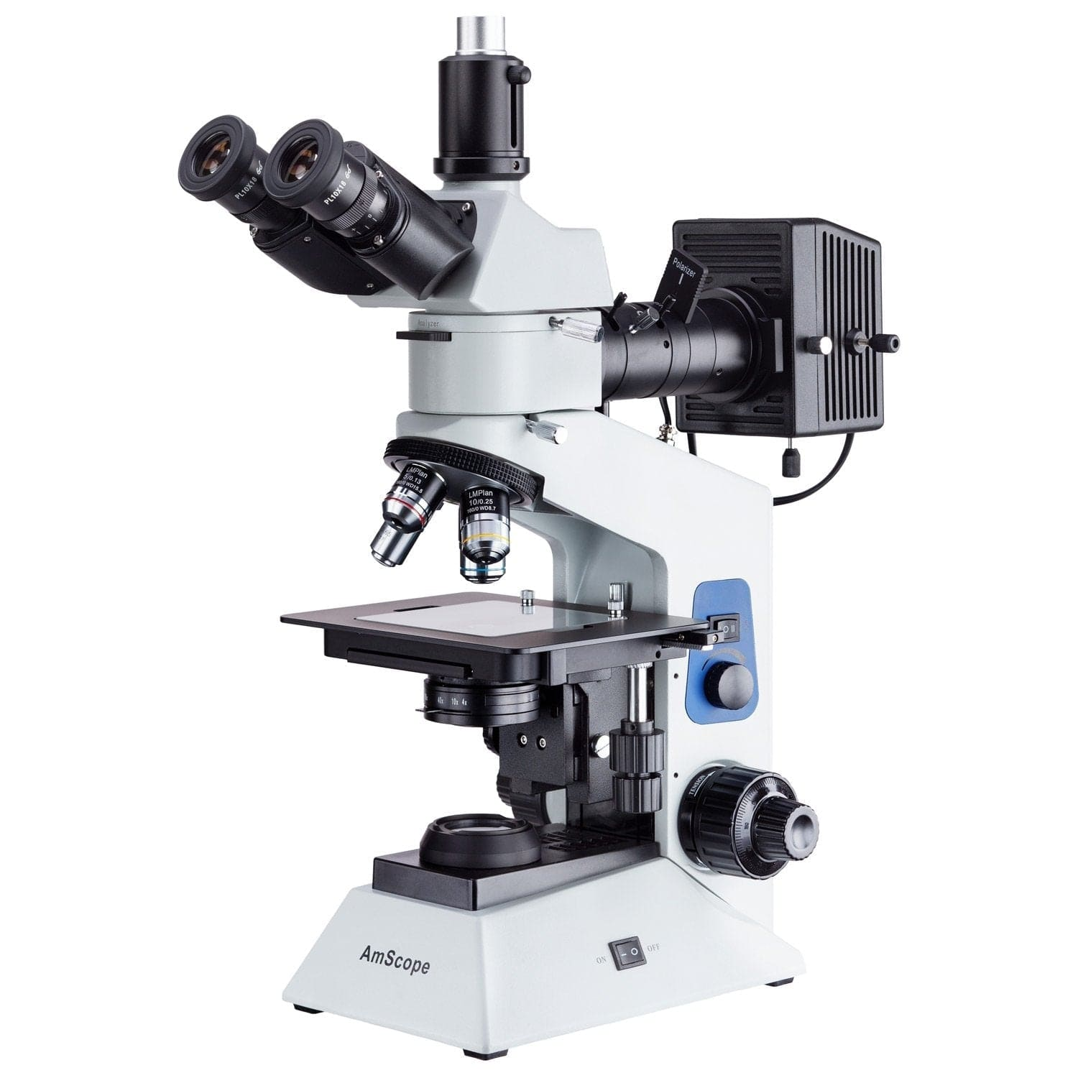](https://amscope.com/collections/metallurgical-microscopes/products/c-me580t-pz-2l)](https://amscope.com/collections/metallurgical-microscopes/products/c-me580t-pz-2l)

[Dual Illumination Polarized Light Compact Trinocular Metallurgical Microscope w/Optional Digital Camera](https://amscope.com/collections/metallurgical-microscopes/products/c-me580t-pz-2l)

5.0 star rating[1 Review](javascript:void(0))

Sku: ME580T-PZ-2L

Starting at$994.99

[VIEW OPTIONS](https://amscope.com/collections/metallurgical-microscopes/products/c-me580t-pz-2l)

[[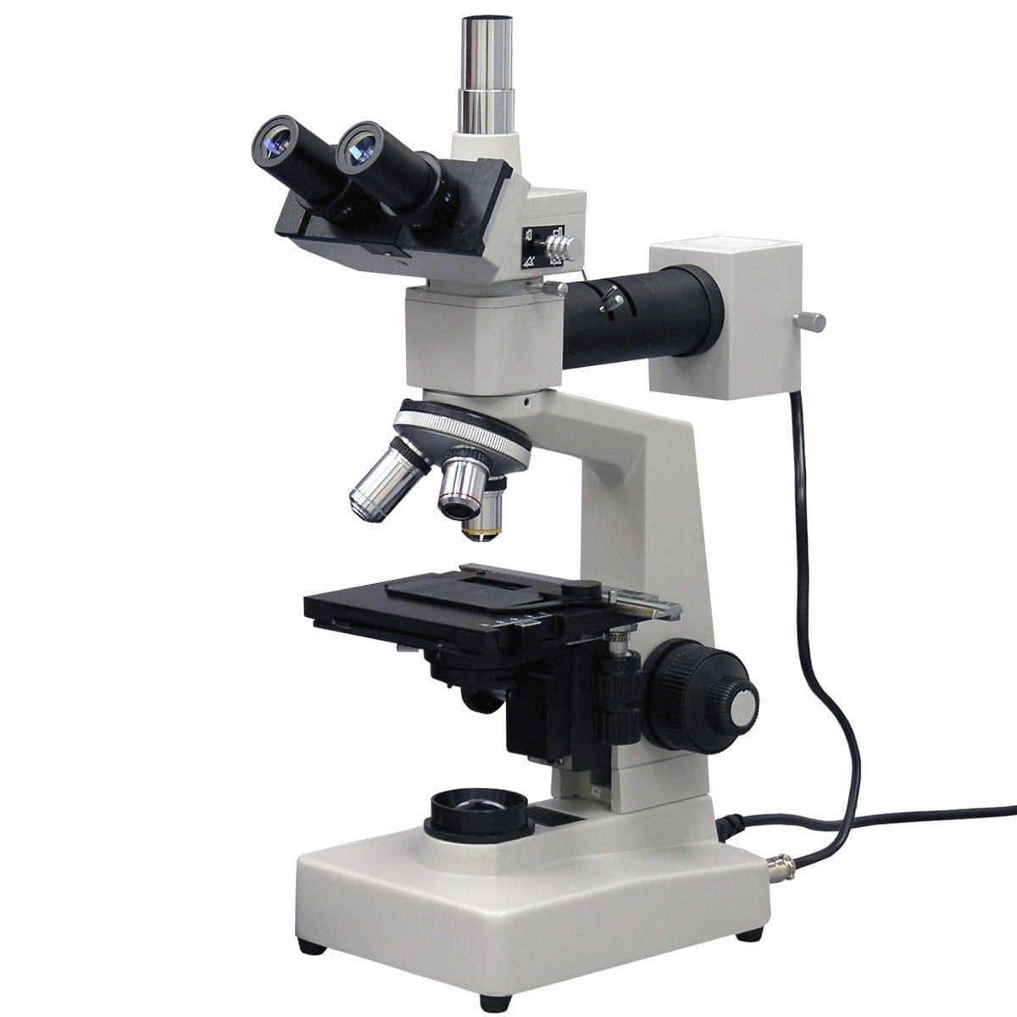](https://amscope.com/collections/metallurgical-microscopes/products/c-me300tz-2l)](https://amscope.com/collections/metallurgical-microscopes/products/c-me300tz-2l)

[Dual-illumination Trinocular Metallurgical Microscope](https://amscope.com/collections/metallurgical-microscopes/products/c-me300tz-2l)

Sku: ME300TZ-2L

Starting at$940.99

[VIEW OPTIONS](https://amscope.com/collections/metallurgical-microscopes/products/c-me300tz-2l)

[[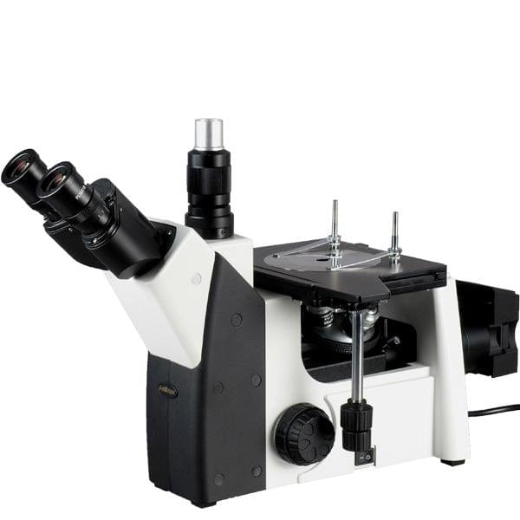](https://amscope.com/collections/metallurgical-microscopes/products/c-me1200t)](https://amscope.com/collections/metallurgical-microscopes/products/c-me1200t)

[Binocular Inverted Plan Optics Metallurgical Microscope w/Optional Digital Camera](https://amscope.com/collections/metallurgical-microscopes/products/c-me1200t)

5.0 star rating[3 Reviews](javascript:void(0))

Sku: ME1200T

Starting at$1,661.99

[VIEW OPTIONS](https://amscope.com/collections/metallurgical-microscopes/products/c-me1200t)

[[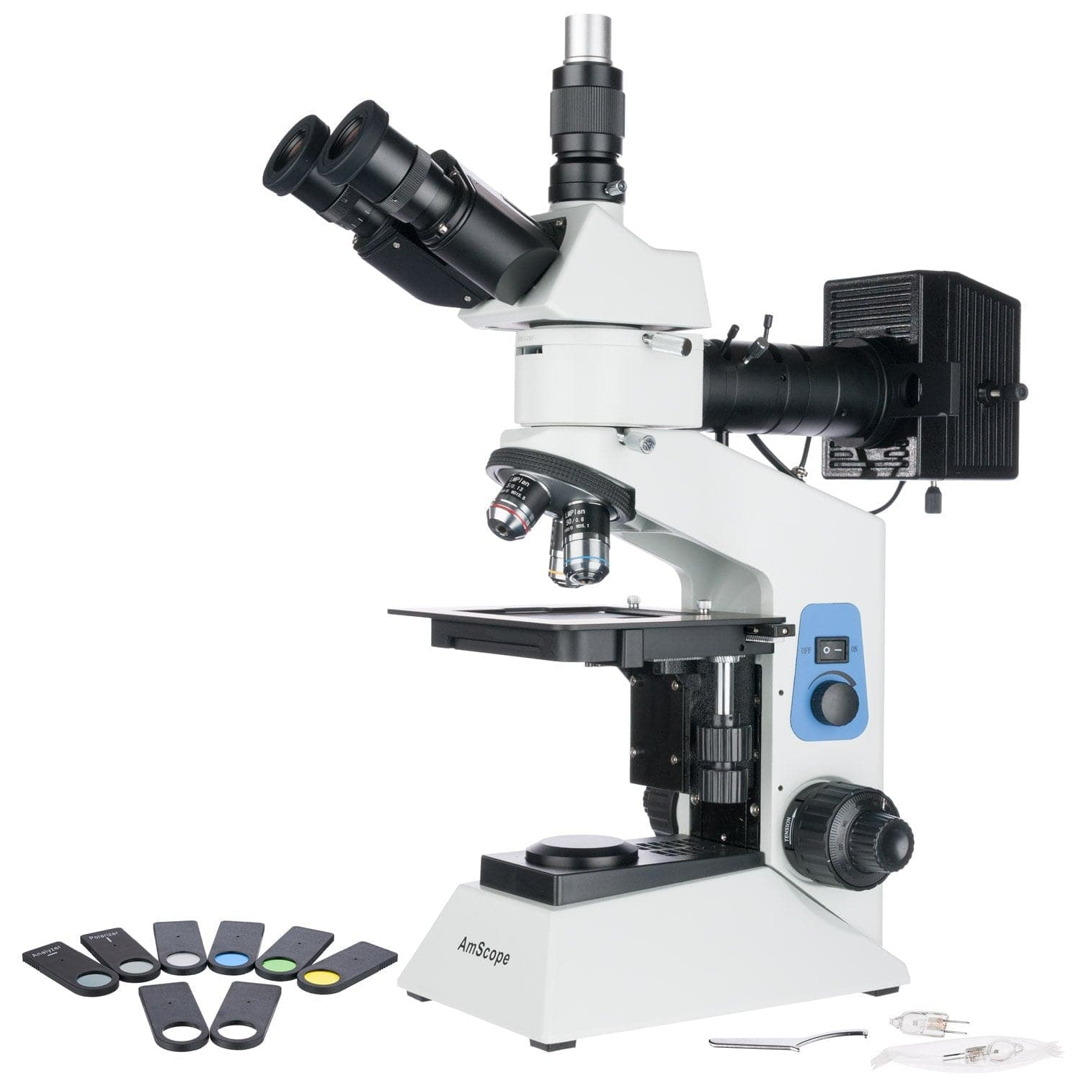](https://amscope.com/collections/metallurgical-microscopes/products/c-me580t-pz)](https://amscope.com/collections/metallurgical-microscopes/products/c-me580t-pz)

[Compact Trinocular Polarized Light Metallurgical Microscope w/Optional Digital Camera](https://amscope.com/collections/metallurgical-microscopes/products/c-me580t-pz)

Sku: ME580T-PZ

Starting at$940.99

[VIEW OPTIONS](https://amscope.com/collections/metallurgical-microscopes/products/c-me580t-pz)

[[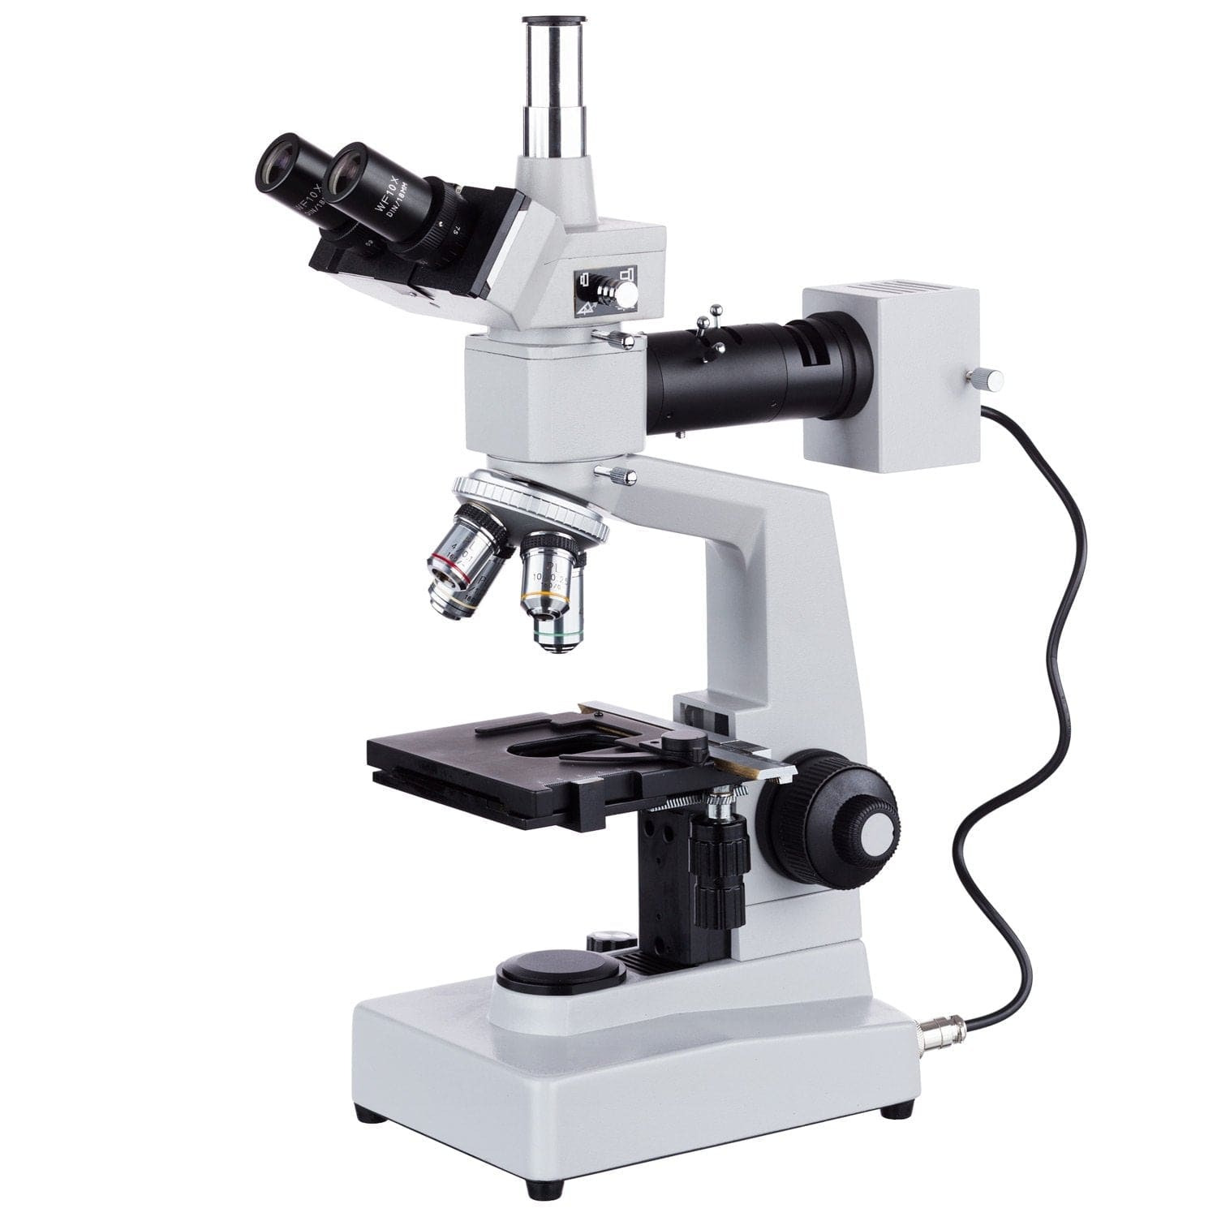](https://amscope.com/collections/metallurgical-microscopes/products/c-me300tz)](https://amscope.com/collections/metallurgical-microscopes/products/c-me300tz)

[Trinocular Metallurgical Microscope](https://amscope.com/collections/metallurgical-microscopes/products/c-me300tz)

Sku: ME300TZ

Starting at$915.99

[VIEW OPTIONS](https://amscope.com/collections/metallurgical-microscopes/products/c-me300tz)

[[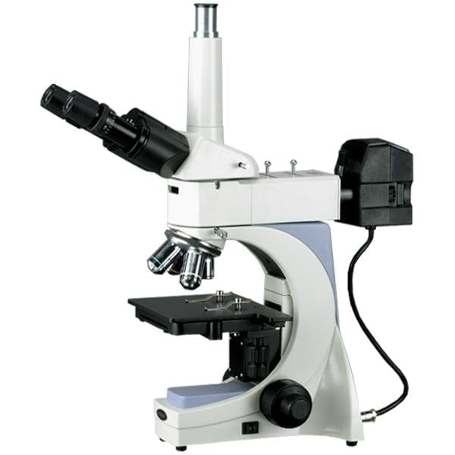](https://amscope.com/collections/metallurgical-microscopes/products/c-me400t)](https://amscope.com/collections/metallurgical-microscopes/products/c-me400t)

[Trinocular Infinity-Corrected Plan Metallurgical Microscope w/Optional Digital Camera](https://amscope.com/collections/metallurgical-microscopes/products/c-me400t)

Sku: ME400T

Starting at$1,649.99

[VIEW OPTIONS](https://amscope.com/collections/metallurgical-microscopes/products/c-me400t)

[[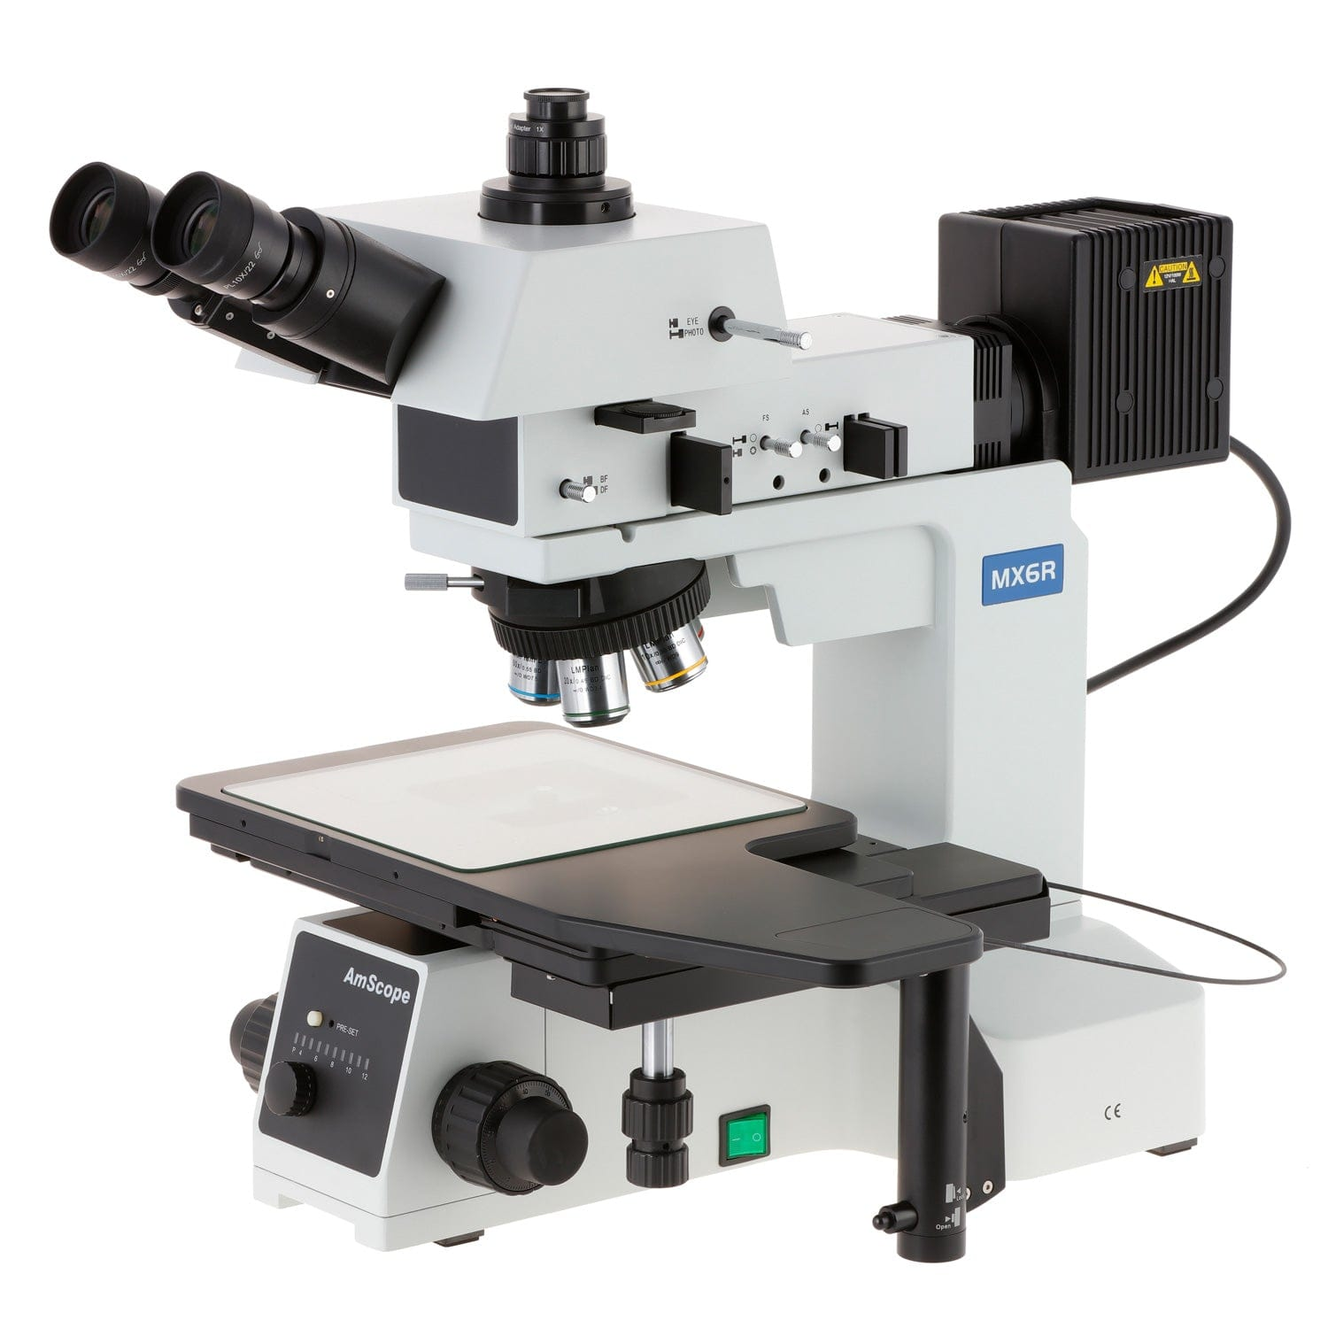](https://amscope.com/collections/metallurgical-microscopes/products/c-me600t)](https://amscope.com/collections/metallurgical-microscopes/products/c-me600t)

[Large-Format Stage Trinocular Brightfield, Darkfield and Polarizing Metallurgical Microscope w/Optional Digital Camera](https://amscope.com/collections/metallurgical-microscopes/products/c-me600t)

Sku: ME600T

Starting at$9,327.99

[VIEW OPTIONS](https://amscope.com/collections/metallurgical-microscopes/products/c-me600t)

[[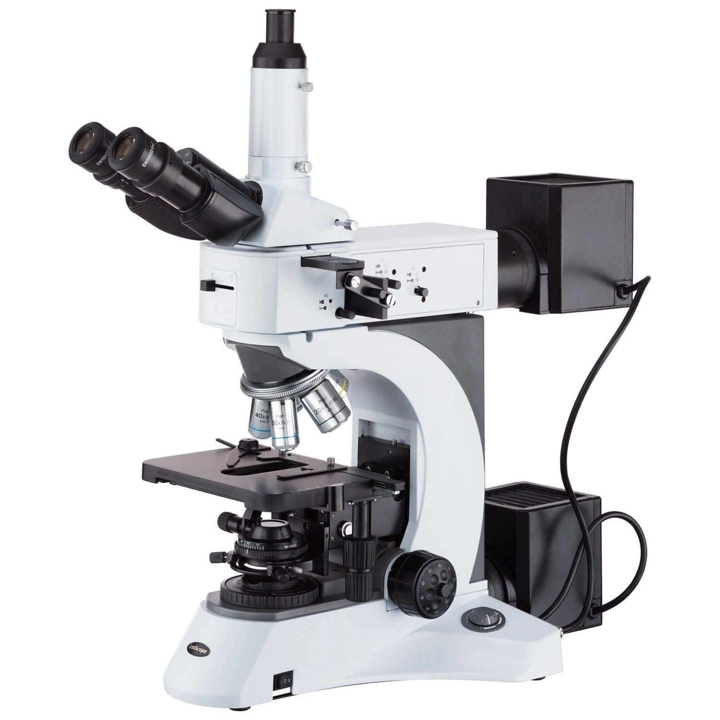](https://amscope.com/collections/metallurgical-microscopes/products/c-me520t-hd)](https://amscope.com/collections/metallurgical-microscopes/products/c-me520t-hd)

[Trinocular Infinity-Corrected Darkfield Polarizing Metallurgical Microscope w/Optional HDMI Digital Camera](https://amscope.com/collections/metallurgical-microscopes/products/c-me520t-hd)

Sku: ME520T-HD2

Starting at$4,393.99

[VIEW OPTIONS](https://amscope.com/collections/metallurgical-microscopes/products/c-me520t-hd)

[[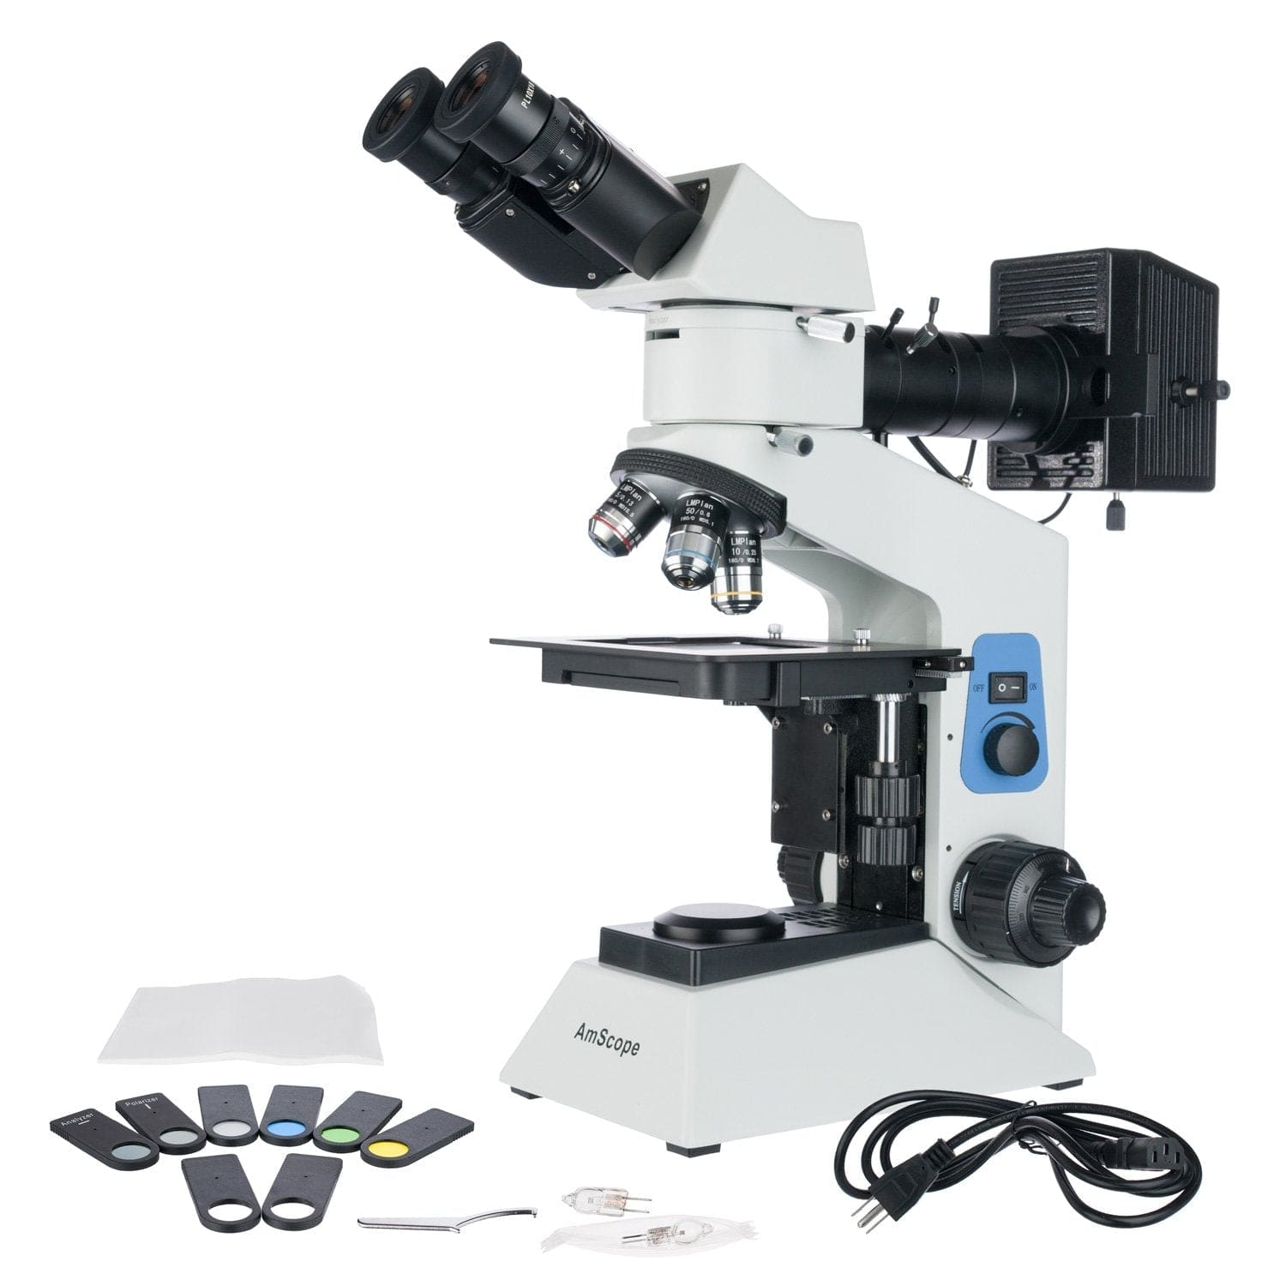](https://amscope.com/collections/metallurgical-microscopes/products/c-me580b-pz)](https://amscope.com/collections/metallurgical-microscopes/products/c-me580b-pz)

[Dual Illumination Binocular Polarized Light Metallurgical Microscope w/Optional Digital Camera](https://amscope.com/collections/metallurgical-microscopes/products/c-me580b-pz)

Sku: ME580B-PZ

Starting at$913.99

[VIEW OPTIONS](https://amscope.com/collections/metallurgical-microscopes/products/c-me580b-pz)

[[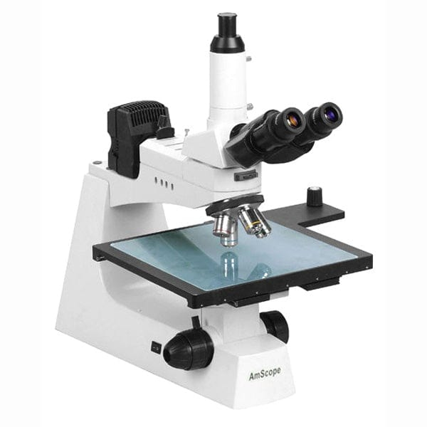](https://amscope.com/collections/metallurgical-microscopes/products/c-me450tx)](https://amscope.com/collections/metallurgical-microscopes/products/c-me450tx)

[Trinocular Large-Format Metallographic Infinity-Corrected Inspection Microscope w/Optional Digital Camera](https://amscope.com/collections/metallurgical-microscopes/products/c-me450tx)

Sku: ME450TX

Starting at$3,258.99

[VIEW OPTIONS](https://amscope.com/collections/metallurgical-microscopes/products/c-me450tx)

[[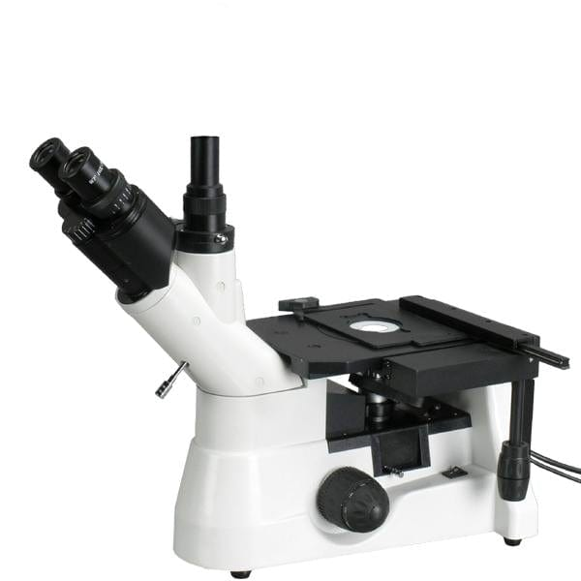](https://amscope.com/collections/metallurgical-microscopes/products/c-me1400t-inf)](https://amscope.com/collections/metallurgical-microscopes/products/c-me1400t-inf)

[Trinocular Inverted Plan Optics Infinity-Corrected Polarizing Metallurgical Microscope w/Optional Digital Camera](https://amscope.com/collections/metallurgical-microscopes/products/c-me1400t-inf)

Sku: ME1400T-INF

Starting at$1,475.99

[VIEW OPTIONS](https://amscope.com/collections/metallurgical-microscopes/products/c-me1400t-inf)

[[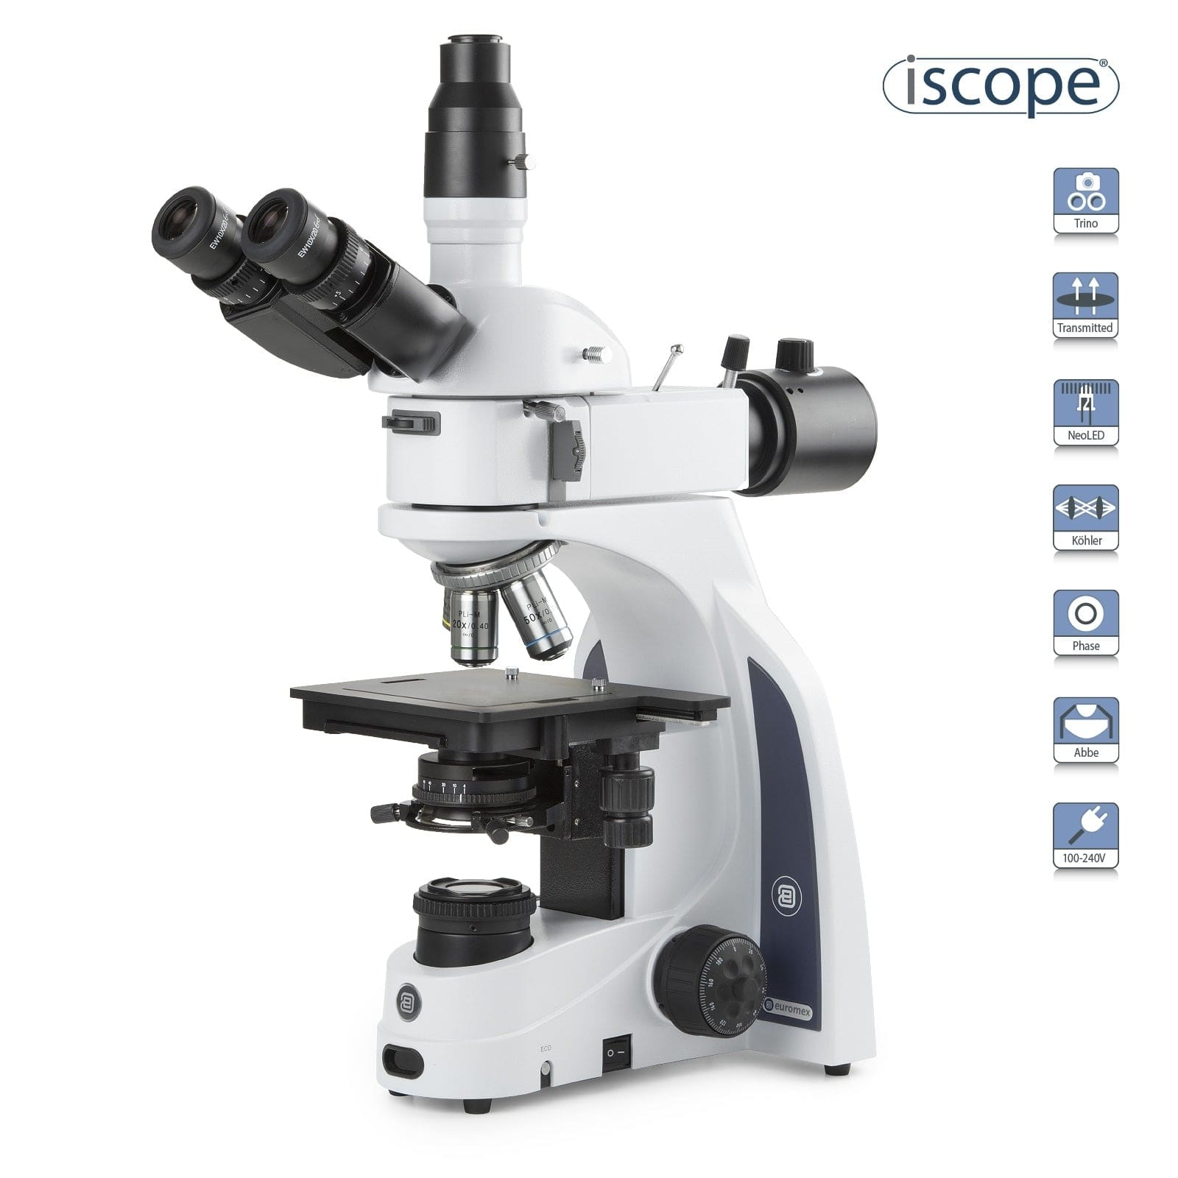](https://amscope.com/collections/metallurgical-microscopes/products/c-is1053-plmi)](https://amscope.com/collections/metallurgical-microscopes/products/c-is1053-plmi)

[iScope Trinocular Materials and Metallurgy Compound Microscope](https://amscope.com/collections/metallurgical-microscopes/products/c-is1053-plmi)

Sku: IS1053-PLMI

Starting at$3,190.99

[VIEW OPTIONS](https://amscope.com/collections/metallurgical-microscopes/products/c-is1053-plmi)

[[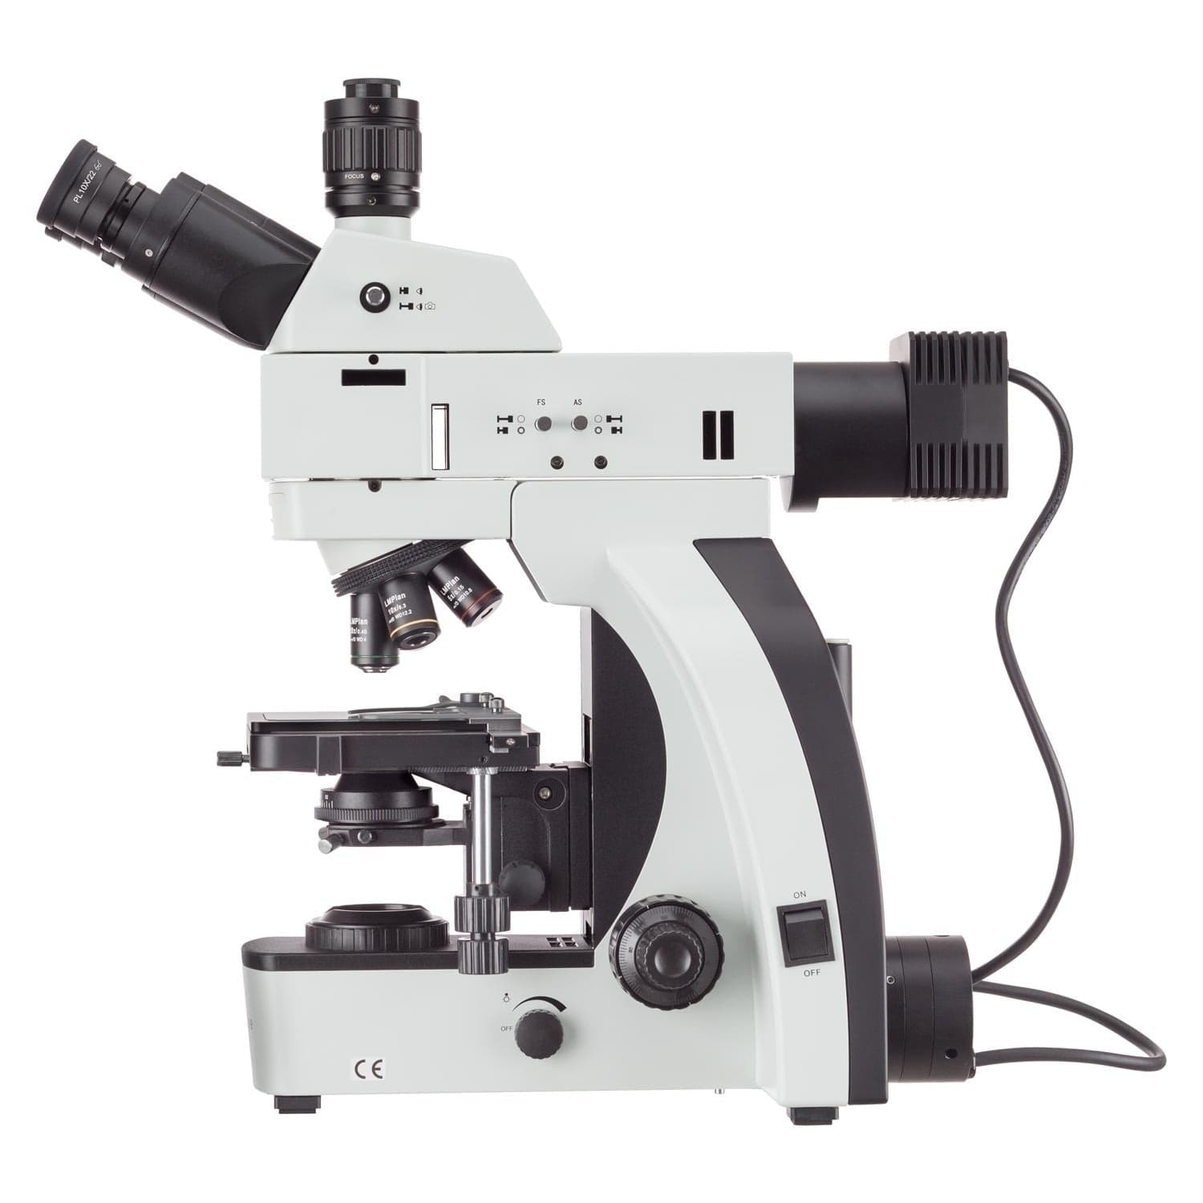](https://amscope.com/collections/metallurgical-microscopes/products/c-t800m-mg)](https://amscope.com/collections/metallurgical-microscopes/products/c-t800m-mg)

[Dual Illumination Professional Grade Polarized-Light Trinocular Microscope w/Optional Back-Lit Camera and 3D Mechanical Stage](https://amscope.com/collections/metallurgical-microscopes/products/c-t800m-mg)

Sku: T800M-MG3

Starting at$4,502.99

[VIEW OPTIONS](https://amscope.com/collections/metallurgical-microscopes/products/c-t800m-mg)

[[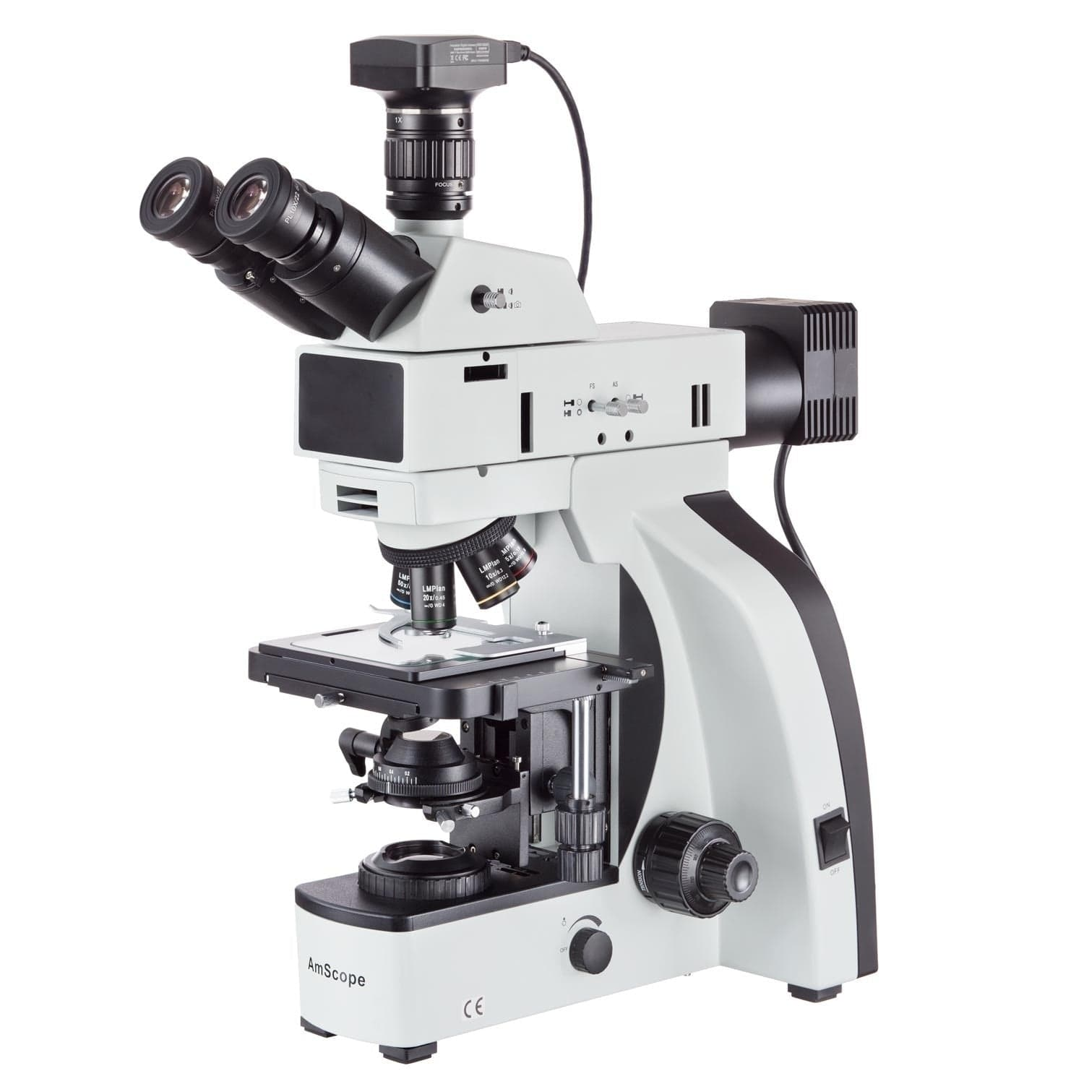](https://amscope.com/collections/metallurgical-microscopes/products/c-t800m-mf2c)](https://amscope.com/collections/metallurgical-microscopes/products/c-t800m-mf2c)

[Trinocular Dual-Illumination Metallurgical Compound Microscope](https://amscope.com/collections/metallurgical-microscopes/products/c-t800m-mf2c)

Sku: T800M-MF2003C

Starting at$5,392.99

[VIEW OPTIONS](https://amscope.com/collections/metallurgical-microscopes/products/c-t800m-mf2c)

[[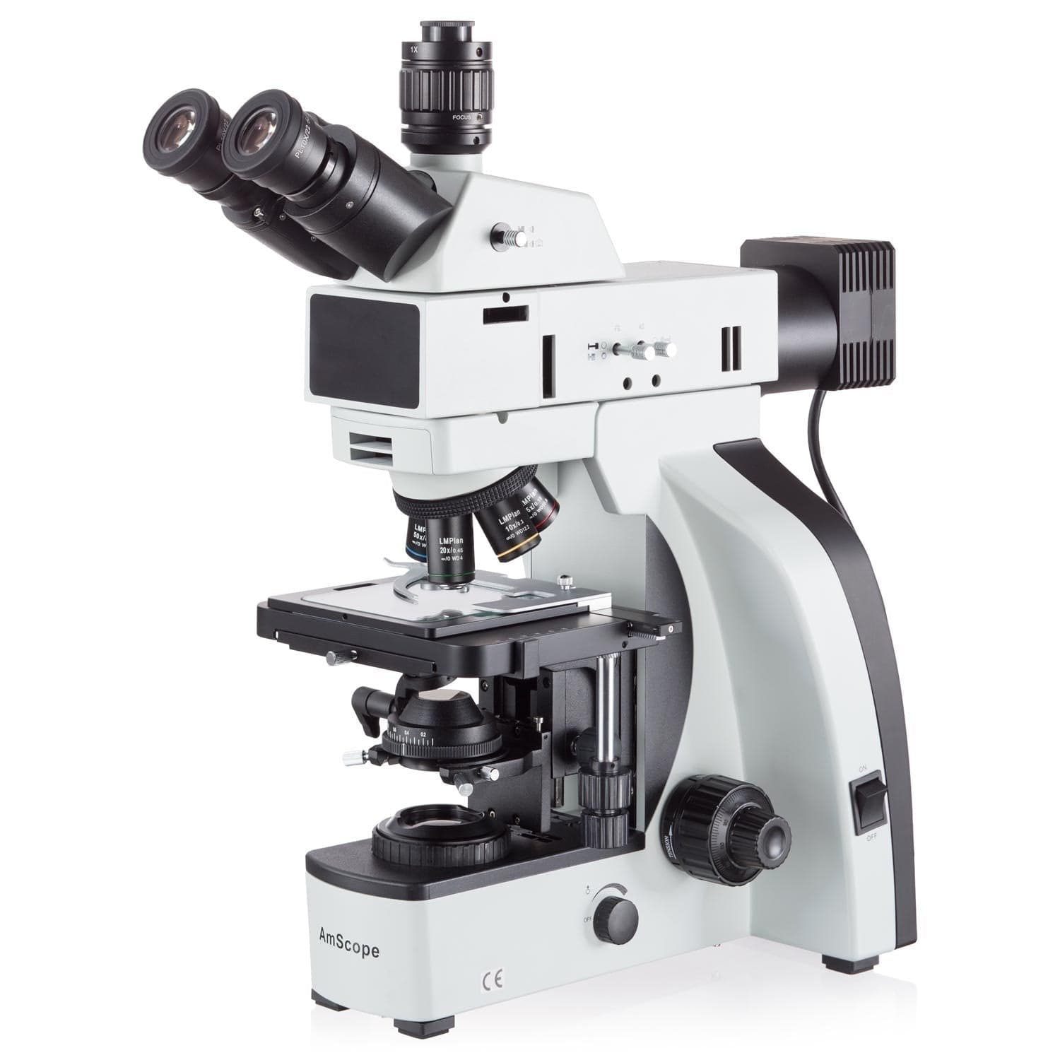](https://amscope.com/collections/metallurgical-microscopes/products/c-t800m)](https://amscope.com/collections/metallurgical-microscopes/products/c-t800m)

[Dual Illumination Infinity-Corrected Metallurgical 3W LED Trinocular Microscope w/Optional Global Shutter Digital Camera](https://amscope.com/collections/metallurgical-microscopes/products/c-t800m)

Sku: T800M

Starting at$3,802.99

[VIEW OPTIONS](https://amscope.com/collections/metallurgical-microscopes/products/c-t800m)

[[](https://amscope.com/collections/metallurgical-microscopes/products/cl-me600t)](https://amscope.com/collections/metallurgical-microscopes/products/cl-me600t)

[Open Box 50X-500X Large-format Trinocular Upright Metallurgical Microscope](https://amscope.com/collections/metallurgical-microscopes/products/cl-me600t)

Sku: CL-ME600T

~~$9,327.99~~$5,776.99

[VIEW PRODUCT](https://amscope.com/collections/metallurgical-microscopes/products/cl-me600t)

[[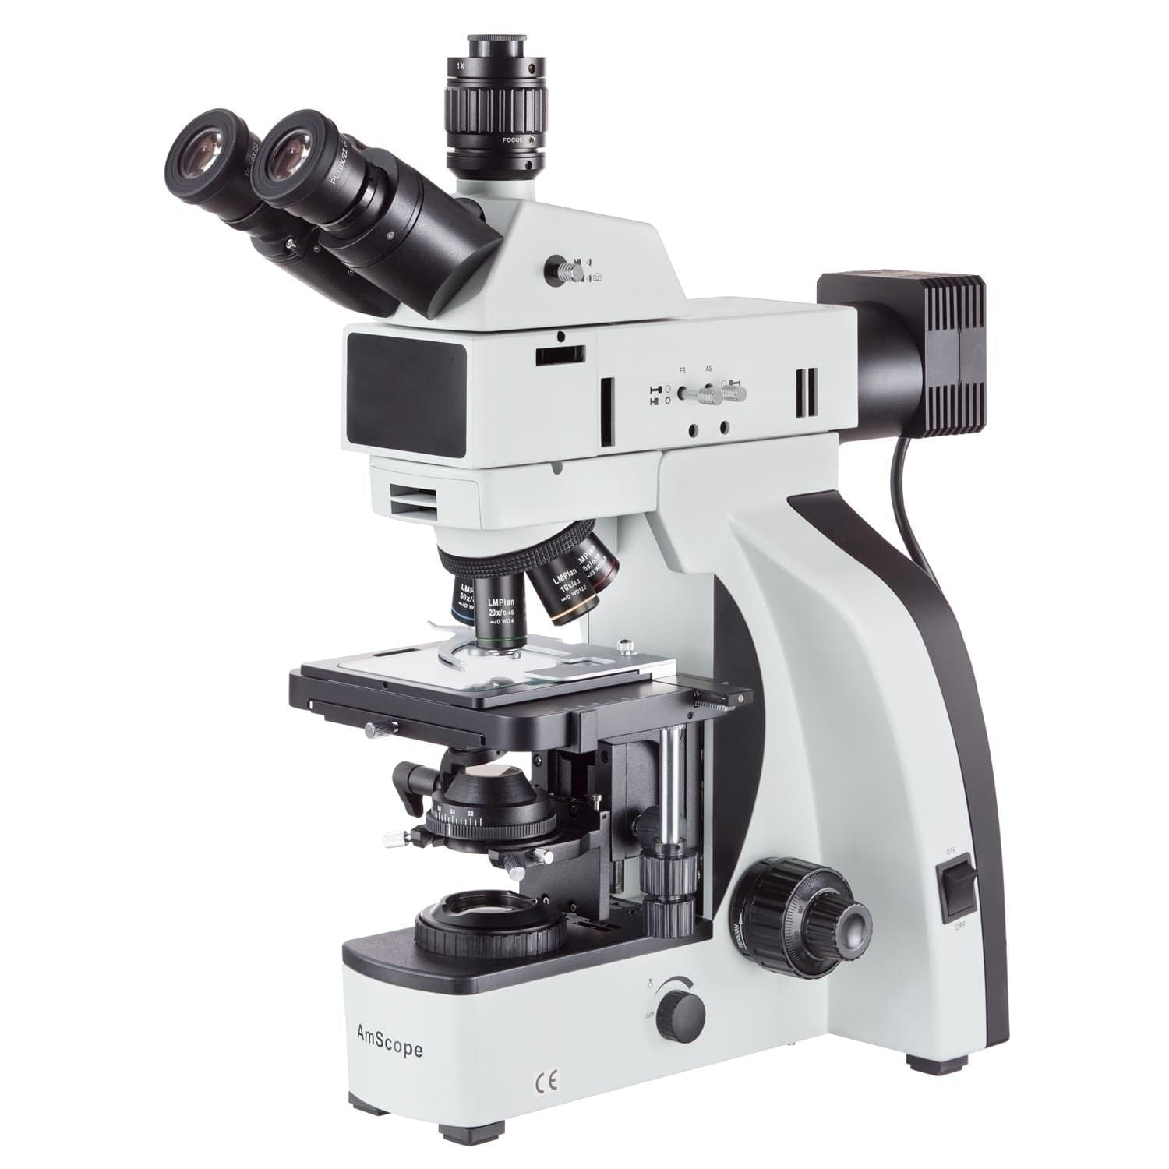](https://amscope.com/collections/metallurgical-microscopes/products/c-t800m-mfc)](https://amscope.com/collections/metallurgical-microscopes/products/c-t800m-mfc)

[Trinocular Dual-Illumination Metallurgical Compound Microscope](https://amscope.com/collections/metallurgical-microscopes/products/c-t800m-mfc)

Sku: T800M-MF143C

Starting at$6,952.99

[VIEW OPTIONS](https://amscope.com/collections/metallurgical-microscopes/products/c-t800m-mfc)

[[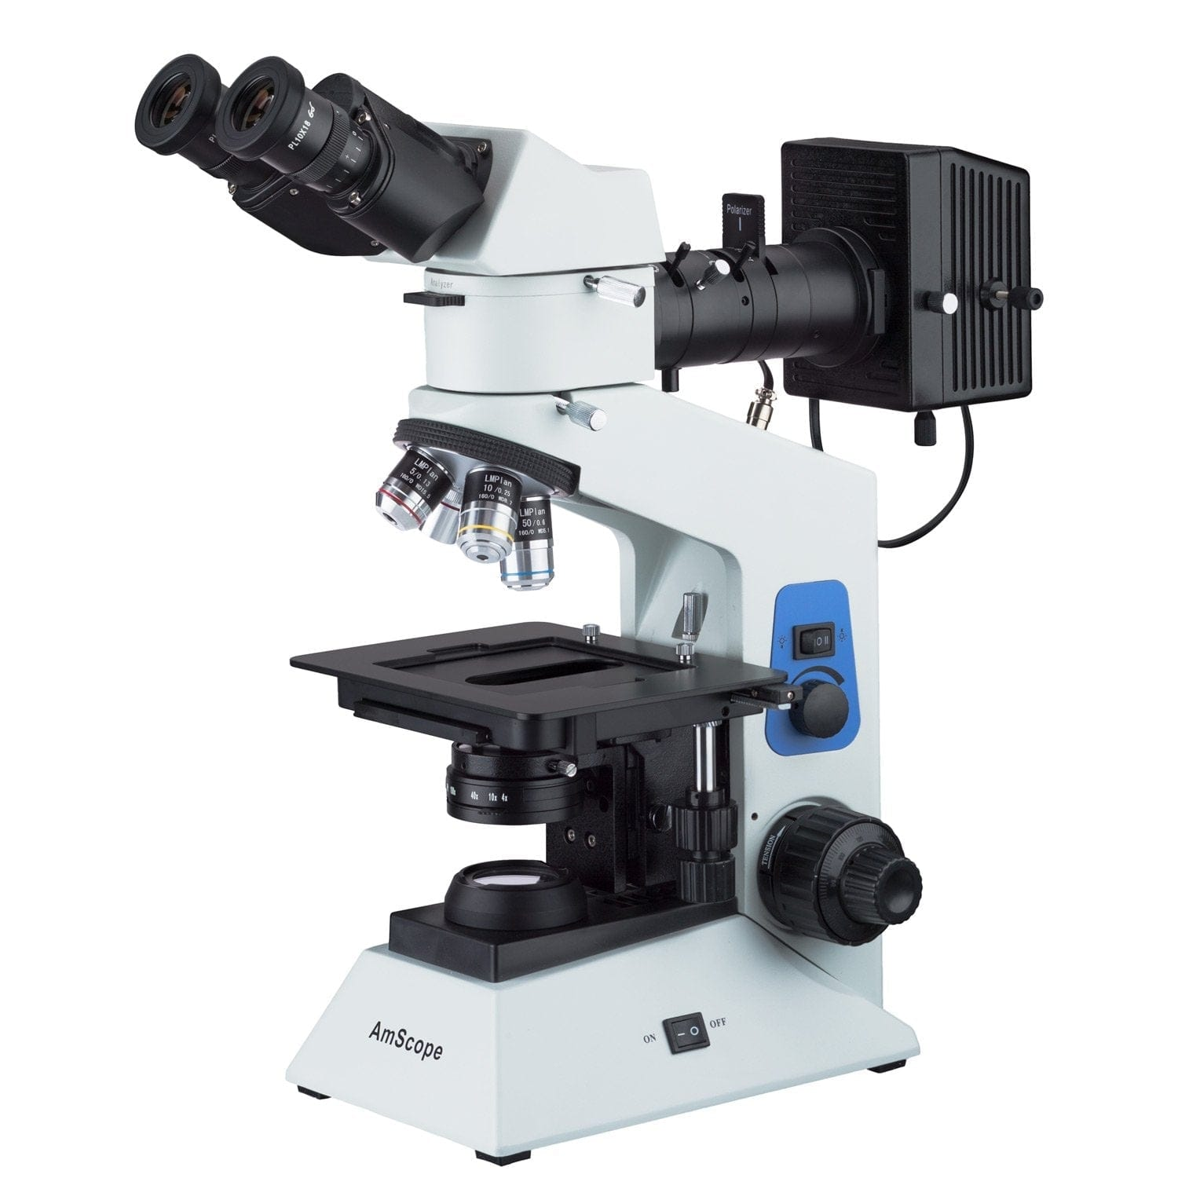](https://amscope.com/collections/metallurgical-microscopes/products/c-me580b-pz-2l)](https://amscope.com/collections/metallurgical-microscopes/products/c-me580b-pz-2l)

[Compact Dual Illumination Polarized Light Binocular Metallurgical Microscope w/Optional Digital Camera](https://amscope.com/collections/metallurgical-microscopes/products/c-me580b-pz-2l)

Sku: ME580B-PZ-2L

Starting at$956.99

[VIEW OPTIONS](https://amscope.com/collections/metallurgical-microscopes/products/c-me580b-pz-2l)

[[](https://amscope.com/collections/metallurgical-microscopes/products/c-me1400t)](https://amscope.com/collections/metallurgical-microscopes/products/c-me1400t)

[Trinocular Inverted Plan Optics Polarizing Metallurgical Microscope w/Optional Digital Camera](https://amscope.com/collections/metallurgical-microscopes/products/c-me1400t)

4.7 star rating[3 Reviews](javascript:void(0))

Sku: ME1400T

Starting at$1,270.99

[VIEW OPTIONS](https://amscope.com/collections/metallurgical-microscopes/products/c-me1400t)

[[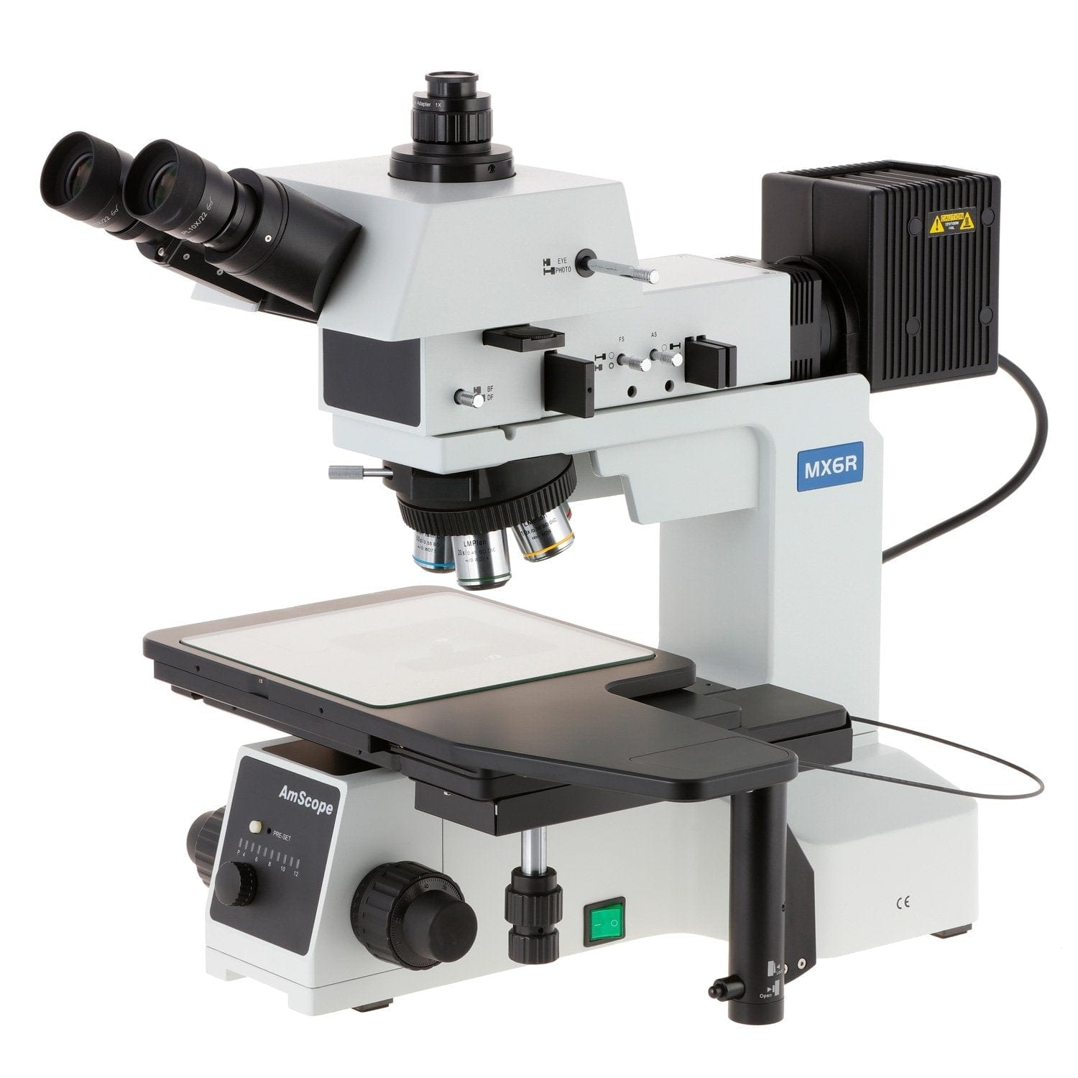](https://amscope.com/collections/metallurgical-microscopes/products/c-me600tz)](https://amscope.com/collections/metallurgical-microscopes/products/c-me600tz)

[Large-Format Stage Trinocular Brightfield and Polarizing Metallurgical Microscope w/Additional 100X Objective Lens and Optional Digital Camera](https://amscope.com/collections/metallurgical-microscopes/products/c-me600tz)

Sku: ME600TZ

Starting at$10,321.99

[VIEW OPTIONS](https://amscope.com/collections/metallurgical-microscopes/products/c-me600tz)

Free shipping on orders over $75

Easy 30 Day Returns

Quality Products

Do you have a question?

Sign up today and get 10% off your next purchase!

Top of Form

Email:

Bottom of Form

Customer Support

* [Help](https://amscope.com/pages/frequently-asked-questions)
* [Technical Support](https://amscope.com/pages/technical-support)
* [Camera Software Download](https://amscope.com/pages/software-downloads)
* [Manual Download](https://amscope.com/pages/manual-downloads)

Information Center

* [AmScope Business](https://amscope.com/pages/business)
* [Shop By Industry](https://amscope.com/pages/shop-by-industry)
* [Choosing a Microscope](https://amscope.com/pages/how-to-choose-microscope)
* [Using a Microscope](https://amscope.com/pages/how-to-use-microscope)
* [Microscope Parts and Functions](https://amscope.com/pages/microscope-parts-and-functions)
* [Educational Resources](https://amscope.com/pages/educational-resources)
* [Blog](https://amscope.com/blogs/news)

My Account

* [Create A New Account](https://amscope.com/account/register)
* [View Cart](https://amscope.com/cart)
* [My Account](https://amscope.com/account)
* [Reseller Program](https://amscope.com/pages/reseller-program)

Company

* [About Us](https://amscope.com/pages/about-us)
* [Terms & Conditions](https://amscope.com/pages/terms-conditions)
* [Refund Policy](https://amscope.com/policies/refund-policy)
* [Privacy](https://amscope.com/pages/privacy-policy)
* [Do not sell my personal information](https://amscope.com/pages/ccpa-opt-out)
* [Contact Us](https://amscope.com/pages/contact-us)
* [Our Customers](https://amscope.com/pages/customer-list)

Follow Us

* [Facebook](https://www.facebook.com/Amscope)

* [Instagram](https://www.instagram.com/amscope_/)

* [YouTube](https://www.youtube.com/user/Amscopecom)

* [LinkedIn](https://www.linkedin.com/showcase/amscope/)

© 2023 AmScope. All Rights Reserved.

[TOP](https://amscope.com/collections/metallurgical-microscopes)

[Skip to Content](https://amscope.com/collections/metallurgical-microscopes/products/c-me600tz?variant=40841859661999" \l "acsbContent)

[↵ENTER](https://amscope.com/collections/metallurgical-microscopes/products/c-me600tz?variant=40841859661999" \l "acsbContent)

[Skip to content](https://amscope.com/collections/metallurgical-microscopes/products/c-me600tz?variant=40841859661999#MainContent)

0

[[](https://amscope.com/collections/blowout-clearance-sale-up-to-60-off)](https://amscope.com/collections/blowout-clearance-sale-up-to-60-off)

1. [Home](https://amscope.com/) /
2. [Metallurgical Microscopes](https://amscope.com/collections/metallurgical-microscopes) /
3. Large-Format Stage Trinocular Brightfield and Polarizing Metallurgical Microscope w/Additional 100X Objective Lens and Optional Digital Camera



50X-2500X Large-format Trinocular Upright Metallurgical Microscope w/ 20MP USB 3.0 C-mount Camera

Top of Form

SKU: ME600TZC-20MBI3

0.0 star ratingWrite a review

QTY:

−+

ADD TO CART

AVAILABILITY: IN STOCK

Regular price~~$13,804.99~~ $11,503.99

[**>> How to Buy A Microscope**](https://amscope.com/collections/metallurgical-microscopes/products/c-me600tz?variant=40841859661999#guide)

**Magnification**

50X-1000X

50X-1500X

50X-2000X

50X-2500X

**Camera Type**

none selected

USB 2.0

USB 3.0

**Camera Pixels**

3.0MP

5.0MP

10.0MP

14.0MP

16.0MP

18.0MP

20.0MP

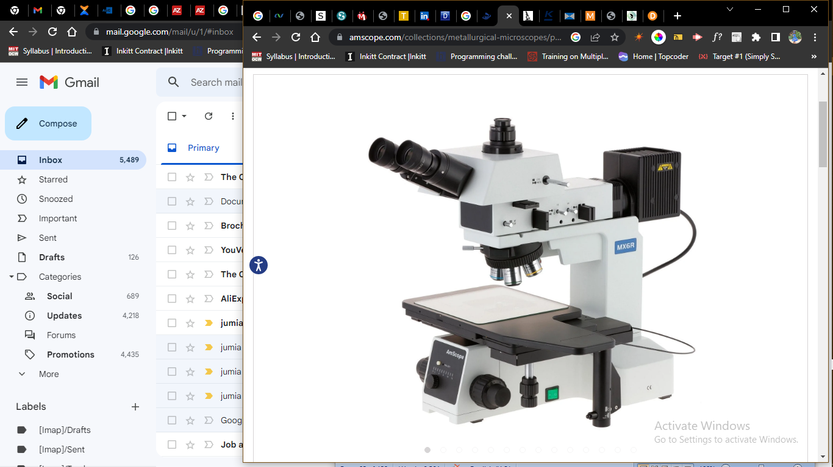

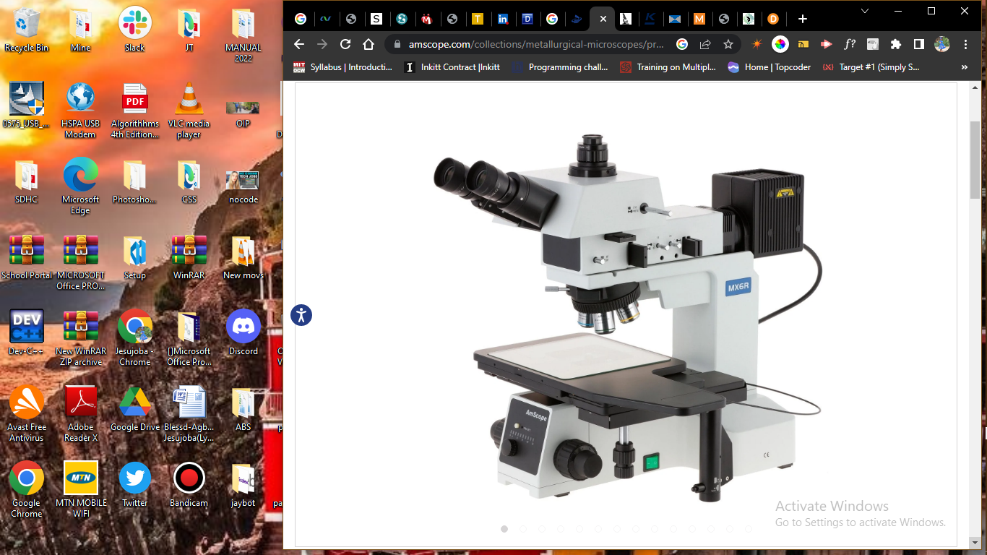



Bottom of Form

Key Features

* 50X to 2500X magnification with five brightfield/darkfield objective lenses and 10X and 25X eyepieces.
* Designed for manufacturing, QC, and materials analysis, this large format microscope provides multiple observation methods including brightfield, darkfield, and simple polarization.
* Extra-large stage with clutch control for coarse positioning, and precision X-Y controls for microscopic adjustments
* Five large-diameter, plan-achromatic BD objective lenses provide increased field-of-view and high resolutions.
* Use a combination of brightfield, darkfield, and simple polarization to bring out complex details such as stress in metal and other materials.
* The infinity-corrected optical system eliminates certain optical errors when using filters and other in-line components, ensuring highly-precise images.
* The trinocular head provides a dedicated photo port for adding a camera for recording photos and videos.
* Monitor and capture photos and videos with the included back-illuminated 20MP USB 3.0 camera. Professional microscopy software for Windows, Mac, and Linux provide tools for image processing, measuring, and more.

DESCRIPTION

This is an advanced reflected-brightfield, darkfield and polarizing metallurgical microscopy system. The microscope comes with a quintuple nosepiece, four infinity Plan objectives and a powerful 100W reflected Koehler illumination system, providing brightfield, darkfield and polarizing features. This microscopy system is perfect for metallurgical labs and foundries for silicon wafer inspection, integrated circuit examination, quality control and R&D applications. It is an ideal instrument for metallurgical, mineral and crystal identification.

**Optics**

The ME600T uses M25 BD objective lenses which provide a larger field-of-view, and can be used with reflected-light darkfield illumination. The quintuple turret allows you to quickly switch between the five lenses. With the included 10X and 25X eyepieces, the overall magnification range spans 50X to 2500X with nine unique settings.

**Features :**

• A brightfield, darkfield and polarizing metallurgical microscopy system with 100W Kohler illumination

• Color corrected infinity optical system (CCIS)

• 25 degree inclined 360 degree rotatable gemel trinocular head with vertical image

• 100% prismatic rate

• Quintuple nosepiece with brightfield (BF) and darkfield (DF)

• Five infinity PLAN Achromatic objectives included

• Eyepiece with 0.1mm micrometer and cross hair included

• 100 Watt halogen reflected EPI-illumination system

• Digital controlled intensity adjustment and light reset

• 6" extremely large mechanical stage with clutch for swift moving control

• Low position stage traveling controls

• Full optical glass elements

• Precise ground glass lenses

• All metal mechanical parts

• Coaxial coarse and fine focusing system

• Dual focusing control knobs

• Focusing tension control mechanism

• Adjustable interpupillary distance

• Adjustable diopters on both eye tubes

Monitor and capture photos and videos with the included high-resolution 20MP USB3.0 camera. The sensitive back-illuminated sensor is designed for improved low-light imaging, making it suitable for fluorescence and darkfield microscopy. Our professional software for Windows provides a wide assortment of capture and photo-editing functions including color correction, time-lapse capture, image stitching, and a full complement of measuring tools. A lite version of our software is available for Mac and Linux with essential functionality for capturing photos and videos.

Technical drawings with measurements (in mm)

**Specifications :**

• Optical system: color corrected infinity optical system (CCIS)

• Eyepieces: 10X, 25X

• Nosepiece: quintuple nosepiece with 5 M25 BD brightfield/darkfield ports

• Objective: infinity-corrected plan-achromatic metallurgical 5X, 10X, 20X, and 50X for both brightfield and darkfield

• Focusing System: coaxial coarse and fine; moving range: 33mm, fine precision: 0.001mm

• Stage: 6" rectangle mechanical stage; moving range: 158mm x 158mm; low hand adjustment and clutch for swift moving control

• Illuminator: reflected Kohler illuminator with BF and DF; 12V/100W halogen; digital adjustment of brightness and light renew function

• Power Supply: 110-240VAC 50Hz/60Hz wide band

**Objective Lenses**

|  |  |  |  |  |
| --- | --- | --- | --- | --- |
| **Magnification** | **Corrections** | **NA** | **Working Distance** | **Cover-glass Thickness** |
| 5X | Plan-achromatic | 0.14 | 11mm | 0 |
| 10X | Plan-achromatic | 0.25 | 9.5mm | 0 |
| 20X | Plan-achromatic | 0.40 | 3.4mm | 0 |
| 50X | Plan-achromatic | 0.55 | 7.5mm | 0 |
| 100X | Plan-achromatic | 0.8 | 2mm | 0 |

|  |  |
| --- | --- |
| Camera Specifications | |
|  | |
| Sensor Type | Back-illuminated CMOS |
|  | |
| Sensor Optical Format | 1" |
|  | |
| Active Pixels | 20M (5440 x 3648) |
|  | |
| Pixel Size | 2.4µm x 2.4µm |
|  | |
| Active Sensor Area | 13.06mm x 8.76mm |
|  | |
| Shutter | electronic rolling shutter |
|  | |
| Sensitivity | 462mV @ 1/30s |
|  | |
| Spectral Response | 380-650nm with IR-cut filter |
|  | |
| Capture Resolution and Maximum Framerate | 15fps @ 5440x3648, 50fps @ 2736x1824, 60fps @ 1824x1216 |
|  | |
| Connectivity | USB 3.0 |
|  | |
| Lens-mount | C-mount |
|  | |
| Compensating Lens | 1X |
|  | |
| Power | 5VDC over USB |
|  | |

**Software**

|  |  |
| --- | --- |
| **OS Requirements** | Windows (32/64 bit) XP/Vista/7/8/10, Mac OS 10.8+, Linux kernel 3.13+ |
| **Hardware Requirements** | Intel Core2 2.8GHz or comparable processor, 4GB RAM |
| **Features** | |  | | --- | | Windows Version | | Live video preview | | Captures still images and video | | Time-lapse capture | | Exposure and white-balance controls | | Dark-field correction | | Digital binning | | Image processing | | Measurement tools, including lines, arcs, polygons | | Segmentation and counting tools | | Image-stitching, extended depth-of-field, HDR | | Fluorescence color-mapping | | Mac/Linux Versions | | Live video preview | | Captures still images and video | | Exposure control | | Color adjustment | | Measurement tools, including lines, arcs, polygons | |

**Packing List:**

• One microscope body

• One trinocular head

• One photo-port

• One episcopic illumination assembly

• One pair 10X eyepieces

• One pair 25X eyepieces

• Five BD objective lenses: 5X, 10X, 20X, 50X, 100X

• Assorted filters

• One AC power cable

• One C-mount USB camera

• One USB 3.0 Type B to USB 3.0 type A cable

• One software CD

ADDITIONAL INFO

REVIEWS

People Also Viewed



Dual Illumination Polarized Light Compact Trinocular Metallurgical Microscope w/Optional Digital Camera

Sku: ME580T-PZ-2L

~~$1,193.99~~$994.99

[VIEW PRODUCT](https://amscope.com/products/c-me580t-pz-2l?pr_prod_strat=collection_fallback&pr_rec_id=021533a00&pr_rec_pid=7083019042991&pr_ref_pid=6999684481199&pr_seq=uniform)



Binocular Inverted Plan Optics Metallurgical Microscope w/Optional Digital Camera

Sku: ME1200T

~~$1,993.99~~$1,661.99

[VIEW PRODUCT](https://amscope.com/products/c-me1200t?pr_prod_strat=collection_fallback&pr_rec_id=021533a00&pr_rec_pid=7083018649775&pr_ref_pid=6999684481199&pr_seq=uniform)



Trinocular Metallurgical Microscope

Sku: ME300TZ

~~$1,098.99~~$915.99

[VIEW PRODUCT](https://amscope.com/products/c-me300tz?pr_prod_strat=collection_fallback&pr_rec_id=021533a00&pr_rec_pid=7083018453167&pr_ref_pid=6999684481199&pr_seq=uniform)



Large-Format Stage Trinocular Brightfield, Darkfield and Polarizing Metallurgical Microscope w/Optional Digital Camera

Sku: ME600T

~~$11,193.99~~$9,327.99

[VIEW PRODUCT](https://amscope.com/products/c-me600t?pr_prod_strat=collection_fallback&pr_rec_id=021533a00&pr_rec_pid=6856931213487&pr_ref_pid=6999684481199&pr_seq=uniform)



Trinocular Infinity-Corrected Darkfield Polarizing Metallurgical Microscope w/Optional HDMI Digital Camera

Sku: ME520T-HD2

~~$5,140.99~~$4,393.99

[VIEW PRODUCT](https://amscope.com/products/c-me520t-hd?pr_prod_strat=collection_fallback&pr_rec_id=021533a00&pr_rec_pid=7083018879151&pr_ref_pid=6999684481199&pr_seq=uniform)



Dual Illumination Binocular Polarized Light Metallurgical Microscope w/Optional Digital Camera

Sku: ME580B-PZ

~~$1,096.99~~$913.99

[VIEW PRODUCT](https://amscope.com/products/c-me580b-pz?pr_prod_strat=collection_fallback&pr_rec_id=021533a00&pr_rec_pid=7083018846383&pr_ref_pid=6999684481199&pr_seq=uniform)



iScope Trinocular Materials and Metallurgy Compound Microscope

Sku: IS1053-PLMI

~~$3,828.99~~$3,190.99

[VIEW PRODUCT](https://amscope.com/products/c-is1053-plmi?pr_prod_strat=collection_fallback&pr_rec_id=021533a00&pr_rec_pid=6929943199919&pr_ref_pid=6999684481199&pr_seq=uniform)



Trinocular Inverted Plan Optics Infinity-Corrected Polarizing Metallurgical Microscope w/Optional Digital Camera

Sku: ME1400T-INF

~~$1,726.99~~$1,475.99

[VIEW PRODUCT](https://amscope.com/products/c-me1400t-inf?pr_prod_strat=collection_fallback&pr_rec_id=021533a00&pr_rec_pid=7083018485935&pr_ref_pid=6999684481199&pr_seq=uniform)



Compact Dual Illumination Polarized Light Binocular Metallurgical Microscope w/Optional Digital Camera

Sku: ME580B-PZ-2L

~~$1,147.99~~$956.99

[VIEW PRODUCT](https://amscope.com/products/c-me580b-pz-2l?pr_prod_strat=collection_fallback&pr_rec_id=021533a00&pr_rec_pid=7083018911919&pr_ref_pid=6999684481199&pr_seq=uniform)



Trinocular Inverted Plan Optics Polarizing Metallurgical Microscope w/Optional Digital Camera

Sku: ME1400T

~~$1,486.99~~$1,270.99

[VIEW PRODUCT](https://amscope.com/products/c-me1400t?pr_prod_strat=collection_fallback&pr_rec_id=021533a00&pr_rec_pid=7083018584239&pr_ref_pid=6999684481199&pr_seq=uniform)

Free shipping on orders over $75

Easy 30 Day Returns

Quality Products

Do you have a question?

Sign up today and get 10% off your next purchase!

Top of Form

Email:

Bottom of Form

Customer Support

* [Help](https://amscope.com/pages/frequently-asked-questions)
* [Technical Support](https://amscope.com/pages/technical-support)
* [Camera Software Download](https://amscope.com/pages/software-downloads)
* [Manual Download](https://amscope.com/pages/manual-downloads)

Information Center

* [AmScope Business](https://amscope.com/pages/business)
* [Shop By Industry](https://amscope.com/pages/shop-by-industry)
* [Choosing a Microscope](https://amscope.com/pages/how-to-choose-microscope)
* [Using a Microscope](https://amscope.com/pages/how-to-use-microscope)
* [Microscope Parts and Functions](https://amscope.com/pages/microscope-parts-and-functions)
* [Educational Resources](https://amscope.com/pages/educational-resources)
* [Blog](https://amscope.com/blogs/news)

My Account

* [Create A New Account](https://amscope.com/account/register)
* [View Cart](https://amscope.com/cart)
* [My Account](https://amscope.com/account)
* [Reseller Program](https://amscope.com/pages/reseller-program)

Company

* [About Us](https://amscope.com/pages/about-us)
* [Terms & Conditions](https://amscope.com/pages/terms-conditions)
* [Refund Policy](https://amscope.com/policies/refund-policy)
* [Privacy](https://amscope.com/pages/privacy-policy)
* [Do not sell my personal information](https://amscope.com/pages/ccpa-opt-out)
* [Contact Us](https://amscope.com/pages/contact-us)
* [Our Customers](https://amscope.com/pages/customer-list)

Follow Us

* [Facebook](https://www.facebook.com/Amscope)

* [Instagram](https://www.instagram.com/amscope_/)

* [YouTube](https://www.youtube.com/user/Amscopecom)

* [LinkedIn](https://www.linkedin.com/showcase/amscope/)

© 2023 AmScope. All Rights Reserved.

[TOP](https://amscope.com/collections/metallurgical-microscopes/products/c-me600tz?variant=40841859661999)  [Skip to Content](https://amscope.com/collections/metallurgical-microscopes/products/c-me600tz?variant=40841859661999" \l "acsbContent)

[↵ENTER](https://amscope.com/collections/metallurgical-microscopes/products/c-me600tz?variant=40841859661999" \l "acsbContent)

[Skip to content](https://amscope.com/collections/metallurgical-microscopes/products/c-me600tz?variant=40841859661999#MainContent)

0

[[](https://amscope.com/collections/blowout-clearance-sale-up-to-60-off)](https://amscope.com/collections/blowout-clearance-sale-up-to-60-off)

1. [Home](https://amscope.com/) /
2. [Metallurgical Microscopes](https://amscope.com/collections/metallurgical-microscopes) /
3. Large-Format Stage Trinocular Brightfield and Polarizing Metallurgical Microscope w/Additional 100X Objective Lens and Optional Digital Camera



50X-2500X Large-format Trinocular Upright Metallurgical Microscope w/ 20MP USB 3.0 C-mount Camera

Top of Form

SKU: ME600TZC-20MBI3

0.0 star ratingWrite a review

QTY:

−+

ADD TO CART

AVAILABILITY: IN STOCK

Regular price~~$13,804.99~~ $11,503.99

[**>> How to Buy A Microscope**](https://amscope.com/collections/metallurgical-microscopes/products/c-me600tz?variant=40841859661999#guide)

**Magnification**

50X-1000X

50X-1500X

50X-2000X

50X-2500X

**Camera Type**

none selected

USB 2.0

USB 3.0

**Camera Pixels**

3.0MP

5.0MP

10.0MP

14.0MP

16.0MP

18.0MP

20.0MP



Bottom of Form

Key Features

* 50X to 2500X magnification with five brightfield/darkfield objective lenses and 10X and 25X eyepieces.
* Designed for manufacturing, QC, and materials analysis, this large format microscope provides multiple observation methods including brightfield, darkfield, and simple polarization.
* Extra-large stage with clutch control for coarse positioning, and precision X-Y controls for microscopic adjustments
* Five large-diameter, plan-achromatic BD objective lenses provide increased field-of-view and high resolutions.
* Use a combination of brightfield, darkfield, and simple polarization to bring out complex details such as stress in metal and other materials.
* The infinity-corrected optical system eliminates certain optical errors when using filters and other in-line components, ensuring highly-precise images.
* The trinocular head provides a dedicated photo port for adding a camera for recording photos and videos.
* Monitor and capture photos and videos with the included back-illuminated 20MP USB 3.0 camera. Professional microscopy software for Windows, Mac, and Linux provide tools for image processing, measuring, and more.

DESCRIPTION

This is an advanced reflected-brightfield, darkfield and polarizing metallurgical microscopy system. The microscope comes with a quintuple nosepiece, four infinity Plan objectives and a powerful 100W reflected Koehler illumination system, providing brightfield, darkfield and polarizing features. This microscopy system is perfect for metallurgical labs and foundries for silicon wafer inspection, integrated circuit examination, quality control and R&D applications. It is an ideal instrument for metallurgical, mineral and crystal identification.

**Optics**

The ME600T uses M25 BD objective lenses which provide a larger field-of-view, and can be used with reflected-light darkfield illumination. The quintuple turret allows you to quickly switch between the five lenses. With the included 10X and 25X eyepieces, the overall magnification range spans 50X to 2500X with nine unique settings.

**Features :**

• A brightfield, darkfield and polarizing metallurgical microscopy system with 100W Kohler illumination

• Color corrected infinity optical system (CCIS)

• 25 degree inclined 360 degree rotatable gemel trinocular head with vertical image

• 100% prismatic rate

• Quintuple nosepiece with brightfield (BF) and darkfield (DF)

• Five infinity PLAN Achromatic objectives included

• Eyepiece with 0.1mm micrometer and cross hair included

• 100 Watt halogen reflected EPI-illumination system

• Digital controlled intensity adjustment and light reset

• 6" extremely large mechanical stage with clutch for swift moving control

• Low position stage traveling controls

• Full optical glass elements

• Precise ground glass lenses

• All metal mechanical parts

• Coaxial coarse and fine focusing system

• Dual focusing control knobs

• Focusing tension control mechanism

• Adjustable interpupillary distance

• Adjustable diopters on both eye tubes

Monitor and capture photos and videos with the included high-resolution 20MP USB3.0 camera. The sensitive back-illuminated sensor is designed for improved low-light imaging, making it suitable for fluorescence and darkfield microscopy. Our professional software for Windows provides a wide assortment of capture and photo-editing functions including color correction, time-lapse capture, image stitching, and a full complement of measuring tools. A lite version of our software is available for Mac and Linux with essential functionality for capturing photos and videos.

Technical drawings with measurements (in mm)

**Specifications :**

• Optical system: color corrected infinity optical system (CCIS)

• Eyepieces: 10X, 25X

• Nosepiece: quintuple nosepiece with 5 M25 BD brightfield/darkfield ports

• Objective: infinity-corrected plan-achromatic metallurgical 5X, 10X, 20X, and 50X for both brightfield and darkfield

• Focusing System: coaxial coarse and fine; moving range: 33mm, fine precision: 0.001mm

• Stage: 6" rectangle mechanical stage; moving range: 158mm x 158mm; low hand adjustment and clutch for swift moving control

• Illuminator: reflected Kohler illuminator with BF and DF; 12V/100W halogen; digital adjustment of brightness and light renew function

• Power Supply: 110-240VAC 50Hz/60Hz wide band

**Objective Lenses**

|  |  |  |  |  |
| --- | --- | --- | --- | --- |
| **Magnification** | **Corrections** | **NA** | **Working Distance** | **Cover-glass Thickness** |
| 5X | Plan-achromatic | 0.14 | 11mm | 0 |
| 10X | Plan-achromatic | 0.25 | 9.5mm | 0 |
| 20X | Plan-achromatic | 0.40 | 3.4mm | 0 |
| 50X | Plan-achromatic | 0.55 | 7.5mm | 0 |
| 100X | Plan-achromatic | 0.8 | 2mm | 0 |

|  |  |
| --- | --- |
| Camera Specifications | |
|  | |
| Sensor Type | Back-illuminated CMOS |
|  | |
| Sensor Optical Format | 1" |
|  | |
| Active Pixels | 20M (5440 x 3648) |
|  | |
| Pixel Size | 2.4µm x 2.4µm |
|  | |
| Active Sensor Area | 13.06mm x 8.76mm |
|  | |
| Shutter | electronic rolling shutter |
|  | |
| Sensitivity | 462mV @ 1/30s |
|  | |
| Spectral Response | 380-650nm with IR-cut filter |
|  | |
| Capture Resolution and Maximum Framerate | 15fps @ 5440x3648, 50fps @ 2736x1824, 60fps @ 1824x1216 |
|  | |
| Connectivity | USB 3.0 |
|  | |
| Lens-mount | C-mount |
|  | |
| Compensating Lens | 1X |
|  | |
| Power | 5VDC over USB |
|  | |

**Software**

|  |  |
| --- | --- |
| **OS Requirements** | Windows (32/64 bit) XP/Vista/7/8/10, Mac OS 10.8+, Linux kernel 3.13+ |
| **Hardware Requirements** | Intel Core2 2.8GHz or comparable processor, 4GB RAM |
| **Features** | |  | | --- | | Windows Version | | Live video preview | | Captures still images and video | | Time-lapse capture | | Exposure and white-balance controls | | Dark-field correction | | Digital binning | | Image processing | | Measurement tools, including lines, arcs, polygons | | Segmentation and counting tools | | Image-stitching, extended depth-of-field, HDR | | Fluorescence color-mapping | | Mac/Linux Versions | | Live video preview | | Captures still images and video | | Exposure control | | Color adjustment | | Measurement tools, including lines, arcs, polygons | |

**Packing List:**

• One microscope body

• One trinocular head

• One photo-port

• One episcopic illumination assembly

• One pair 10X eyepieces

• One pair 25X eyepieces

• Five BD objective lenses: 5X, 10X, 20X, 50X, 100X

• Assorted filters

• One AC power cable

• One C-mount USB camera

• One USB 3.0 Type B to USB 3.0 type A cable

• One software CD

ADDITIONAL INFO

REVIEWS

People Also Viewed



Dual Illumination Polarized Light Compact Trinocular Metallurgical Microscope w/Optional Digital Camera

Sku: ME580T-PZ-2L

~~$1,193.99~~$994.99

[VIEW PRODUCT](https://amscope.com/products/c-me580t-pz-2l?pr_prod_strat=collection_fallback&pr_rec_id=021533a00&pr_rec_pid=7083019042991&pr_ref_pid=6999684481199&pr_seq=uniform)



Binocular Inverted Plan Optics Metallurgical Microscope w/Optional Digital Camera

Sku: ME1200T

~~$1,993.99~~$1,661.99

[VIEW PRODUCT](https://amscope.com/products/c-me1200t?pr_prod_strat=collection_fallback&pr_rec_id=021533a00&pr_rec_pid=7083018649775&pr_ref_pid=6999684481199&pr_seq=uniform)



Trinocular Metallurgical Microscope

Sku: ME300TZ

~~$1,098.99~~$915.99

[VIEW PRODUCT](https://amscope.com/products/c-me300tz?pr_prod_strat=collection_fallback&pr_rec_id=021533a00&pr_rec_pid=7083018453167&pr_ref_pid=6999684481199&pr_seq=uniform)



Large-Format Stage Trinocular Brightfield, Darkfield and Polarizing Metallurgical Microscope w/Optional Digital Camera

Sku: ME600T

~~$11,193.99~~$9,327.99

[VIEW PRODUCT](https://amscope.com/products/c-me600t?pr_prod_strat=collection_fallback&pr_rec_id=021533a00&pr_rec_pid=6856931213487&pr_ref_pid=6999684481199&pr_seq=uniform)



Trinocular Infinity-Corrected Darkfield Polarizing Metallurgical Microscope w/Optional HDMI Digital Camera

Sku: ME520T-HD2

~~$5,140.99~~$4,393.99

[VIEW PRODUCT](https://amscope.com/products/c-me520t-hd?pr_prod_strat=collection_fallback&pr_rec_id=021533a00&pr_rec_pid=7083018879151&pr_ref_pid=6999684481199&pr_seq=uniform)



Dual Illumination Binocular Polarized Light Metallurgical Microscope w/Optional Digital Camera

Sku: ME580B-PZ

~~$1,096.99~~$913.99

[VIEW PRODUCT](https://amscope.com/products/c-me580b-pz?pr_prod_strat=collection_fallback&pr_rec_id=021533a00&pr_rec_pid=7083018846383&pr_ref_pid=6999684481199&pr_seq=uniform)



iScope Trinocular Materials and Metallurgy Compound Microscope

Sku: IS1053-PLMI

~~$3,828.99~~$3,190.99

[VIEW PRODUCT](https://amscope.com/products/c-is1053-plmi?pr_prod_strat=collection_fallback&pr_rec_id=021533a00&pr_rec_pid=6929943199919&pr_ref_pid=6999684481199&pr_seq=uniform)



Trinocular Inverted Plan Optics Infinity-Corrected Polarizing Metallurgical Microscope w/Optional Digital Camera

Sku: ME1400T-INF

~~$1,726.99~~$1,475.99

[VIEW PRODUCT](https://amscope.com/products/c-me1400t-inf?pr_prod_strat=collection_fallback&pr_rec_id=021533a00&pr_rec_pid=7083018485935&pr_ref_pid=6999684481199&pr_seq=uniform)



Compact Dual Illumination Polarized Light Binocular Metallurgical Microscope w/Optional Digital Camera

Sku: ME580B-PZ-2L

~~$1,147.99~~$956.99

[VIEW PRODUCT](https://amscope.com/products/c-me580b-pz-2l?pr_prod_strat=collection_fallback&pr_rec_id=021533a00&pr_rec_pid=7083018911919&pr_ref_pid=6999684481199&pr_seq=uniform)



Trinocular Inverted Plan Optics Polarizing Metallurgical Microscope w/Optional Digital Camera

Sku: ME1400T

~~$1,486.99~~$1,270.99

[VIEW PRODUCT](https://amscope.com/products/c-me1400t?pr_prod_strat=collection_fallback&pr_rec_id=021533a00&pr_rec_pid=7083018584239&pr_ref_pid=6999684481199&pr_seq=uniform)

Free shipping on orders over $75

Easy 30 Day Returns

Quality Products

Do you have a question?

Sign up today and get 10% off your next purchase!

Top of Form

Email:

Bottom of Form

Customer Support

* [Help](https://amscope.com/pages/frequently-asked-questions)
* [Technical Support](https://amscope.com/pages/technical-support)
* [Camera Software Download](https://amscope.com/pages/software-downloads)
* [Manual Download](https://amscope.com/pages/manual-downloads)

Information Center

* [AmScope Business](https://amscope.com/pages/business)
* [Shop By Industry](https://amscope.com/pages/shop-by-industry)
* [Choosing a Microscope](https://amscope.com/pages/how-to-choose-microscope)
* [Using a Microscope](https://amscope.com/pages/how-to-use-microscope)
* [Microscope Parts and Functions](https://amscope.com/pages/microscope-parts-and-functions)
* [Educational Resources](https://amscope.com/pages/educational-resources)
* [Blog](https://amscope.com/blogs/news)

My Account

* [Create A New Account](https://amscope.com/account/register)
* [View Cart](https://amscope.com/cart)
* [My Account](https://amscope.com/account)
* [Reseller Program](https://amscope.com/pages/reseller-program)

Company

* [About Us](https://amscope.com/pages/about-us)
* [Terms & Conditions](https://amscope.com/pages/terms-conditions)
* [Refund Policy](https://amscope.com/policies/refund-policy)
* [Privacy](https://amscope.com/pages/privacy-policy)
* [Do not sell my personal information](https://amscope.com/pages/ccpa-opt-out)
* [Contact Us](https://amscope.com/pages/contact-us)
* [Our Customers](https://amscope.com/pages/customer-list)

Follow Us

* [Facebook](https://www.facebook.com/Amscope)

* [Instagram](https://www.instagram.com/amscope_/)

* [YouTube](https://www.youtube.com/user/Amscopecom)

* [LinkedIn](https://www.linkedin.com/showcase/amscope/)

© 2023 AmScope. All Rights Reserved.

[TOP](https://amscope.com/collections/metallurgical-microscopes/products/c-me600tz?variant=40841859661999)

[Skip to content](https://amscope.com/pages/how-to-choose-microscope#MainContent)

Top of Form

Search our store

Bottom of Form

[Free U.S. Shipping](https://amscope.com/pages/faq#faq-shipping)

[1-888-950-2888](tel:18889502888)

[My Account](https://amscope.com/account)0Cart

* [MICROSCOPES](https://amscope.com/collections/microscopes)
* [CAMERAS](https://amscope.com/collections/microscope-cameras)
  + [Cameras](https://amscope.com/collections/microscope-cameras)
  + [Digital Microscopes](https://amscope.com/collections/digital-microscopes)
* [KIDS & STUDENTS](https://amscope.com/collections/student-microscopes)
  + [Shop By Microscope Category](https://amscope.com/pages/how-to-choose-microscope)
  + [Shop By Age](https://amscope.com/pages/how-to-choose-microscope)
  + [Kid's Activity Kits](https://amscope.com/collections/kids-activity-kits)
  + [Premium Student Bundles](https://amscope.com/pages/school)
  + [Telescopes](https://amscope.com/collections/telescopes)
* [TELESCOPES](https://amscope.com/collections/telescopes)
  + [Telescopes](https://amscope.com/collections/telescopes)
* [LAB EQUIPMENT & SUPPLIES](https://amscope.com/pages/lab-equipment)
  + [Shop By Brand](https://amscope.com/pages/how-to-choose-microscope)
  + [Shop By Lab Category](https://amscope.com/pages/how-to-choose-microscope)
  + [Promotions](https://amscope.com/pages/all-lab-equipment-and-supplies-promotions)
  + [Lab Equipment](https://amscope.com/pages/how-to-choose-microscope)
  + [Lab Supplies](https://amscope.com/pages/how-to-choose-microscope)
* [SLIDES & ACCESSORIES](https://amscope-us-dev.myshopify.com/collections/microscope-parts-accessories)
  + [Slides](https://amscope.com/collections/collections-microscope-parts-accessories-microscope-slides)
  + [Cameras](https://amscope.com/collections/microscope-cameras)
  + [Illuminators](https://amscope.com/collections/microscope-parts-accessories-microscope-illuminators-ring-lights)
  + [Adapters](https://amscope.com/collections/microscope-parts-accessories-microscope-adapters)
  + [Eyepieces / Objectives](https://amscope.com/pages/how-to-choose-microscope)
  + [Bulbs](https://amscope.com/collections/microscope-parts-accessories-microscope-bulbs)
  + [Magnifying Lamps](https://amscope.com/collections/magnifying-lamps)
  + [Monitors and Tablets](https://amscope.com/collections/monitors-and-tablets/Category_Monitors-&-Tablets)
  + [View All Categories](https://amscope.com/collections/microscope-parts-accessories)
* [NEW & DEALS](https://amscope.com/pages/how-to-choose-microscope)
  + [Overstock](https://amscope.com/collections/discount-microscopes-and-microscope-parts)
  + [Deals](https://amscope.com/pages/how-to-choose-microscope)
  + [New](https://amscope.com/collections/new-products)
  + [Open Box](https://amscope.com/collections/open-box)

**[SHOP STUDENT PREMIUM BUNDLES](https://amscope.com/pages/school)**

* + [Premium Microscopes](https://amscope.com/pages/premium-microscopes)
  + [Compound Microscopes](https://amscope.com/collections/compound-microscopes)
  + [Stereo Microscopes](https://amscope.com/collections/stereo-microscope)
  + [Kids, Student Microscopes](https://amscope.com/collections/student-microscopes)
  + [Digital Microscopes](https://amscope.com/collections/digital-microscopes)

[[](https://amscope.com/collections/blowout-clearance-sale-up-to-60-off)](https://amscope.com/collections/blowout-clearance-sale-up-to-60-off)

1. [Home](https://amscope.com/) /
2. [How to Choose Microscope](https://amscope.com/pages/how-to-choose-microscope)

# HOW TO CHOOSE A MICROSCOPE: TYPES & COMPARISONS | AMSCOPE

**How to Choose a Microscope**

Your application (what kind of samples/objects you intend to view) is the most important factor in choosing a microscope. What you need to see and what you want to do with that image will determine what kind of microscope you need; contrary to common knowledge, there are many different types of microscopes, and no single microscope can view everything. Much like any industry, the key for success with microscopy is having the right tool for the job at hand.

When you’ve learned what type of microscope is appropriate for your application, please feel free to use the navigation bar at the top and our filter-based sorting system to narrow down our many options to specifically what you are looking for. As a bonus, if you see something that catches your eye here, we’ve provided several convenient links to take you directly to similar products, so feel free to click around!

# Table of Contents

1. [Compound vs. Stereo Microscopes](https://amscope.com/pages/how-to-choose-microscope#dwbasics)

2. [Monocular, Binocular, and Trinocular Microscopes](https://amscope.com/pages/how-to-choose-microscope#monocular)

3. [Compound Microscopes](https://amscope.com/pages/how-to-choose-microscope#compound)

4. [Stereo Microscopes](https://amscope.com/pages/how-to-choose-microscope#stereo)

5. [Microphotography](https://amscope.com/pages/how-to-choose-microscope#microphotography)

6. [Why Buy From Us?](https://amscope.com/pages/how-to-choose-microscope#whybuy)

# Compound vs. Stereo

There are two basic types of optical light microscopes: compound (high power) and stereo (low power). Consider what you can see with each microscope.

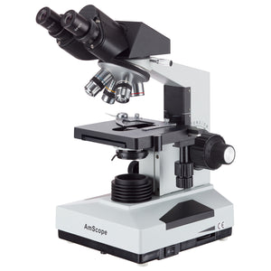

**AmScope B490 Compound Microscope**

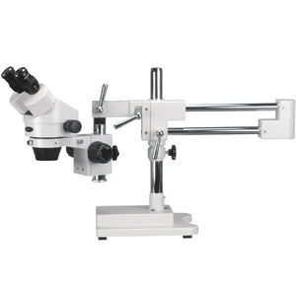

**AmScope SM-4T Stereo Microscope**

If you need very high magnification to view the internal structures of cells, you would most likely use a compound microscope. Compound microscopes have not only very high magnification settings, but also have very high optical resolution (meaning, you can visualize very small features in an image with the objective lenses that come with these microscopes).

Here is an example of what you would expect to see with a compound microscope:

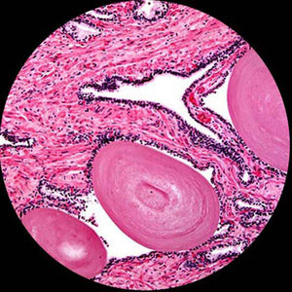

**Compound Microscope Field of View**

If you need to examine solder joints on circuit boards or other relatively large objects, you would probably use a stereo microscope. Stereo microscopes have relatively low magnification settings, but also have larger focusing distances, so you can fit hands and tools between the lens and the sample. They also have larger fields of view, so you can see a larger area of a sample under the microscope. Here is an example of what you would expect to see while using a stereo microscope:

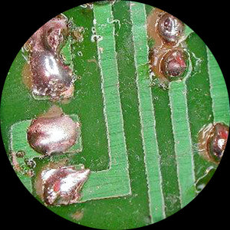

**Stereo Microscope Field of View**

# Monocular, Binocular, and Trinocular Microscopes

An important thing to consider when choosing a microscope is its head type. Monocular, binocular, and trinocular head types are designed differently and suited for particular types of observations.

**Monocular Microscopes**

Monocular microscopes have a single tube that houses an eyepiece at one end and an objective lens at the other. The design means that specimens will appear flat and without depth when you look in the eyepiece. Monocular microscopes are easy to use and ideal for classrooms or as a home microscope for kids and teens.

**Binocular Microscopes**

Binocular microscopes have two tubes and eyepieces, and this can make it more comfortable to examine specimens. Binocular head pieces can be used in educational, research, and commercial settings.

**Trinocular Microscopes**

Trinocular microscopes are similar to binocular ones except that they have an extra port for attaching a camera and taking photographs or videos. This makes the trinocular head type ideal for educators or researchers.

**Which Microscope is Best for You?**

Each microscope type will be further defined below in their respective section, however, a very simple way to determine what kind of microscope you need is by thinking of the sample type you want to view. Compound microscopes tend to require samples that you can pass light through to create an image, as the light comes from the bottom of the microscope up through the sample (transmitted illumination). Stereo microscopes, on the other hand, tend to work best with samples that you cannot pass light through, as they have upper light sources (reflected illumination) to shine down and bounce off of those samples to create an image.

As an example, you wouldn’t want to use a compound microscope with a transmitted light if you wanted to view a coin. A coin cannot pass light through it, so, you would be better off with a stereo microscope with a reflected light (as well as because you want a big field of view to see the whole coin). If you used a transmitted light, you’d get a black image in your microscope, as no light can pass through the coin.

Conversely, if you wanted to view a bacterial cell, you would want to use a compound microscope with a transmitted light, because a reflected light would wash your sample out, as it does not reflect enough light to make an image (as well as because you need the higher magnification to view such small details). You would probably see a very small outline of the cell, without much detail inside, if any at all, trying to use a stereo microscope with a reflected light with a slide that had a cell sample on it.

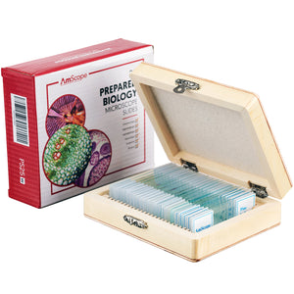

**Slides for Mounting Samples to View with a Compound Microscope**

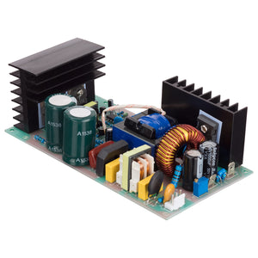

**Circuit Board to View with a Stereo Microscopes**

Within each of these basic microscope types, however, there can be far more demanding requirements, and a variety of advanced microscopy methods or techniques exist within each base type of microscope. There exist some compound microscopes that use reflected light to view solid objects at very high magnifications, and some stereo microscopes with transmitted lights meant to view semi-opaque/semi-translucent samples, as an example. We will go over those in more specific sections, however; if you have a very specific or unique application, you may need a highly specialized microscope or special accessories to equip with one of our products. With our wide range of microscopes and accessories, we can help you configure an instrument for almost any application.

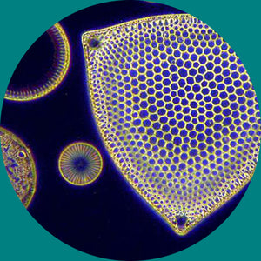

**Compound Darkfield Microscopy**

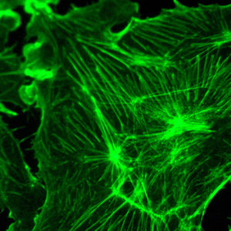

**Fluorescence Microscopy**

If unsure of what you specifically need, please don’t hesitate to [contact our Customer Success team](https://www.amscope.com/contacts) at 1-888-950-2888, toll-free! We are more than happy to apply our knowledge and years of experience in the microscopy industry to help you succeed at whatever your application is with our equipment.

**Compound Microscopes**

[Compound microscopes](https://www.amscope.com/compound-microscopes.html) are what most people visualize when they think about microscopes. They are available in monocular, binocular, and trinocular formats, which refers to the number of ocular tubes that the microscope has. We've discussed these above, but not in respect to only compound micrscopes.

Objective Turret & Objective Lenses, 4X, 10X, 40X, & 100X, SKU: T490

Many compound microscopes also have a lens underneath the stage that focuses the light from the light source through the sample and into the objective lens, called a [condenser](https://www.amscope.com/accessories/condenser.html). Some have simply a disc that controls the amount of light allowed through, called a disc diaphragm, while others have a slider with an iris and adjustable positioning, and even more have a completely replaceable condenser, allowing more advanced microscopy methods to be used, such as [darkfield](https://www.amscope.com/special-microscopes/darkfield-microscopes.html) and [phase contrast](https://www.amscope.com/special-microscopes/phase-contrast-microscopes.html).

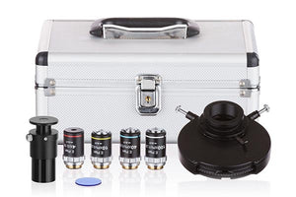

**Phase Contrast Condenser Kit, SKU: PCT200-INF**

If you know what you’d like to do with a compound microscope, the following table can assist in getting you started with what you’re looking for with some common suggestions, or you can use the top navigation bar to click “Applications” to browse by solution, or “[Compound](https://www.amscope.com/compound-microscopes.html)” to browse by microscopy type/specifications. Otherwise, you can continue on to read about the other major type of microscopes—stereo microscopes.

|  |  |  |
| --- | --- | --- |
| **Applications** | **Microscopy Method** | **Age/Education Group** |
| Consumables (Food, Drink, Cosmetics) | Brightfield | K-8 (Elementary) |
| Environmental (Water/Soil) | Darkfield | 9-12 (Junior High/High School) |
| Live Blood Analysis | Phase Contrast | Undergraduate Studies |
| Medical/Clinical | EPI-Fluorescence | Graduate Studies |
| Microbiology | Metallurgical | Research/Professional Use |
| Pharmaceutical Research | Polarizing |  |
| Opaque Samples/Metallurgy | Inverted |  |
| Veterinary | Multi-View/Training |  |

# Stereo Microscopes

Unlike a compound microscope that offers a 2-dimensional image, [stereo microscopes](https://www.amscope.com/stereo-microscopes.html) give the viewer an erect (upright and un-reversed), 3-dimensional image because they use two completely independent paths of light (one to each eyepiece) that are created using objectives that are focused at slightly offset positions in relation to the sample. The name “stereo” comes from the term “stereoscopic,” meaning, using two different angles of viewing to create an impression of depth and solidity.

Because of this, true stereo microscopes only come in [binocular](https://www.amscope.com/stereo-microscopes.html?i_head_style=1016) and [trinocular](https://www.amscope.com/stereo-microscopes.html?i_head_style=1015) styles, however, a special type of stereo microscope called an “[inspection](https://www.amscope.com/stereo-microscopes.html?i_head_style=1017)” microscopes exists as well. These are very similar in nature to stereo microscopes, however, they only have a single ocular tube, so they provide a flat image view of larger, opaque objects, rather than a true stereoscopic view. We classify these here as they are capable of viewing the same sample types as stereo microscopes.

Stereo microscopes are particularly useful for biologists performing [dissections](https://www.amscope.com/stereo-microscopes/dissecting-stereo-microscopes.html), technicians [repairing circuit boards](https://www.amscope.com/stereo-microscopes/industrial-inspection-stereo-microscopes.html), paleontologists [cleaning and examining fossils](https://www.amscope.com/stereo-microscopes/mineralogy-stereo-microscopes.html), or anyone who needs to work with their hands or tools on small objects, that are large enough to be seen or handled without the aid of a high power compound microscope. Thus, stereo microscopes have a very broad set of potential applications across many industries.

There are two main subdivisions of stereo microscopes at the most basic form, based on the magnification type—fixed power & zoom power. [Fixed power stereo microscopes](https://www.amscope.com/catalogsearch/result/?q=se305r-a) have a set number of fixed position objectives, and offer only the magnification options listed; nothing in between. They are best for their ease of use and ease of focusing, making younger audiences and amateurs great candidates for these kinds of stereo microscopes, but they lack the flexibility of other stereo microscope types.

On the other hand, [zoom power stereo microscopes](https://www.amscope.com/stereo-microscopes.html?i_magnifying_style=1142) have much greater flexibility because the objective lenses can be moved closer or farther from the sample within the microscope. This allows a range of magnification options to be achieved within the maximum and minimum values the microscope provides, such as 7X through 45X. They require finer levels of refocusing when changing magnification values making it a bit harder to use, but offering far greater flexibility in terms of how much working distance, magnification, and field of view can be achieved.

Most stereo microscopes are used at magnifications from 2X to 90X, but with the proper microscope and accessories, magnifications up to and approaching 180X can be achieved, or even up to 225X! This is achieved using an accessory called a Barlow lens with or without different magnification eyepieces (15X, 20X, 25X, or even 30X eyepieces) that we also offer.

# What is a Barlow Lense?

A [Barlow lens](https://www.amscope.com/accessories/barlow-lens.html) is an auxiliary lens that is attached to the end of a stereo microscope’s objective, which alters the magnification range (or fixed settings available) on the microscope by a multiple of the Barlow lens’ power. This can work for both increasing or decreasing the magnification, which will either decrease the field of view and working distance by magnifying the image or increase the field of view and working distance by reducing the magnification of the image, respectively.

These properties have an inverse relationship, meaning the more magnification one uses, the smaller the field of view will be, and the closer the microscope lens needs to be to the sample to focus (which means less space to use tools, called working distance or focal distance). Vice versa, the less magnification being used, the larger the field of view and working distance are. In this case, more is not always better! You want the right magnification for your sample based on your needs.

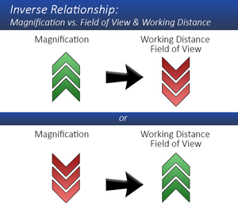

Also, this means that any [SM-](https://www.amscope.com/catalogsearch/result/?q=sm-) (7X-45X base magnification) or [ZM-](https://www.amscope.com/catalogsearch/result/?q=zm-) (6.7X-45X base magnification) series stereo microscope package can be altered by adding in any number of Barlow lenses that are offered to expand the range out. Just like compound microscopes, total magnification is a product of all magnifying elements, so a stereo microscope may have 10X eyepieces, and an objective set to 1.0X, which would give you 10X total magnification. A 2.0X Barlow lens could take that up to 20X, while a 0.5X Barlow lens could take that down to 5X, depending on which is installed (not both, as stacking will throw the focus of the objectives off, while cancelling each other out in terms of magnification modification).

The great part about stereo microscopes is that they are very modular in nature, so whether you want a [pre-made package](https://www.amscope.com/stereo-microscopes.html) designed by us, or to [customize your own setup](https://www.amscope.com/bundled-microscopes.html?i_category=1128) based on your preferences, we can accommodate your needs!

Have a large sample that you need to view multiple areas of? We have a boom stand or articulating arm stand option for you. Need a simple table stand with a large area for dissection? No problem, we have that too. If you know what you’d like to do with a stereo microscope or an inspection microscope, the following table can assist in getting you started with what you’re looking for with some common suggestions. Alternatively, on the top navigation menu of the website, click “[Stereo](https://www.amscope.com/stereo-microscopes.html)” to browse by microscopy type/specifications. Otherwise, you can continue on to read about taking an optical light microscope of either base microscope types and converting it to a digital microscope so that you can take digital images or record video by adding a camera.

|  |  |  |
| --- | --- | --- |
| **Applications** | **Stand** | **Age/Education Group** |
| Art Appraisal/Restoration | Table Stand w/ Track | K-8 (Elementary) |
| Circuit Boards | Table Stand w/ Pillar | 9-12 (Junior High/High School) |
| Coins | Single Arm Boom Stand | Undergraduate Studies |
| Dissection | Double Arm Boom Stand | Graduate Studies |
| Forensics/Firearms | Ball Bearing Boom Stand | Research/Professional Use |
| Gemology/Jewelry | Articulating Arm w/ Clamp | Hobbyist Use |
| Mechanical Parts | Articulating Arm w/ Pillar & Base |  |
| Watch Repair/Engraving | Inspection Style |  |
|  | Darkfield Equipped Stands |  |

If you’re unsure of what you need, or have questions about creating your own setup, give our Customer Success team a call at 1-888-950-2888, toll-free or send us an email. Our friendly and helpful agents will be happy to assist you in getting the right microscope and accessories for you.

#### Microphotography: Cameras & Videos

For many applications, the ability to capture, display, and preserve specimen images is of equal or greater importance than actually viewing the specimen through the eyepieces. Microphotography (35mm and other chemical formats) has been a common option on microscopes for decades, but the recent development of relatively inexpensive CCD (charged couple device) video and digital cameras has greatly increased both the popularity and flexibility of microscope imaging.

Instead of clicking through slides during a lecture, university professors can now display real-time video images on projection televisions; petroleum geologists can e-mail images of core samples to their laboratories from remote locations around the world; oncologists can refer to CD or on-line catalogues of cell images to help them make faster and more accurate diagnoses.

 There are many different methods for capturing, displaying, and recording microscope images, and each has its own advantages and disadvantages. Some are [USB cameras](https://www.amscope.com/accessories/camera.html?i_compatibility=1096) that require a computer to interface with, but, include advanced software capable of measurements and other forms of data analysis, while others are [HDMI cameras](https://www.amscope.com/accessories/camera.html?i_compatibility=1100) with on-board storage for easy use in training or web uploading, directly to a monitor, without the need of a cumbersome PC. Others have [high sensitivity to light](https://www.amscope.com/accessories/camera.html?cat=103), providing better results in low light photography, such as darkfield or fluorescent microscopy methods, whereas others are more specialized for different applications, such as with [cooling systems](https://www.amscope.com/catalogsearch/result/?q=peltier) to minimize noise for extremely high sensor performance.

It would be impossible to cover all of these options here, but one basic piece of information will be important in selecting your microscope. While it is possible to mount a camera on a monocular or binocular microscope, it is generally far better to use a trinocular microscope designed for camera work. Trinocular models have two eyepieces for normal viewing, plus a third "phototube" on which you can mount a camera without interfering with the normal operation of the microscope—many of them which have their own adjustments to help compensate for any focal differences between the eyepiece path of light and the camera’s path of light (called “simul-focal” trinocular microscopes”).

Trinocular microscopes are ideal for photo, digital or video applications.We also carry [adapters for DSLR/SLR camera](https://www.amscope.com/accessories/adapter.html) bodies, if you’d prefer to use your own body with a microscope—particularly useful for owners of high end cameras or professional photographers.

 If you know what you’d like to do with your camera, the following table can assist in getting you started with what you’re looking for with some common suggestions, or you can use the top navigation bar to click “Cameras” to browse by camera type/specifications.

|  |  |
| --- | --- |
| **Applications** | **Camera Series** |
| General Use | MU (USB2.0/USB3.0) |
| Low Light | MA (USB2.0) |
| [Wireless](https://www.amscope.com/accessories/camera.html?cat=102) | HD (HDMI & On-Board Storage) |
|  | WF (WiFi Enabled) |
|  | AF (Auto-Focus) |
|  | DSLR (Adapters for DSLR/SLR Bodies) |

Depending upon your application, additional components may be required for your microscope. Our friendly Customer Succ ess team can assist you in choosing the appropriate items required by giving us a call toll-free at 1-888-950-2888 or emailing us.

## Why Buy From Us?

* All of our microscopes come with a **five year warranty**!
* **World-class Customer Success Team** available via phone, email, or live chat to support you!
* **Free shipping** within the continental U.S!
* **Best price**, guaranteed!
* **Flexible shopping experience**-- build your own setup or one of our hand-picked bundles!

### Free shipping on orders over $75

Fast and Same Day Shipping for orders  
within the contiguous U.S

### Easy 30 Day Returns

Purchase with confidence with our simple 30 day return policy

### Quality Products

Enjoy high performance products  
with a five year warranty on  
AmScope Microscopes.

### Do you have a question?

Our dedicated customer service team  
is ready assist and find the products  
you need.

## Sign up today and get 10% off your next purchase!

Top of Form

Email:

Bottom of Form

## Customer Support

* [Help](https://amscope.com/pages/frequently-asked-questions)
* [Technical Support](https://amscope.com/pages/technical-support)
* [Camera Software Download](https://amscope.com/pages/software-downloads)
* [Manual Download](https://amscope.com/pages/manual-downloads)

## Information Center

* [AmScope Business](https://amscope.com/pages/business)
* [Shop By Industry](https://amscope.com/pages/shop-by-industry)
* [Choosing a Microscope](https://amscope.com/pages/how-to-choose-microscope)
* [Using a Microscope](https://amscope.com/pages/how-to-use-microscope)
* [Microscope Parts and Functions](https://amscope.com/pages/microscope-parts-and-functions)
* [Educational Resources](https://amscope.com/pages/educational-resources)
* [Blog](https://amscope.com/blogs/news)

## My Account

* [Create A New Account](https://amscope.com/account/register)
* [View Cart](https://amscope.com/cart)
* [My Account](https://amscope.com/account)
* [Reseller Program](https://amscope.com/pages/reseller-program)

## Company

* [About Us](https://amscope.com/pages/about-us)
* [Terms & Conditions](https://amscope.com/pages/terms-conditions)
* [Refund Policy](https://amscope.com/policies/refund-policy)
* [Privacy](https://amscope.com/pages/privacy-policy)
* [Do not sell my personal information](https://amscope.com/pages/ccpa-opt-out)
* [Contact Us](https://amscope.com/pages/contact-us)
* [Our Customers](https://amscope.com/pages/customer-list)

## Follow Us

* [Facebook](https://www.facebook.com/Amscope)

* [Instagram](https://www.instagram.com/amscope_/)

* [YouTube](https://www.youtube.com/user/Amscopecom)

* [LinkedIn](https://www.linkedin.com/showcase/amscope/)

© 2023 AmScope. All Rights Reserved.

[Skip to content](https://amscope.com/pages/microscope-parts-and-functions#MainContent)

Top of Form

Search our store

Bottom of Form

[Free U.S. Shipping](https://amscope.com/pages/faq#faq-shipping)

[1-888-950-2888](tel:18889502888)

[My Account](https://amscope.com/account)0Cart

* [MICROSCOPES](https://amscope.com/collections/microscopes)
* [CAMERAS](https://amscope.com/collections/microscope-cameras)
  + [Cameras](https://amscope.com/collections/microscope-cameras)
  + [Digital Microscopes](https://amscope.com/collections/digital-microscopes)
* [KIDS & STUDENTS](https://amscope.com/collections/student-microscopes)
  + [Shop By Microscope Category](https://amscope.com/pages/microscope-parts-and-functions)
  + [Shop By Age](https://amscope.com/pages/microscope-parts-and-functions)
  + [Kid's Activity Kits](https://amscope.com/collections/kids-activity-kits)
  + [Premium Student Bundles](https://amscope.com/pages/school)
  + [Telescopes](https://amscope.com/collections/telescopes)
* [TELESCOPES](https://amscope.com/collections/telescopes)
  + [Telescopes](https://amscope.com/collections/telescopes)
* [LAB EQUIPMENT & SUPPLIES](https://amscope.com/pages/lab-equipment)
  + [Shop By Brand](https://amscope.com/pages/microscope-parts-and-functions)
  + [Shop By Lab Category](https://amscope.com/pages/microscope-parts-and-functions)
  + [Promotions](https://amscope.com/pages/all-lab-equipment-and-supplies-promotions)
  + [Lab Equipment](https://amscope.com/pages/microscope-parts-and-functions)
  + [Lab Supplies](https://amscope.com/pages/microscope-parts-and-functions)
* [SLIDES & ACCESSORIES](https://amscope-us-dev.myshopify.com/collections/microscope-parts-accessories)
  + [Slides](https://amscope.com/collections/collections-microscope-parts-accessories-microscope-slides)
  + [Cameras](https://amscope.com/collections/microscope-cameras)
  + [Illuminators](https://amscope.com/collections/microscope-parts-accessories-microscope-illuminators-ring-lights)
  + [Adapters](https://amscope.com/collections/microscope-parts-accessories-microscope-adapters)
  + [Eyepieces / Objectives](https://amscope.com/pages/microscope-parts-and-functions)
  + [Bulbs](https://amscope.com/collections/microscope-parts-accessories-microscope-bulbs)
  + [Magnifying Lamps](https://amscope.com/collections/magnifying-lamps)
  + [Monitors and Tablets](https://amscope.com/collections/monitors-and-tablets/Category_Monitors-&-Tablets)
  + [View All Categories](https://amscope.com/collections/microscope-parts-accessories)
* [NEW & DEALS](https://amscope.com/pages/microscope-parts-and-functions)
  + [Overstock](https://amscope.com/collections/discount-microscopes-and-microscope-parts)
  + [Deals](https://amscope.com/pages/microscope-parts-and-functions)
  + [New](https://amscope.com/collections/new-products)
  + [Open Box](https://amscope.com/collections/open-box)

**[SHOP STUDENT PREMIUM BUNDLES](https://amscope.com/pages/school)**

* + [Premium Microscopes](https://amscope.com/pages/premium-microscopes)
  + [Compound Microscopes](https://amscope.com/collections/compound-microscopes)
  + [Stereo Microscopes](https://amscope.com/collections/stereo-microscope)
  + [Kids, Student Microscopes](https://amscope.com/collections/student-microscopes)
  + [Digital Microscopes](https://amscope.com/collections/digital-microscopes)

[[](https://amscope.com/collections/blowout-clearance-sale-up-to-60-off)](https://amscope.com/collections/blowout-clearance-sale-up-to-60-off)

1. [Home](https://amscope.com/) /
2. [Microscope Parts and Functions](https://amscope.com/pages/microscope-parts-and-functions)

Microscope Parts and Functions

Invented by a Dutch spectacle maker in the late 16th century, compound light microscopes use two sets of lenses to magnify images for study and observation.

The first set of lenses are the oculars, or eyepieces, that the viewer looks into; the second set of lenses are the objectives, which are closest to the specimen. These lenses, along with a light source, allow scientists, technicians, and students to get an up-close view of samples.

If this is your first time purchasing or using a microscope it’s a good idea to familiarize yourself with its construction to get the most out of this essential scientific instrument.

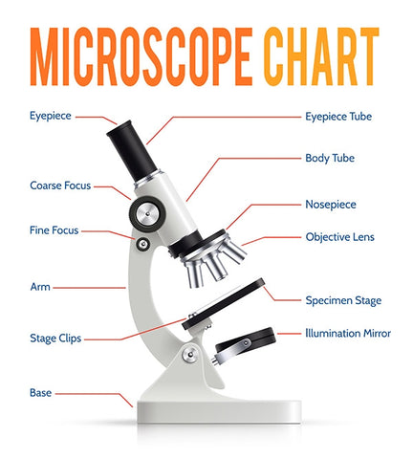

**Main Microscope Parts and Functions**

**Head:**The upper part of the microscope houses the eyepiece and objective lenses.

**Tube**: Where the eyepieces are dropped in. Also, it connects the eyepieces to the objective lenses.

**Stage**: The flat platform that supports the slides. Stage clips hold the slides in place. If your microscope has a mechanical stage, the slide is controlled by turning two knobs instead of having to move it manually. One knob moves the slide left and right, the other moves it forward and backward.

**Arm**: Structural element that connects the head of the microscope to the base.

**Base**: The bottom of the microscope—what the microscope stands on.

**Other Important Parts and Their Functions**

**Eyepieces**: The eyepieces are the lenses at the top that the viewer looks through; they are usually 10X or 15X. To get the total magnification level, multiply the magnification of the objective used (ex: 10X eyepiece \* 40X objective = 400X total magnification).

**Illuminator**: A steady light source (110 volts in the US) that shines up through the slide. Mirrors are sometimes used in lieu of a built-in light. If your microscope has a mirror, it is used to reflect light from an external light source up through the bottom of the stage.

**Nosepiece**: This circular structure is where the different objective lenses are screwed in. To change the magnification power, simply rotate the turret.

**Objective Lenses**: Usually you will find 3 or 4 objective lenses on a microscope. The most common ones are 4X (shortest lens), 10X, 40X and 100X (longest lens). The higher power objectives (starting from 40x) are spring loaded. Spring loaded objective lenses will retract if the objective lens hits a slide, preventing damage to both the lens and the slide. All quality microscopes have achromatic, parcentered, parfocal lenses. In addition, to get the greatest clarity at high levels of magnification, you will need a microscope with an Abbe condenser. Lenses are color coded and are interchangeable between microscopes if built to DIN standards.

**Rack Stop**: This feature determines how far up the stage can go. Setting the rack stop is useful in preventing the slide from coming too far up and hitting the objective lens. Normally, this adjustment is set at the factory, and changing the rack stop is only necessary if your slides are exceptionally thin and you are unable to focus the specimen at higher powers.

**Condenser Lens**: Condenser lenses focus the light that shines up through the slide and are useful for attaining sharp images at magnifications of 400X and above. If the maximum power of your microscope is 400X, a stage mounted 0.65 NA (or greater) condenser is ideal since it give you greater clarity without having to be focused separately. However, if your microscope goes to 1000X or above, focusable condenser lens with an N.A. of 1.25 or greater is needed. Most microscopes that go up to 1000X come equipped with an Abbe condenser, which can be focused by moving it up and down. The Abbe condenser should be set closest to the slide at 1000X and moved further away as the magnification level gets lower.

**Diaphragm or Iris**: The diaphragm or iris is located under the stage and is an apparatus that can be adjusted to vary the intensity, and size, of the cone of light that is projected through the slide. As there is no set rule on which setting to use for a particular power, the setting depends on the transparency of the specimen and the degree of contrast you desire in your image.

What to look for when purchasing a microscope: If you want an instrument that can provide you with crisp, high-quality images at high resolutions, stay away from microscopes with plastic components. Instead, look for a microscope that has a metal body and all glass lenses. Make sure you purchase your precision instrument from a well-established dealer who will be around to help you with technical problems in case you have issues with your microscope. At AmScope.com, we pride ourselves on providing the best instruments at the lowest prices without sacrificing customer service. Technical support is one simple phone call or email away.

**How to Buy a Microscope**

What to look for when purchasing a microscope: If you want an instrument that can provide you with crisp, high-quality images at high resolutions, stay away from microscopes with plastic components. Instead, look for a microscope that has a metal body and all glass lenses. Make sure you purchase your precision instrument from a well-established dealer who will be around to help you with technical problems in case you have issues with your microscope. At [AmScope](https://www.amscope.com/), we pride ourselves on providing the best instruments at the lowest prices without sacrificing customer service. Technical support is one simple phone call or email away.

**Microscope Terms**

This is a glossary of commonly used microscopy terms.

**Abbe Condenser**: A lens that is specially designed to mount under the stage and which typically moves in a vertical direction. An adjustable iris controls the diameter of the beam of light entering the lens system. Both by changing the size of this iris and by moving the lens toward or away from the stage, the diameter and focal point of the cone of light that goes through the specimen can be controlled. Abbe condensers are useful at magnifications above 400X where the condenser lens has a numerical aperture equal to or greater than the N.A. of the objective lens being used.

**Achromatic Lens**: A lens that helps to correct the misalignment of light that occurs when it is refracted through a prism or lens. Since different color light refracts at different angles, an achromatic lens is made of different types of glass with varying indices of refraction. As a result, an improved color alignment is achieved although not as good as is achieved with plan or semi-plan objective lens. Most microscopes use achromatic lens with more exacting applications requiring plan or semi-plan objectives.

**Arm**: The part of the microscope that connects the eyepiece tube to the base.

**Articulated Arm**: Part of a boom microscope stand, an articulated arm has one or more joints to enable a greater variety of movement of the microscope head and, as a result, more versatile range of viewing options.

**Base**: A microscope is typically composed of a head or body and a base. The base is the support mechanism.

**Binocular Microscope**: A microscope with a head that has two eyepiece lenses. Nowadays, binocular is typically used to refer to compound or high-power microscopes where the two eyepieces view through a single objective lens. A stereo (or low power microscope) may also have two eyepieces, but since each eyepiece views through a separate objective lens, the specimen appears in stereo (3-Dimensional). In order to distinguish from monocular or trinocular microscopes, we have included both types of binocular microscopes in our Binocular Microscope category.

**Body**: Often referred to as the head, the body is the upper part of a microscope including, eyepieces and objectives. Most modern microscopes are modular in the sense that the same body can be used with different bases and vice versa.

**Boom Stand (Universal Boom Stand)**: A microscope base that incorporates an adjustable arm or boom and enables the body to be aligned in a variety of different positions. Used in commercial inspection applications.

**Calibration**: The mathematical process of determining true distance when using a reticle.

**Camera Adapter**: An adapter kit designed to enable a camera to fit on to the trinocular port of a microscope (23mm or 30mm port diameter). The camera connects to a step ring (or T-Mount) and then to the camera adapter.

**Clamp Base**: A clamp that replaces the traditional base on the bottom of a boom microscope and enables the pole to be clamped on to the side of a work bench or table.

**C-Mount**: This is an adapter with a standard thread for mounting a lens to a camera. It fits into a trinocular port. The mechanical standard is 1 diameter, 32 TPI (threads per inch), male on the lens and female on the camera. The optical standard is that the image reaches the focal plane at 17.5mm past the edge of the lens mounting threads.

**Coarse Focus**: This is the knob on the side of the microscope that moves the objective lens up and down. It is used in conjunction with the fine focus.

**Coaxial Focus**: A focusing system with both the coarse and fine focusing knobs mounted on the same axis. The coarse focus is typically the larger, outside knob and vice versa. On some coaxial systems, the fine adjustment is calibrated, allowing differential measurements to be recorded.

**Comparison Microscope**: A microscope that enables side-by-side viewing of two different specimens. The microscope has two sets of objectives with a single set of eyepieces (monocular or binocular), often used in forensic science.

**Compound Microscope**: Originally used to describe a microscope with more than one objective lens, a compound microscope is now generally understood to be a high power microscope with multiple, selectable objective lens of varied magnifications. See stereo/low power.

**Condenser**: A lens that concentrates the light on a specimen and increases the resolution. Found in or below the stage on compound microscopes, only.

**Contrast** **Plate**: Found only on stereo microscopes, one side is white and one black. Either side can be used depending on your specimen.

**Cover** **Slip**: A thin, square piece of glass or plastic placed over the specimen on a microscope slide. It flattens out liquid samples and helps single plane focusing.

**Darkfield** **Microscopy**: a technique used to enhance the contrast in unstained specimens. It works on the principle of illuminating the sample with light that will not be collected by the objective lens, so not form part of the image. This produces the classic appearance of a dark, almost black, background with bright objects on it.

**Darkfield** **Plate**: A circular iris that sits on the base of the microscope above the light source and reflects the light horizontally to the specimen, thereby achieving lateral illumination.

**Digital** **Microscope**: A microscope with a built in digital camera that enables direct feed to a PC, TV or printer.

**DIN**: Deutsches Institut für Normung, or in English, the German Institute for Standardization, is an international standards organization that determines the "standard" for a wide variety of different types of technology. "DIN standard" microscope objective lenses use a 20mm diameter attachment thread and are usually interchangeable between microscope manufacturers.

**Dissecting** **Microscope**: Typically interchangeable with stereo microscope, a dissecting microscope is a stereo microscope used in laboratory work.

**Doublet** **Lens**: A lens with two different lenses "welded" together. Used in widefield eyepieces to obtain improved color performance.

**Dual**-**View**: A monocular microscope that has a second, vertical viewing port. Often used by teachers. It can also be used for photographic applications.

**Electron** **Microscope**: A type of microscope that uses electrons rather than light to create an image of the target. It has much higher magnification or resolving power than a normal light microscope, up to two million times, allowing it to see smaller objects and details.

**Eyepiece**: Otherwise referred to as an ocular, the eyepiece is the lens nearest to your eye. Total magnification of a microscope is determined by the sum of the eyepiece magnification multiplied by that of the objective lens.

**Eyepiece** **Tube**: The tube in which the eyepiece lens is situated.

**Fine Focus**: A knob used to fine-tune the focus of a specimen in conjunction with the coarse focus.

**Field of View**: The diameter of the circle of light seen through a microscope.

**Focus**: The ability to achieve a clear image, typically achieved by moving either the eyepiece tubes or the stage.

**Gem**/**Jeweler's** **Microscope**: A stereo microscope designed for viewing gems and jewelry, typically incorporating an inclined pole, powerful zoom, darkfield plate and intense, variable lighting.

**Head**: Often referred to as the body, it is the upper part of the microscope that includes the eyepiece tubes and prisms.

**Illumination System**: The light source on light microscopes, typically mounted under the stage except on inverted microscopes.

**Immersion Oil:** A special oil used with the 100X objective in order to concentrate the light and increase the resolution of the image. A drop of oil is placed on the cover slip and the objective is lowered until it touches the oil. There are two primary types of immersion oil: Type A and Type B; Type B is more viscous.

**Interpupillary Distance:** The distance between the two eyepieces, usually adjustable to fit individual users.

**Inverted Microscope**: A microscope designed with the objectives under the stage and the light source above. Used for viewing larger specimens, often in containers.

**Iris Diaphragm**: Found on high power microscopes under the stage, the diaphragm is, typically, a five hole-disc with each hole having a different diameter. It is used to vary the light that passes through the stage opening and helps to adjust both the contrast and resolution of a specimen. It is particularly useful at higher powers.

**Jeweler's Clip**: A special clip that attaches to the stage and is designed to hold precious stones and jewelry for easier viewing.

**Koehler Illumination**: A method of illumination named after August Koehler, the man who invented it. It is also known as double diaphragm illumination because it employs both a field and an aperture iris diaphragm to control the illumination. If the light path is adjusted properly, it is possible to enjoy the advantages of an evenly illuminated field, a bright image without glare and minimum heating of the specimen.

**Light Microscopes**: Any microscope that uses a source of light to create an image of the specimen and, essentially includes all compound and stereo microscopes.

**Magnification**: The essence of a microscope is its ability to magnify a specimen. Total magnification of a microscope is determined by multiplying the magnification capability of the eyepiece lens by that of the objective lens.

**Mechanical Stage**: A flat mechanism that sits on top of the stage and allows the viewer to move a specimen small distances - a task that is otherwise difficult at higher magnifications. Most mechanical stages are equipped with an X and Y axis so the viewer can see how far the slide has moved.

**Monocular Microscope**: A compound microscope with a single eyepiece.

**Nosepiece**: The upper part of a compound microscope that holds the objective lens. Also called a revolving nosepiece or turret.

**Numerical Aperture (N.A):** A measure of the diameter of the aperture compared to the focal length of a lens and ultimately, of the resolving power of a microscope. N.A. is equal to the index of refraction of the medium in which the object is placed multiplied by the sine of the angle made with the axis by the most oblique ray entering the instrument, the resolving power increasing as the product increases.

**Objective Lens**: The lens closest to the specimen that first receives the rays from the specimen (the object) and forms the image in the focal plane of the eyepiece.

**Oil Immersion Lens**: Typically, a 100X (or higher) objective lens designed to work with a drop of immersion oil.

**Parcentered**: When changing objectives, the image of the specimen stays centered. Most compound microscopes are parcentered.

**Parfocal**: When changing objectives, the image of the specimen stays in focus without needing to adjust the focusing knobs. Most compound microscopes are parfocal.

**Phase Contrast:** A contrast enhancing technique developed by Frits Zernike in 1953 for which he won the Nobel Prize in Physics. The technique shifts the light phase wavelength, thereby causing the light deviated by the specimen to appear dark on a light background. It is useful for viewing transparent specimens such as living tissue cells.

**Plan Lens**: The finest objective lens that "flattens" the image of the specimen and greatly enhances the resolution and clarity of the image.

**Portable Microscope**: A cordless or field microscope with a light source independent of 110/220V. Typically, includes a rechargeable LED light source so that it can be used in the field where 110/220V electric supply is unavailable.

**Pointer**: A piece of high tensile wire that sits in the eyepiece and enables a viewer to point at a specific area of a specimen.

**Pole Stand**: A microscope stand composed of a base with a single vertical pole (or post). Typically, the body can move up and down as well as rotate round the pole.

**Rack** **and Pinion Focusing Mechanism**: A metal rack and pinion used in better quality microscopes for focusing purposes and moving mechanical stages.

**Rack Stop**: A safety feature that prevents the viewer from allowing the objective lens to accidentally hit the stage and damage the specimen or slide.

**Resolution**: The ability of a lens to distinguish the fine details of the specimens being viewed.

**Reticle**: A small glass circle etched by laser with fine measurements and placed within the eyepiece in order to enable actual measurements of the specimen to be taken.

**Revolving Nosepiece**: A nosepiece with multiple objectives that revolves in order to enable the viewer to use, typically, one of four different objectives.

**Ring Light**: An extraneous light source that connects to the microscope and emits a ring of light for enhanced lighting. Ring lights are LED, fluorescent, halogen or fiber optic and are typically, used on boom microscopes.

**Semi**-**Plan** **Objectives**: Improve the clarity and resolution of an image compared to chromatic lens, by partially "flattening" the image of the specimen.

**Siedentopf** **Head**: A head design where the interpupillary adjustment is achieved by twisting the eyepieces in a vertical arc like binoculars.

**Slide**: A flat, rectangular, glass plate on which a specimen may be placed.

**Slip Clutch**: A mechanical device on the focusing knob that allows the knob to "slip" if a viewer keeps turning the knob beyond its range of travel. Prevents damage from occurring to the focusing system.

**Stage**: The platform on which slides and specimens are placed for viewing.

**Stage Clips**: Clips that are attached to the stage and retain the slide.

**Stand**: Describes the connection between the body and base a stereo or low power microscope.

**Stereo Microscope**: A low power microscope or dissecting microscope with a separate eyepiece and objective lens for each eye. These separate optical channels enable stereo or three-dimensional images of the specimen. See Compound Microscope.

**Sub-Stage**: The parts of the microscope below the stage, including the illumination system.

**T-Mount:** A standard adapter for mounting 35mm cameras to microscopes. Also known as a step-ring.

**Tension Adjustment:** A factory set adjustment to the focusing mechanism that ensures it is both, sufficiently easy to focus and sufficiently tight to ensure that the stage does not drift during the focusing process.

**Turret**: A mechanism which rotates including nosepiece, condenser, etc.

**Widefield Eyepiece**: An improved eyepiece lens with a broader diameter that enables a broader field of vision and greater ease of use.

Free shipping on orders over $75

Fast and Same Day Shipping for orders  
within the contiguous U.S

Easy 30 Day Returns

Purchase with confidence with our simple 30 day return policy

Quality Products

Enjoy high performance products  
with a five year warranty on  
AmScope Microscopes.

Do you have a question?

Our dedicated customer service team  
is ready assist and find the products  
you need.

Sign up today and get 10% off your next purchase!

Top of Form

Email:

Bottom of Form

Customer Support

* [Help](https://amscope.com/pages/frequently-asked-questions)
* [Technical Support](https://amscope.com/pages/technical-support)
* [Camera Software Download](https://amscope.com/pages/software-downloads)
* [Manual Download](https://amscope.com/pages/manual-downloads)

Information Center

* [AmScope Business](https://amscope.com/pages/business)
* [Shop By Industry](https://amscope.com/pages/shop-by-industry)
* [Choosing a Microscope](https://amscope.com/pages/how-to-choose-microscope)
* [Using a Microscope](https://amscope.com/pages/how-to-use-microscope)
* [Microscope Parts and Functions](https://amscope.com/pages/microscope-parts-and-functions)
* [Educational Resources](https://amscope.com/pages/educational-resources)
* [Blog](https://amscope.com/blogs/news)

My Account

* [Create A New Account](https://amscope.com/account/register)
* [View Cart](https://amscope.com/cart)
* [My Account](https://amscope.com/account)
* [Reseller Program](https://amscope.com/pages/reseller-program)

Company

* [About Us](https://amscope.com/pages/about-us)
* [Terms & Conditions](https://amscope.com/pages/terms-conditions)
* [Refund Policy](https://amscope.com/policies/refund-policy)
* [Privacy](https://amscope.com/pages/privacy-policy)
* [Do not sell my personal information](https://amscope.com/pages/ccpa-opt-out)
* [Contact Us](https://amscope.com/pages/contact-us)
* [Our Customers](https://amscope.com/pages/customer-list)

Follow Us

* [Facebook](https://www.facebook.com/Amscope)

* [Instagram](https://www.instagram.com/amscope_/)

* [YouTube](https://www.youtube.com/user/Amscopecom)

* [LinkedIn](https://www.linkedin.com/showcase/amscope/)

© 2023 AmScope. All Rights Reserved.

[Skip to content](https://amscope.com/pages/educational-resources#MainContent)

Top of Form

Search our store

Bottom of Form

[Free U.S. Shipping](https://amscope.com/pages/faq#faq-shipping)

[1-888-950-2888](tel:18889502888)

[My Account](https://amscope.com/account)0Cart

* [MICROSCOPES](https://amscope.com/collections/microscopes)
* [CAMERAS](https://amscope.com/collections/microscope-cameras)
  + [Cameras](https://amscope.com/collections/microscope-cameras)
  + [Digital Microscopes](https://amscope.com/collections/digital-microscopes)
* [KIDS & STUDENTS](https://amscope.com/collections/student-microscopes)
  + [Shop By Microscope Category](https://amscope.com/pages/educational-resources)
  + [Shop By Age](https://amscope.com/pages/educational-resources)
  + [Kid's Activity Kits](https://amscope.com/collections/kids-activity-kits)
  + [Premium Student Bundles](https://amscope.com/pages/school)
  + [Telescopes](https://amscope.com/collections/telescopes)
* [TELESCOPES](https://amscope.com/collections/telescopes)
  + [Telescopes](https://amscope.com/collections/telescopes)
* [LAB EQUIPMENT & SUPPLIES](https://amscope.com/pages/lab-equipment)
  + [Shop By Brand](https://amscope.com/pages/educational-resources)
  + [Shop By Lab Category](https://amscope.com/pages/educational-resources)
  + [Promotions](https://amscope.com/pages/all-lab-equipment-and-supplies-promotions)
  + [Lab Equipment](https://amscope.com/pages/educational-resources)
  + [Lab Supplies](https://amscope.com/pages/educational-resources)
* [SLIDES & ACCESSORIES](https://amscope-us-dev.myshopify.com/collections/microscope-parts-accessories)
  + [Slides](https://amscope.com/collections/collections-microscope-parts-accessories-microscope-slides)
  + [Cameras](https://amscope.com/collections/microscope-cameras)
  + [Illuminators](https://amscope.com/collections/microscope-parts-accessories-microscope-illuminators-ring-lights)
  + [Adapters](https://amscope.com/collections/microscope-parts-accessories-microscope-adapters)
  + [Eyepieces / Objectives](https://amscope.com/pages/educational-resources)
  + [Bulbs](https://amscope.com/collections/microscope-parts-accessories-microscope-bulbs)
  + [Magnifying Lamps](https://amscope.com/collections/magnifying-lamps)
  + [Monitors and Tablets](https://amscope.com/collections/monitors-and-tablets/Category_Monitors-&-Tablets)
  + [View All Categories](https://amscope.com/collections/microscope-parts-accessories)
* [NEW & DEALS](https://amscope.com/pages/educational-resources)
  + [Overstock](https://amscope.com/collections/discount-microscopes-and-microscope-parts)
  + [Deals](https://amscope.com/pages/educational-resources)
  + [New](https://amscope.com/collections/new-products)
  + [Open Box](https://amscope.com/collections/open-box)

**[SHOP STUDENT PREMIUM BUNDLES](https://amscope.com/pages/school)**

* + [Premium Microscopes](https://amscope.com/pages/premium-microscopes)
  + [Compound Microscopes](https://amscope.com/collections/compound-microscopes)
  + [Stereo Microscopes](https://amscope.com/collections/stereo-microscope)
  + [Kids, Student Microscopes](https://amscope.com/collections/student-microscopes)
  + [Digital Microscopes](https://amscope.com/collections/digital-microscopes)

[[](https://amscope.com/collections/blowout-clearance-sale-up-to-60-off)](https://amscope.com/collections/blowout-clearance-sale-up-to-60-off)

1. [Home](https://amscope.com/) /
2. [Educational Resources](https://amscope.com/pages/educational-resources)

[](https://www.amscope.com/microscope-glossary)

[**Glossary of Terms**](https://amscope.com/pages/glossary-of-terms)

An A-to-Z of microscope terms.

[**HISTORY OF THE MICROSCOPE**](https://amscope.com/pages/history-of-the-microscope)

During that historic period known as the Renaissance, after the "dark" Middle Ages, there occurred the inventions of printing, gunpowder and the mariner's compass, followed by the discovery of America. Equally remarkable was the invention of the light microscope: an instrument that enables ...

[More info ... ...](https://amscope.com/pages/history-of-the-microscope)

[**MICROSCOPE PARTS AND FUNCTIONS**](https://amscope.com/pages/microscope-parts-and-functions)

Before purchasing or using a microscope, it is important to know the functions of each part.  
  
Eyepieces: The eyepieces are the lenses at the top that the viewer looks through; they are usually 10X or 15X. To get the total magnification level, multiply the magnification of the eyepiece and the magnification of the objective used (ex: 10X eyepiece \* 40X objective = 400X total magnification).

[More info ... ...](https://amscope.com/pages/microscope-parts-and-functions)

[**HOW TO CHOOSE A MICROSCOPE**](https://amscope-us-dev.myshopify.com/pages/how-to-choose-microscope)

Your application is the most important factor in choosing a microscope. What you need to see and what you want to do with that image will determine what kind of microscope you need. There are two

[More info ... ...](https://amscope.com/pages/how-to-choose-microscope)

[**HOW TO USE A MICROSCOPE PROPERLY**](https://amscope.com/pages/how-to-use-a-properly-use-a-microscope)

Basics:  
1. When transporting the microscope, carry it close to your body with one hand on the arm and the other ...

[More info ... ...](https://amscope.com/pages/how-to-use-a-properly-use-a-microscope)

[**HOW TO CHOOSE A MICROSCOPE CAMERA**](https://amscope.com/pages/how-to-choose-a-microscope-camera-for-your-microscope)

Previously, scientists had to sketch their microscopic observations on paper. Today, they use microscopes with cameras, as they make the job much simpler and more accurate. ...

[Read More ...](https://amscope.com/pages/how-to-choose-a-microscope-camera-for-your-microscope)

Free shipping on orders over $75

Fast and Same Day Shipping for orders  
within the contiguous U.S

Easy 30 Day Returns

Purchase with confidence with our simple 30 day return policy

Quality Products

Enjoy high performance products  
with a five year warranty on  
AmScope Microscopes.

Do you have a question?

Our dedicated customer service team  
is ready assist and find the products  
you need.

Sign up today and get 10% off your next purchase!

Top of Form

Email:

Bottom of Form

Customer Support

* [Help](https://amscope.com/pages/frequently-asked-questions)
* [Technical Support](https://amscope.com/pages/technical-support)
* [Camera Software Download](https://amscope.com/pages/software-downloads)
* [Manual Download](https://amscope.com/pages/manual-downloads)

Information Center

* [AmScope Business](https://amscope.com/pages/business)
* [Shop By Industry](https://amscope.com/pages/shop-by-industry)
* [Choosing a Microscope](https://amscope.com/pages/how-to-choose-microscope)
* [Using a Microscope](https://amscope.com/pages/how-to-use-microscope)
* [Microscope Parts and Functions](https://amscope.com/pages/microscope-parts-and-functions)
* [Educational Resources](https://amscope.com/pages/educational-resources)
* [Blog](https://amscope.com/blogs/news)

My Account

* [Create A New Account](https://amscope.com/account/register)
* [View Cart](https://amscope.com/cart)
* [My Account](https://amscope.com/account)
* [Reseller Program](https://amscope.com/pages/reseller-program)

Company

* [About Us](https://amscope.com/pages/about-us)
* [Terms & Conditions](https://amscope.com/pages/terms-conditions)
* [Refund Policy](https://amscope.com/policies/refund-policy)
* [Privacy](https://amscope.com/pages/privacy-policy)
* [Do not sell my personal information](https://amscope.com/pages/ccpa-opt-out)
* [Contact Us](https://amscope.com/pages/contact-us)
* [Our Customers](https://amscope.com/pages/customer-list)

Follow Us

* [Facebook](https://www.facebook.com/Amscope)

* [Instagram](https://www.instagram.com/amscope_/)

* [YouTube](https://www.youtube.com/user/Amscopecom)

* [LinkedIn](https://www.linkedin.com/showcase/amscope/)

© 2023 AmScope. All Rights Reserved.

[Skip to Content](https://amscope.com/pages/manual-downloads" \l "acsbContent)

[↵ENTER](https://amscope.com/pages/manual-downloads" \l "acsbContent)

[Skip to Menu](https://amscope.com/pages/manual-downloads" \l "acsbMenu)

[↵ENTER](https://amscope.com/pages/manual-downloads" \l "acsbMenu)

[Skip to Footer](https://amscope.com/pages/manual-downloads" \l "acsbFooter)

[↵ENTER](https://amscope.com/pages/manual-downloads" \l "acsbFooter)

[Skip to content](https://amscope.com/pages/manual-downloads#MainContent)

Top of Form

Search our store

Bottom of Form

[Free U.S. Shipping](https://amscope.com/pages/faq#faq-shipping)

[1-888-950-2888](tel:18889502888)

[My Account](https://amscope.com/account)0Cart

* [MICROSCOPES](https://amscope.com/collections/microscopes)
* [CAMERAS](https://amscope.com/collections/microscope-cameras)
  + [Cameras](https://amscope.com/collections/microscope-cameras)
  + [Digital Microscopes](https://amscope.com/collections/digital-microscopes)
* [KIDS & STUDENTS](https://amscope.com/collections/student-microscopes)
  + [Shop By Microscope Category](https://amscope.com/pages/manual-downloads)
  + [Shop By Age](https://amscope.com/pages/manual-downloads)
  + [Kid's Activity Kits](https://amscope.com/collections/kids-activity-kits)
  + [Premium Student Bundles](https://amscope.com/pages/school)
  + [Telescopes](https://amscope.com/collections/telescopes)
* [TELESCOPES](https://amscope.com/collections/telescopes)
  + [Telescopes](https://amscope.com/collections/telescopes)
* [LAB EQUIPMENT & SUPPLIES](https://amscope.com/pages/lab-equipment)
  + [Shop By Brand](https://amscope.com/pages/manual-downloads)
  + [Shop By Lab Category](https://amscope.com/pages/manual-downloads)
  + [Promotions](https://amscope.com/pages/all-lab-equipment-and-supplies-promotions)
  + [Lab Equipment](https://amscope.com/pages/manual-downloads)
  + [Lab Supplies](https://amscope.com/pages/manual-downloads)
* [SLIDES & ACCESSORIES](https://amscope-us-dev.myshopify.com/collections/microscope-parts-accessories)
  + [Slides](https://amscope.com/collections/collections-microscope-parts-accessories-microscope-slides)
  + [Cameras](https://amscope.com/collections/microscope-cameras)
  + [Illuminators](https://amscope.com/collections/microscope-parts-accessories-microscope-illuminators-ring-lights)
  + [Adapters](https://amscope.com/collections/microscope-parts-accessories-microscope-adapters)
  + [Eyepieces / Objectives](https://amscope.com/pages/manual-downloads)
  + [Bulbs](https://amscope.com/collections/microscope-parts-accessories-microscope-bulbs)
  + [Magnifying Lamps](https://amscope.com/collections/magnifying-lamps)
  + [Monitors and Tablets](https://amscope.com/collections/monitors-and-tablets/Category_Monitors-&-Tablets)
  + [View All Categories](https://amscope.com/collections/microscope-parts-accessories)
* [NEW & DEALS](https://amscope.com/pages/manual-downloads)
  + [Overstock](https://amscope.com/collections/discount-microscopes-and-microscope-parts)
  + [Deals](https://amscope.com/pages/manual-downloads)
  + [New](https://amscope.com/collections/new-products)
  + [Open Box](https://amscope.com/collections/open-box)

**[SHOP STUDENT PREMIUM BUNDLES](https://amscope.com/pages/school)**

* + [Premium Microscopes](https://amscope.com/pages/premium-microscopes)
  + [Compound Microscopes](https://amscope.com/collections/compound-microscopes)
  + [Stereo Microscopes](https://amscope.com/collections/stereo-microscope)
  + [Kids, Student Microscopes](https://amscope.com/collections/student-microscopes)
  + [Digital Microscopes](https://amscope.com/collections/digital-microscopes)

[[](https://amscope.com/collections/blowout-clearance-sale-up-to-60-off)](https://amscope.com/collections/blowout-clearance-sale-up-to-60-off)

1. [Home](https://amscope.com/) /
2. [Manual Downloads](https://amscope.com/pages/manual-downloads)

Manual Downloads

Step 1. Select your product

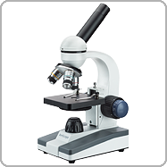

**Compound Microscopes**

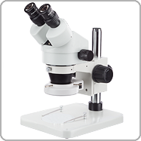

**Stereo Microscopes**

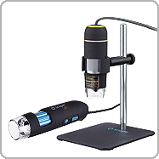

**Digital Microscopes**

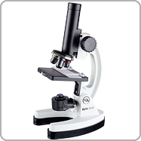

**Kids Microscopes**

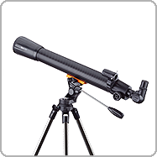

**Telescopes**

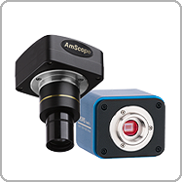

**Cameras**

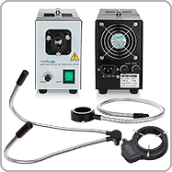

**Accessories**

Step 2. Select your Model#



Step 3. Download Manual

**Manual Downloads Instructions**

1. Select your Product Category
2. Select the Model # from the dropdown selection
3. Click the download button to start downloading

Free shipping on orders over $75

Fast and Same Day Shipping for orders  
within the contiguous U.S

Easy 30 Day Returns

Purchase with confidence with our simple 30 day return policy

Quality Products

Enjoy high performance products  
with a five year warranty on  
AmScope Microscopes.

Do you have a question?

Our dedicated customer service team  
is ready assist and find the products  
you need.

Sign up today and get 10% off your next purchase!

Top of Form

Email:

Bottom of Form

Customer Support

* [Help](https://amscope.com/pages/frequently-asked-questions)
* [Technical Support](https://amscope.com/pages/technical-support)
* [Camera Software Download](https://amscope.com/pages/software-downloads)
* [Manual Download](https://amscope.com/pages/manual-downloads)

Information Center

* [AmScope Business](https://amscope.com/pages/business)
* [Shop By Industry](https://amscope.com/pages/shop-by-industry)
* [Choosing a Microscope](https://amscope.com/pages/how-to-choose-microscope)
* [Using a Microscope](https://amscope.com/pages/how-to-use-microscope)
* [Microscope Parts and Functions](https://amscope.com/pages/microscope-parts-and-functions)
* [Educational Resources](https://amscope.com/pages/educational-resources)
* [Blog](https://amscope.com/blogs/news)

My Account

* [Create A New Account](https://amscope.com/account/register)
* [View Cart](https://amscope.com/cart)
* [My Account](https://amscope.com/account)
* [Reseller Program](https://amscope.com/pages/reseller-program)

Company

* [About Us](https://amscope.com/pages/about-us)
* [Terms & Conditions](https://amscope.com/pages/terms-conditions)
* [Refund Policy](https://amscope.com/policies/refund-policy)
* [Privacy](https://amscope.com/pages/privacy-policy)
* [Do not sell my personal information](https://amscope.com/pages/ccpa-opt-out)
* [Contact Us](https://amscope.com/pages/contact-us)
* [Our Customers](https://amscope.com/pages/customer-list)

Follow Us

* [Facebook](https://www.facebook.com/Amscope)

* [Instagram](https://www.instagram.com/amscope_/)

* [YouTube](https://www.youtube.com/user/Amscopecom)

* [LinkedIn](https://www.linkedin.com/showcase/amscope/)

© 2023 AmScope. All Rights Reserved.

**[Metlab Equipments & Engineering Systems](https://www.metlab.net.in/)**

[Ahmedabad, GujaratGST No.](https://www.metlab.net.in/)**[24AVGPB1199J1ZM](https://www.metlab.net.in/)**

**Call +91-804861921474% Response Rate**

**Send Email**

* [**Home**](https://www.metlab.net.in/)
* [**Introduction & Profiles**](https://www.metlab.net.in/profile.html)

 Watch Company Video

* [**Contact Us**](https://www.metlab.net.in/enquiry.html)
* **Our Products**

**[Metallurgical Microscopes (25)](https://www.metlab.net.in/metallurgical-microscopes.html)**

* + - [Inverted Metallurgical Microscope](https://www.metlab.net.in/metallurgical-microscopes.html#inverted-metallurgical-microscope)
    - [Inverted Trinocular Metallurgical Microscope](https://www.metlab.net.in/metallurgical-microscopes.html#inverted-trinocular-metallurgical-microscope)
    - [Trinocular Metallurgical Microscopes](https://www.metlab.net.in/metallurgical-microscopes.html#trinocular-metallurgical-microscopes)
    - [Trinocular Metallurgical Microscope](https://www.metlab.net.in/metallurgical-microscopes.html#trinocular-metallurgical-microscope)
    - [Trinocular Metallurgical Microscope](https://www.metlab.net.in/metallurgical-microscopes.html#trinocular-metallurgical-microscope)

[Polishing And Grinder Machines (23)](https://www.metlab.net.in/polishing-and-grinder-machines.html)

[Hardness Tester (16)](https://www.metlab.net.in/hardness-tester.html)

[Laboratory Instruments (21)](https://www.metlab.net.in/laboratory-instruments.html)

[Abrasive Cutt Off Machine (5)](https://www.metlab.net.in/abrasive-cutt-off-machine.html)

[Metallurgical Laboratory Equipment (5)](https://www.metlab.net.in/metallurgical-laboratory-equipment.html)

[Hot Mounting Press (4)](https://www.metlab.net.in/hot-mounting-press.html)

* [**+ View all**](https://www.metlab.net.in/metallurgical-equipments.html)

Top of Form

Bottom of Form

* [Home](https://www.metlab.net.in/)
* »
* [Our Products](https://www.metlab.net.in/metallurgical-equipments.html)
* »
* Metallurgical Microscopes

**Metallurgical Microscopes**

Prominent & Leading Manufacturer from Ahmedabad, we offer inverted metallurgical microscope, inverted trinocular metallurgical microscope, trinocular metallurgical microscopes, trinocular metallurgical microscope, wf 10x inverted metallurgical microscope and 1000x magnification inverted metallurgical microscopes.

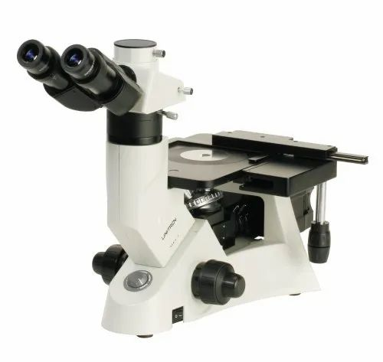

* 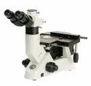
* 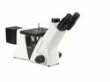
* 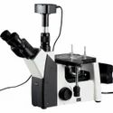
* 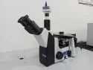
* 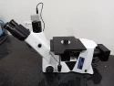
* 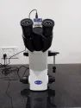

**Inverted Metallurgical Microscope**

**Product Price:** Rs 34,000 / Piece**Get Best Price**

Minimum Order Quantity: **1 Piece**

Product Brochure

Product Details:

|  |  |
| --- | --- |
| Eyepiece | 10X (paired) |
| Is It Portable | Portable |
| Model Name/Number | Metlab 1000 |
| Moving Range | 75 mmX40 mm |
| Usage/Application | Metallurgical |
| Drawtube | Trinocular |
| Interpupillary Distance | 54 mm to 75 mm |
| Mechanical Stage | 180 mm X 155 mm |
| Display | Digital Display |
| Brand | Metlab |

**Trinocular Observation Head**

· Side and top observation head inclined at 45°.

· Vertical phototube for micro photography light split (80:20).

· Diopter adjustment ring on ocular tube (±5).

· Interpupillary distance from 54mm to 75mm.

**Eyepiece**

· Wide field eyepiece 10X (paired)

· F.O.V. 18mm

**Illuminator**

·      The Epi illuminator has 5W LED lamp adjustable brightness.

**Optional Accessories**

·      Digital USB Microscopy Camera

·      Metallurgical Image Analysis Software

**Objectives (Infinity Corrected)**

·      M Long Working Distance Plan Achromatic 5X (WD 15.5 mm)

·      M Long Working Distance Plan Achromatic 10X (WD 8.7mm)

·      M Long Working Distance Plan Achromatic 20X (WD 8.8 mm)

·      M Long Working Distance Plan Achromatic 50X (WD S L ) (5.1mm)

·      M Long Working Distance Plan Achromatic 100 X ( WD SL (0.6mm) ( Optional )

**Mechanical Body**

·      Co-axial focusing system with large knobs, Pre focusing lever & tension adjustment ring.

·      Quadruple nosepiece on ball bearing.

·      Mechanical stage is 180mmX155mm.

·      Moving range: 75mmX40mm.

·      The Mechanical stage has low positioned co-axial controls on ball bearing guide ways.

**Additional Information:**

* **Production Capacity:**10-15 Units per month
* **Delivery Time:**1-2 Week
* **Packaging Details:**Export Worthy Wooden Box Packaging

**View Complete details**

**Get Best QuoteRequest A Callback**

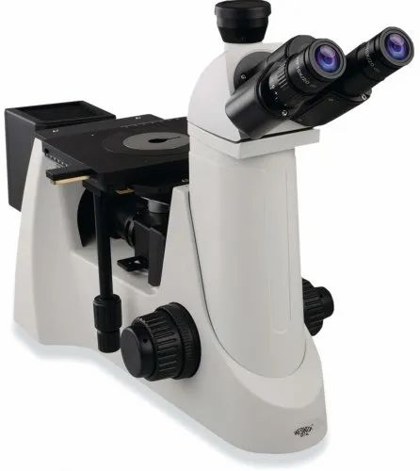

* 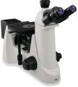
* 
* 
* 
* 
* 

**Inverted Trinocular Metallurgical Microscope**

**Product Price:** Rs 34,000 / Piece**Get Best Price**

Product Brochure

Product Details:

|  |  |
| --- | --- |
| Usage/Application | Laboratory |
| Brand | Metlab |
| Magnification | 50 X to 2000 X |
| Interpupillary Distance | 54 mm to 75 mm |
| Moving Range | 75 mm x 40 mm |
| Mechanical Stage | 180 mm x 155 mm |
| Working Distance | 0.6 mm |

**Objectives (Infinity Corrected) :**

* M Long Working Distance Plan Achromatic 5X (WD 15.5 mm)
* M Long Working Distance Plan Achromatic 10X (WD 8.7mm)
* M Long Working Distance Plan Achromatic 20X (WD 8.8 mm)
* M Long Working Distance Plan Achromatic 50X (WD S L ) (5.1mm)
* M Long Working Distance Plan Achromatic 100 X ( WD SL (0.6mm) ( Optional )

**Mechanical Body :**

* Co-axial focusing system with large knobs, Pre focusing lever & tension adjustment ring.
* Quadruple nosepiece on ball bearing.
* Mechanical stage is 180mmX155mm.
* The Mechanical stage has low positioned co-axial controls on ball bearing guide ways.

**View Complete details**

**Get Best QuoteRequest A Callback**

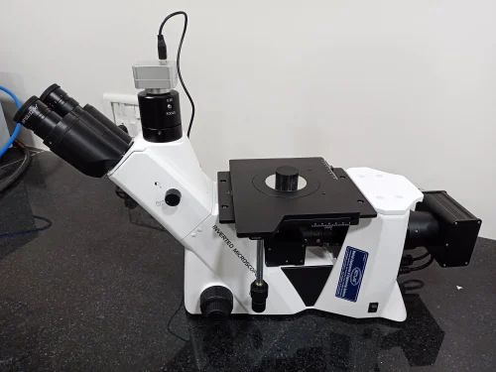

* 
* 
* 
* 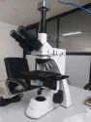
* 

**Trinocular Metallurgical Microscopes**

**Product Price:** Rs 35,000 / Piece**Get Best Price**

Product Brochure

Product Details:

|  |  |
| --- | --- |
| Magnification | 1000X |
| Usage/Application | Laboratory |
| Model Name/Number | METLAB 1000 |
| Eyepiece | 10X |
| Brand | Metlab |
| Moving Range | 80mm X 50mm |
| Mechanical Stage | 180mm X 155mm |
| Size | 150mm x 200mm |
| Power | 20 W |

**Trinocular Observation Head:**

* Side and top observation head inclined at 45°.
* Vertical phototube for micro photography light split (80:20).
* Diopter adjustment ring on ocular tube (±5).

**Objectives (Infinity Corrected) :**

* M Long working distance plan 10X (WD 11.0mm)
* M Long working distance plan 20X ( WD 9.0mm)
* M Long working distance plan 50X (WD 3.8mm)
* M Long working distance plan 100X (S.L.) Dry (WD .0.4mm)

**Polarizing Outfit :**

* Analyzer rotatable at 360°. Polarizer & Analyzer can be slide in/out of the optical path.

**Mechanical Body :**

* Co-axial focusing system with large knobs, PRE-FOCUSING LEVER & TENSION ADJUSTMENT RING.
* Quadruple nosepiece on ball bearing.

**View Complete details**

**Get Best QuoteRequest A Callback**

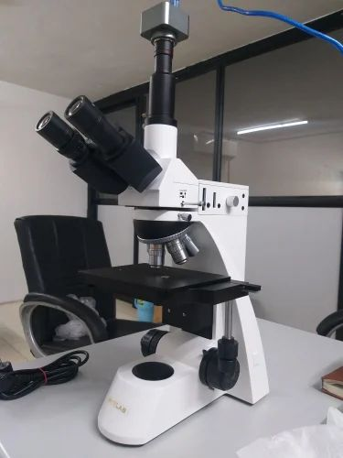

**Trinocular Metallurgical Microscope**

**Product Price:** Rs 35,000 / Piece**Get Best Price**

Product Brochure

Product Details:

|  |  |
| --- | --- |
| Usage/Application | Laboratory |
| Brand | Metlab |
| Interpupillary Distance | 54mm to 75mm |
| Voltage | 12V |
| Moving Range | 80mm X 50mm |
| Mechanical Stage | 180mm X 155mm |
| Power | 50W |

We are backed by a highly committed team of professionals who have in-depth knowledge and vast expertise in their field of operations. To ensure optimum quality products, these scientific instruments are manufactured utilizing quality-assured raw material procured from certified vendors. Further, we have an advanced infrastructure facility that is outfitted with technologically advanced machines and tools. The latest machinery of our manufacturing unit allows us to deliver precisely and accurately designed testing instruments. We also have a warehousing unit that facilitates adequate and safe storage of our products.

**View Complete details**

**Get Best QuoteRequest A Callback**

**Trinocular Metallurgical Microscope**

**Product Price:** Rs 34,000 / Piece**Get Best Price**

Product Brochure

Product Details:

|  |  |
| --- | --- |
| Usage/Application | Laboratory |
| Model Name/Number | IMM 901 |
| Eyepiece | WF10x Paired (Field of View 16 mm ) |
| Brand | Metlab |
| Portable | Yes |
| Is It Portable | Portable |
| Weight | 9 Kg |
| Moving Range | 15 x 15 mm |
| Objectives | 10x/0.25 (W.D. 6.7 mm), 20x/0.40 (W.D. 0.76 mm) |
| Dimensions | 540 x 195 x 320 mm |
| Basic Magnification | 100x - 1000x |

The model IMM 901 series metallurgical microscopes are used for identification and analysis of the structures of different metals and alloys. They are important instruments for the research of metallography. They can be used for quality research of foundry, smelt and heat treatment, for testing of raw and processed materials or for analysis of heat treatment materials. They are ideal instrument for scientific research, teaching, factories and so on. The model IMM 901 series can be taken euploid pictures for the atlas of metallography, with selecting special photography device.

**View Complete details**

**Get Best QuoteRequest A Callback**

**WF 10X Inverted Metallurgical Microscope**

**Product Price:** Rs 34,000 / Piece**Get Best Price**

Minimum Order Quantity: **1 Piece**

Product Brochure

Product Details:

|  |  |
| --- | --- |
| Eyepiece | WF 10X |
| Brand | Metlab |
| Country of Origin | Made in India |
| Model Name/Number | Metlab 1000 |
| Usage/Application | Laboratory |
| Drawtube | Trinocular |
| Is It Portable | Portable |
| Display | Digital Display |
| Stage Size | 150 mm x 200 mm |
| Voltage | 6 V |
| Power | 20 W |
| Lamp Type | LED Light |

**Trinocular Observation Head**

· Side and top observation head inclined at 45°.

· Vertical phototube for micro photography light split (80:20).

· Diopter adjustment ring on ocular tube (±5).

· Interpupillary distance from 54mm to 75mm.

**Eyepiece**

· Wide field eyepiece 10X (paired)

· F.O.V. 18mm

**Illuminator**

·      The Epi illuminator has 5W LED lamp adjustable brightness.

**Optional Accessories**

·      Digital USB Microscopy Camera

·      Metallurgical Image Analysis Software

**Objectives (Infinity Corrected)**

·      M Long Working Distance Plan Achromatic 5X (WD 15.5 mm)

·      M Long Working Distance Plan Achromatic 10X (WD 8.7mm)

·      M Long Working Distance Plan Achromatic 20X (WD 8.8 mm)

·      M Long Working Distance Plan Achromatic 50X (WD S L ) (5.1mm)

·      M Long Working Distance Plan Achromatic 100 X ( WD SL (0.6mm) ( Optional )

**Mechanical Body**

·      Co-axial focusing system with large knobs, Pre focusing lever & tension adjustment ring.

·      Quadruple nosepiece on ball bearing.

·      Mechanical stage is 180mmX155mm.

·      Moving range: 75mmX40mm.

·      The Mechanical stage has low positioned co-axial controls on ball bearing guide ways.

**Additional Information:**

* **Production Capacity:**10-15 Units Per Month
* **Delivery Time:**1-2 Week
* **Packaging Details:**Export Worthy Cartoon Box Packaging

**View Complete details**

**Get Best QuoteRequest A Callback**

**1000x Magnification Inverted Metallurgical Microscopes**

**Product Price:** Rs 34,000 / Piece**Get Best Price**

Minimum Order Quantity: **1 Piece**

Product Brochure

Product Details:

|  |  |
| --- | --- |
| Display | Digital Display |
| Mechanical Stage | 180 mm x 155 mm |
| Ccd Camera Unit | 5MP |
| Drawtube | Trinocular |
| Diopter Adjustment Ring | 75mm |
| Nose Piece | 5 nos |
| Eyepiece | 10X (Paired) |
| Interpupillary Distance | 54 mm to 75 mm |
| Working Distance | 10mm |
| Model Name/Number | Metlab 1000 |
| Capacity G | 1000X |
| Moving Range | 75 mm x 40 mm |
| Infinite Plan Achromatic | Yes |
| Mechanical Tube Length | 100mm |
| Color | Black + White |
| Brand | Metlab |
| Magnification | 1000x |
| Is It Portable | Portable |
| Usage/Application | Metallurgical |
| Automation Grade | Automatic |
| Power | 5 W |

**Specifications:**

* Trinocular observation head
* Siedentopf observation head inclined at 45o.
* Diopter adjustment ring on ocular tube.
* Interpupillary distance from 50 MM to 75 MM.
* co-axial and fine focusing system with slide traveling on ball bearing guide ways.
* Inner locating ball bearing nose - piece.
* Observation on trinocular head,compensation(inclined 30 degrees)
* Triple plate for X and Y movement of workstage.
* Anti-fungal coated objectives.
* Illumination unit 6V 20W halogen lamp, adjustable brightness.

**Features :**

* Wide field eyepiece 10X (paired) for 22 mm
* M- long working distance plan achromatic 10X WD 11 MM
* M - long working distance plan achromatic 20X WD 9 MM
* M - long working distance plan achromatic 50X WD 3. 8 MM
* M - long working distance plan achromatic 80X (SL) or 100X

**Optional Accessories :**

* CCD / Digital USB Microscopy Camera
* Metallurgical Image Analyzer Software
* Supplementary Lenses
* Dark field attachments for gems & Diamond testing, lOx
* Grain Size eyepiece

**Additional Information:**

* **Item Code:**9011
* **Production Capacity:**10-12 Units Per Month
* **Delivery Time:**1-2 Week
* **Packaging Details:**Export Worthy Cartoon Box Packing

**View Complete details**

**Get Best QuoteRequest A Callback**

**Portable Field Metallurgical Microscope**

**Product Price:** Rs 35,000 / Piece**Get Best Price**

Product Brochure

Product Details:

|  |  |
| --- | --- |
| Usage/Application | Laboratory |
| Model Name/Number | 1631441 |
| Eyepiece | WF 10 x (paired) |
| Brand | Omano |
| Magnification | 50x to 1000x |
| Interpupillary Distance | 55 mm to 75 mm |
| Is It Portable | Portable |
| Objectives | 10x, 20x, 40x, 100x |
| Power | 30 W |

**Portable Field Metallurgical Microscope** are very compact microscope useful for small jobs and field work, Equipped with bright filled horizontal 6V/20W halogen lamp, with separate variable control power supply, fixed magnification of 50x OR 100x, focusing with rack and pinion movement.

**View Complete details**

**Get Best QuoteRequest A Callback**

**Metallurgical Microscope With Camera**

**Product Price:** Rs 32,000 / Piece**Get Best Price**

Product Brochure

Product Details:

|  |  |
| --- | --- |
| Usage/Application | Laboratory |
| Eyepiece | 10X with FOV 18 mm |
| Brand | Metlab |
| Portable | Yes |
| Magnification | 50x to 1000X |
| Interpupillary Distance | 55 mm to 75mm |
| Filter | Green, Blue |
| Objectives | 5X,10x,20x,50x and 100x |

**Features:**

* Binocular Siedentop inclined at 30 degree.
* Phototube for micro photography.
* Diopter adjustment ring on ocular tube.Interpupillary distance from 55mm to 75mm.
* Co-axial focusing system with large knobs, pre-focusing lever & tension adjustment ring
* Reverse Angle quadruple nosepiece on ball bearing.
* Mechanical stage.
* The Mechanical stage has low positioned co-axial controls on ball bearing guide ways. Hand rests on both sides.

**Features :**

* Co-axial and fine focusing system with slide traveling on ball bearing guide ways.
* Inner locating ball bearing nosepiece.
* Observation on trinocular head, compensation(inclined 30degrees)
* Triple plate for X and Y movement of workstage.
* Anti-fungal coated objectives.
* Illumination unit 6V 20W halogen lamp, adjustable brightness…

**View Complete details**

**Get Best QuoteRequest A Callback**

**Industrial Stereo Microscope**

**Product Price:** Rs 35,000 / Piece**Get Best Price**

Product Brochure

Product Details:

|  |  |
| --- | --- |
| Brand | METLAB |
| Usage/Application | Laboratory |
| Eyepiece | 10X (paired) |
| Is It Portable | Portable |
| I Deal In | New Only |
| Moving Range | 75mmX40mm |
| Mechanical Stage | 180mmX155mm |

We are backed by a highly committed team of professionals who have in-depth knowledge and vast expertise in their field of operations. To ensure optimum quality products, these scientific instruments are manufactured utilizing quality-assured raw material procured from certified vendors. Further, we have an advanced infrastructure facility that is outfitted with technologically advanced machines and tools. The latest machinery of our manufacturing unit allows us to deliver precisely and accurately designed testing instruments. We also have a warehousing unit that facilitates adequate and safe storage of our products.

**View Complete details**

**Get Best QuoteRequest A Callback**

**Diamond Stereo Microscopes**

**Product Price:** Rs 35,000 / Piece**Get Best Price**

Product Brochure

Product Details:

|  |  |
| --- | --- |
| Brand | METLAB |
| Magnification | 16.4 |
| Is It Portable | Portable |
| Working Distance | 100 mm |
| Base Size | 285mm X 238mm |
| Magnification Range | 7X - 45X |
| Interpupillary Distance | 54mm to 76mm |

We are offering **Diamond Stereo Microscopes** to our clients.Interpupillary Distance: 54mm to 76mm

Magnification: 16.4

Base Size: 285mm X 238mm

Working Distance: 100 mm

Brand: METLAB

Magnification Range: 7X - 45X

**View Complete details**

**Get Best QuoteRequest A Callback**

**Stereo Microscope**

**Product Price:** Rs 34,000 / Piece**Get Best Price**

Minimum Order Quantity: **1 Piece**

Product Brochure

Product Details:

|  |  |
| --- | --- |
| Base Size | 198 mm x 250 mm |
| Usage/Application | Used in All Industries |
| Magnification | 7X to 45X |
| Light Source | LED |
| Working Distance | 100 mm |
| Warranty | 1 Year |
| Brand | Metlab |
| Is It Portable | Portable |
| Interpupillary Distance | 55 mm to 75 mm |
| Magnification Range | 7X - 45X |

A new and improved model of zoom stereoscopic microscope which can magnify micro object continuously and accurately to show 3 dimensional imagefor observation studies in health, Medical, Forestry & Zoology department as well as for repair of tiny precision spare parts of electronic and Jewellery.

A latest three dimensional zoom stereoscopic microscope for observation studies in health, Medical, Forestry & Zoology department is provide with special high eye point wide field eye pieces 10x, Para focal zoom objectives of 0.75x to 45x providing Continuous variable depending upon the eye pieces and supplementary lens used, Having well designed pole stand, Having extension pillar, 360 degree revolving zoom Trinocular head and 6 volts 21 watts incident spot light illuminator with light control transformer and built in  base illuminator 6v-20w halogen lamp

EYEPIECE  
Wide field Eyepieces 10X (Paired) FOV 22mm  
OBJECTIVES  
Zoom 7X to 45 X  with magnification ratio of 6:1  
  
  
MECHANICAL BODY  
• Lateral zoom control movement.• Reflected and transmitted light system with 12V-10W halogen tungsten lamp.The system regulated with transformer has intensity control knob.On/off switch provides flexibility to use either both light or any of them.• Clip for holding specimen.• Base size is 260mm X 290mm.  
  
MAGNIFICATION RANGE  
7X – 45 X  
WORKING DISTANCE  
250-300 mm

**Additional Information:**

* **Production Capacity:**10-15 Units per month
* **Delivery Time:**1-2 Week
* **Packaging Details:**Export Worthy Cartoon Box Packing

**View Complete details**

**Get Best QuoteRequest A Callback**

**Inverted Metallurgical Microscope**

**Product Price:** Rs 32,000 / Piece**Get Best Price**

Minimum Order Quantity: **1 Piece**

Product Brochure

Product Details:

|  |  |
| --- | --- |
| Drawtube | Trinocular |
| Moving Range | 30mmX30mm |
| Stage Aperture Size | 242mm X 200mm |
| Model Name/Number | Metlab 1000 |
| Usage/Application | Metallurgical |
| Brand | Metlab |
| Interpupillary Distance | 53mm to 75mm |
| Display | Digital Display |
| Eyepiece | 10X |
| Power W | 30W |

**Trinocular Observation Head**

· Side and top observation head inclined at 45°.

· Vertical phototube for micro photography light split (80:20).

· Diopter adjustment ring on ocular tube (±5).

· Interpupillary distance from 54mm to 75mm.

**Eyepiece**

· Wide field eyepiece 10X (paired)

· F.O.V. 18mm

**Illuminator**

·      The Epi illuminator has 5W LED lamp adjustable brightness.

**Optional Accessories**

·      Digital USB Microscopy Camera

·      Metallurgical Image Analysis Software

**Objectives (Infinity Corrected)**

·      M Long Working Distance Plan Achromatic 5X (WD 15.5 mm)

·      M Long Working Distance Plan Achromatic 10X (WD 8.7mm)

·      M Long Working Distance Plan Achromatic 20X (WD 8.8 mm)

·      M Long Working Distance Plan Achromatic 50X (WD S L ) (5.1mm)

·      M Long Working Distance Plan Achromatic 100 X ( WD SL (0.6mm) ( Optional )

**Mechanical Body**

·      Co-axial focusing system with large knobs, Pre focusing lever & tension adjustment ring.

·      Quadruple nosepiece on ball bearing.

·      Mechanical stage is 180mmX155mm.

·      Moving range: 75mmX40mm.

·      The Mechanical stage has low positioned co-axial controls on ball bearing guide ways.

**Additional Information:**

* **Production Capacity:**10-15 Unit per Month
* **Delivery Time:**1-2 Week
* **Packaging Details:**Export Worthy Cartoon Box Packaging

**View Complete details**

**Get Best QuoteRequest A Callback**

**Digital Microscopes**

**Product Price:** Rs 5,000 / Piece**Get Best Price**

Product Brochure

Product Details:

|  |  |
| --- | --- |
| Model Name/Number | Mikrocam II |
| Brand | Bresser |
| Usage/Application | Laboratory |
| Color | Black |
| Is It Portable | Portable |
| Material | Aluminium |
| Weight | 290 g (Without Accessories) |
| Pixel | 12 MP |
| Resolution | 4000 x 3000 Pixels |
| Data Transmission | USB 3.0 |
| Sensor Type | CMOS Color |
| Image File Formats | JPG |
| Video Formats | AVI, MP4 (Codec: H.264) |
| Operating System | Microsoft Windows 10, Microsoft Windows 8, Microsoft Windows 7 |
| Size | 68 mm x 68 mm x 47 mm (L x W x H) |

The modern Sony® CMOS sensors  give brilliant colors with very low noise and is the perfect choice for any application where true natural colors are important. The included imaging software has multiple adjustments for the capture of still images and videos. The integrated measuring\* routine allows for a measurement in the camera live image. The software can be operated in the following languages: German, English, French, Polish, Russian, Turkish, Chinese. The camera housing includes the c-mount adapter thread. For use with 23,2mm adaptations, we recommend the optional, variable 0,5x reducer (item no. 5914005). For special applications the camera can also be mounted using the 1/4” camera tripod thread.  
  
The BRESSER MikroCamII  are equipped with a USB 3.0 port, compared to the MikroCam SP. This enables up to 8 times faster data transfers to the PC compared with the USB 2.0 standard. The camera is able to deliver more than 50 frames per second (depending of resolution, exposure time and PC performance). This is especially important when observing live microorganisms. In addition to this, the camera is exceptionally sensitive. Even in low light conditions (high magnifications, contrast methods) the camera can be operated with short exposure times.  
  
**Features -**

* High quality metal housing
* Numerous software functions, e.g. measurement, focus-stacking (combines several images for more depth of focus), mosaic (for larger image fields)
* Image and video capture, incl. time lapse function
* Good compatibility with different microscopes
* Highspeed USB 3.0 connection
* Modern Sony® IMX226 sensor 7,53mm x 5,64mm (1/1.7'')

**Scope Of Delivery**

* Camera head, USB 3.0 cable
* 23.2 mm adapter, 30 mm and 30.5 mm adapters
* capture and image processing software

**System Requirements -**

* Personal computer with Windows 7 / 8 / 10 (32/64 Bit)
* 2,8 GHZ Quad Core Prozessor
* 4 GB RAM
* 2 GB freier hard drive space
* CD or DVD drive
* USB 3.0-port

**View Complete details**

**Get Best QuoteRequest A Callback**

**Binocular Metallurgical Microscope**

**Product Price:** Rs 38,000 / Piece**Get Best Price**

Product Brochure

Product Details:

|  |  |
| --- | --- |
| Brand | METLAB |
| Portable | Yes |
| Weight | Defined |
| Color | White & Black |
| Size | Defined |
| Material | Defined |
| Is It Portable | Portable |
| I Deal In | New Only |

**METLAB Binocular Metallurgical Microscope** :  
Fitted with Binocular head assembled from hard coated prism, Bright field horizontal 6 V /20 W illuminator with iris diaphragm and slot for dropping filter, Quadruple revolving nose piece, special graduated mechanical stage, having built in base variable light control transformer, supplied with two coloured filters,Dust cover and following optics in box.  
  
**Objectives:** M 4 X M10x , M 20 X and M 40 x (SL)  
**Eye pieces:**WF 10x and H15x (Paired)  
  
**Magnification : 40 X to 600 X**

**View Complete details**

**Get Best QuoteRequest A Callback**

**Welding Analysis Software**

**Product Price:** Rs 55,000 / Piece**Get Best Price**

Product Brochure

Product Details:

|  |  |
| --- | --- |
| Software Version | 3.5 |
| Brand | METLAB |
| RAM Require | 4 GB |
| Supporting OS | Window 7 |
| Processor | I3 / I5 / I7 Processor |
| I deal In | New only |

We offer **Welding Analysis Software** that is deal for making tough measurements of welded parts. The Welding Analysis Software makes all the measurements accurately by not getting affected with the zooming option. The availability of magnifier tool helps in switching at required part of the image that further increases the drawing precision.

|  |  |
| --- | --- |
| Attributes | * Easy to use * Quick handling of   + Critical welding measurement   + Documentation software * Improves productivity * Tolerance indicator to indicate tolerance range |
| Helps Measuring | * Fillet welds * Phase counting * Throat * Area of HAZ * Leg lengths * Depth of HAZ * Joint penetration * Penetration |

**View Complete details**

**Get Best QuoteRequest A Callback**

**Student Stereo Microscope**

**Product Price:** Rs 22,000 / Piece**Get Best Price**

Product Brochure

Product Details:

|  |  |
| --- | --- |
| Brand | Metlab |
| Is It Portable | Portable |
| Working Distance | 100 mm |
| Usage/Application | Laboratory |
| Base Size | 198mm X 250mm |
| Zoom Ratio | 16.4 |
| Magnification Range | 7X - 45X |

We are offering an exclusive range of superb quality Student Stereo Microscope to our clients.**It is a straight tube Binocular Microscope with one paired 10x WF eyepiece and a 2x Objective, giving a total magnification of 20x**. Rack and Pinion focusing system provided. It has a round glass stage of 90mm dia.

**View Complete details**

**Get Best QuoteRequest A Callback**

**Research Polarizing Microscope**

**Product Price:** Rs 35,000 / Piece**Get Best Price**

Product Brochure

Product Details:

|  |  |
| --- | --- |
| Magnification | 50x to 400x |
| Is It Portable | Portable |
| Usage/Application | Laboratory |
| Power | 20 W |
| Material | Mild Steel |
| Brand | Metlab |
| Voltage V | 6 V |
| Objectives | 5X , 10x, 20x & 40x |

We are backed by a highly committed team of professionals who have in-depth knowledge and vast expertise in their field of operations. To ensure optimum quality products, these scientific instruments are manufactured utilizing quality-assured raw material procured from certified vendors. Further, we have an advanced infrastructure facility that is outfitted with technologically advanced machines and tools. The latest machinery of our manufacturing unit allows us to deliver precisely and accurately designed testing instruments. We also have a warehousing unit that facilitates adequate and safe storage of our products.

**View Complete details**

**Get Best QuoteRequest A Callback**

**Cast Iron Analysis Software**

**Product Price:** Rs 55,000 / Piece**Get Best Price**

Product Brochure

Product Details:

|  |  |
| --- | --- |
| Compatible With | Windows |
| Software Version | 4.0 |
| Operating Systems | Mac, Windows |
| Brand | METLAB |
| Usage/Application | Laboratory |
| RAM | 4 GB |

Clients can easily avail from us sturdily constructed Cast Iron Analysis Software that is applicable in different industries. The Cast Iron Analysis Software that we offer is a result of untiring efforts of the team members who strive hard for innovation as well as client satisfaction. Features  
• Automatic calculations  
• Easy operations  
• Highly efficient  
• Saving cost Suitable For  
• Non-Nodules  
• Pearlete  
• Nodules  
 • Flakes Matrix Graphite percentage  
• Ferrite  
• Corbide Specifications  
• The Software is totally Automatic and provides complete analysis of microstructure of Cast Iron.  
• Choice to get analysis report in ASTM 247-67, ISO 945-1, ISI - 945-1, DIN EN 945, JIS G 5504 standards.  
• Nodules touching boundries are excluded in analysis.  
• Artifacts less than 10 Micron are not excluded in analysis.  
• Nodules are separated from Non-Nodules on predefined Sphroidicity.  
 • The Nodules form ( Designated by Roman no. I to VI ) & Size ( Designated Arabic no. 1 to 8 ) is reported.  
• The Flakes occuring in Cast Iron in the form I, reported on the basis of type of distribution (designated by capital letter Ato E on the basis of orientation ) and size ( designated by Arabic no. 1to 8 ).  
• The percentage of PEAR LITE is calculated by excluding the Graphite area.  
• The Matrix of PEARLITE, FERRITE, GRAPHITE & CARBIDE are reported in etched sample.  
• Rport is generated with specific International standard choosen by user.  
• F% is reported in JIS method.

**View Complete details**

**Get Best QuoteRequest A Callback**

**Live Measurement Software**

**Product Price:** Rs 54,999 / Unit**Get Best Price**

Product Details:

|  |  |
| --- | --- |
| Software Version | 4.0 & 4.5 |
| Brand | METLAB |
| Usage/Application | Laboratory |
| Processor | I3 / I5 / I7 Processor |
| Compatible With | Windows |
| Ram | 4 Gb |
| I deal in | New only |

We provide **Live Measurement Software** that is a simplest set of program to ensure Live Measurement without compromising on accuracy. These measurements can be coating thickness, Depth of Width Measurement of Decarburization, Graphite Flakes Measurement, Particle Size and Volume Percentage, Nodules Analysis, Porosity Analysis, and so forth. Our Live Measurement Software is easy to use.  
  
**Specifications**

* IMAGE EDITING
  + Cut, Copy, and Paste.
  + Selected copy by free hand AOL controlled by four arrow keys available on keyboard or mouse with zoom preview
  + Crop, duplicate, restore
  + Resize
  + Compression
  + Conversion to other format BMP, JPG, TIF, PNG, GIF & PSD
  + Flood fill or spray with selected color at selected portion
  + Grid creation; 5X5, 10X10 & 100X100 lines
  + Drawing tool curve, line, square, and circle with node control and provision to change color & thickness of the line
  + Write text in any color or font
  + Pointer to place on an object in four directions with provision to change its color & thickness
  + Eraser works only on line, arrow or on any drawing tool.(not on original image)
  + Camera Lucida
  + Montage feature to merge stored image together. Useful to Merge different focuses of same image
  + Image stitching
  + Highlighter
  + Pixel by Pixel Correction by key board
  + Multiple image folder with Search facility
  + Filter application on selected area
* VIEW
  + Zoom in/out
  + Zoomed preview
  + Rotation at 90, 180,270 or custom
  + Image flipping; horizontal or vertical axis
  + Intensity histogram
  + Image Information
  + Redo/Undo on all operations
  + Ruler in Various units
  + Slide show
* IMAGE PROCESSING
  + Background subtraction and contrast enhancement of color or monochrome images
  + Arithmetic image functions (Boolean Math; Add, AND, OR, XOR, DIFF, MIN, MAX, +, -, /, \*, And Simple).
* MEASUREMENT
  + Spatial calibration
  + Line measurements for Distance, Length, Width, Perimeter, Angle, and Three Point Radius.
  + Area by enclosed line controlled by four arrow keys available on keyboard arrows with zoomed preview.
* REPORT
  + Three options: Direct printout with original image processed Image & Tabular results
  + Export to MS Office or Excel for further modification.

**View Complete details**

**Get Best QuoteRequest A Callback**

**0.3x Auxiliary Objective Lens**

**Product Price:** Rs 15,000 / Set**Get Best Price**

Product Details:

|  |  |
| --- | --- |
| Country of Origin | Made in India |

This is a Optional Auxiliary Objective Lens 0.3x lens for stereo microscopes with 48mm threading.It reduces magnification by 0.7X (0.3X original magnification), and increases the working distance to a maximum of 287mm (11.3in).The mounting thread is 1-7/8" (48mm), designed for SM and SW series stereo microscopes.Due to the large working-distance, this Barlow lens is only intended for microscopes which support appropriate height-adjustment.

**View Complete details**

**Get Best QuoteRequest A Callback**

**Metallurgical Microscopes With Camera System**

**Product Price:** Rs 55,000 / Piece**Get Best Price**

Minimum Order Quantity: **1 Piece**

Product Brochure

Product Details:

|  |  |
| --- | --- |
| Usage/Application | Laboratory |
| Model Name/Number | Metlab |
| Eyepiece | WF 10 x (paired) |
| Brand | METLAB |
| Portable | Yes |
| Magnification | 50x to 800x |
| Objectives | 5X,10x,20x & 40x |

Metlab metallurgical laboratory microscope is used for identification and analysis of the structure of different metals and alloys. The series is easy to use, versatile and technologically advanced –that’s met micro series no. Matter what the application is biological, metallurgical or scientific. The met micro series is a powerful research tool which lets you observe records and classify your findings. The combination of software, camera and simplicity in programming is the best choice in photo micrography. Features:- •  
• Co-axial and fine focusing system with slide traveling on ball bearing guide ways.  
  
• Inner locating ball bearing nose piece.  
• Observation on trinocular head, compensation(inclined 30degrees)  
• Triple plate for x and y movement of work stage. • Anti-fungal coated objectives.  
• Illumination unit 6v 20w halogen lamp, adjustable brightness. Trinocular observation head :-  
• Binocular siedentop inclined at 30 degree.  
• Phototube for micro photography.  
• Diopter adjustment ring on ocular tube. Interpupillary distance from 55mm to 75mm.  
• Co-axial focusing system with large knobs, pre-focusing lever & tension adjustment ring  
• Reverse angle quadruple nosepiece on ball bearing.  
• Mechanical stage.  
• The mechanical stage has low positioned co-axial controls on ball bearing guide ways. Hand rests on both sides. Specification :  
• Objectives - 10x, 20x, 40x, 100x  
• Eyepiece -wf 10 x (paired)  
• Illumination - light attachment  
• Magnification -50x to 1000x.

**Additional Information:**

* **Production Capacity:**10-15 Units Per Month
* **Delivery Time:**Ready Stock
* **Packaging Details:**Export Worthy Packaging

**View Complete details**

**Get Best QuoteRequest A Callback**

**Auxiliary Lens For Metallurgical Microscopes**

**Product Price:** Rs 1 / Set**Get Best Price**

Product Brochure

Product Details:

|  |  |
| --- | --- |
| Material | Stainless Steel |
| Brand | Metlab |
| Usage/Application | For Metallurgical Microscopes |
| Packaging Type | Box |
| Color | Black |
| Is It Portable | Portable |
| Rust Resistance | Yes |
| Objectives | 5x,10x, 20x & 40x |
| Magnification | 50x to 400x |
| Power | 20 W |
| Interpupillary Distance | 53 - 75 mm |
| Application | Laboratory |
| Voltage | 6 V |

We are offering We are offering **Auxiliary Lens For Metallurgical Microscopes** to our clients. to our clients.

**View Complete details**

**Get Best QuoteRequest A Callback**

**Toolmaker Microscope**

**Product Price:** Rs 45,000 / Piece**Get Best Price**

Product Brochure

Product Details:

|  |  |
| --- | --- |
| Usage/Application | Laboratory |
| Display | Digital |
| Brand | Metlab |
| Eyepiece | 10 (Paired) |
| Working Distance | 100 mm |
| Base Size | 198 mm x 250 mm |
| Magnification Range | 7X - 45X |

**Toolmaker Microscope**: With X-Y movement on ball bearing slides. Having Micrometer (50mm dia) L.C. 0.01 or 0.005mm with gounometer. Toolmaker Microscope having both transmitted and incident light in wooden box.

**Optional Accessories**

* Depth Measuring attachment
* Centre holding device attachment
* V-BLOCK
* V-SUPPORT
* Measuring Eye Pieces with reticles (each)

**View Complete details**

**Get Best QuoteRequest A Callback**

**0.7X Auxiliary Lens For Stereo Microscope**

**Product Price:** Rs 12,000 / Piece**Get Best Price**

Product Brochure

Product Details:

|  |  |
| --- | --- |
| Material | Stainless Steel |
| Usage/Application | For Stereo Microscope |
| Shape | Round |
| Packaging Type | Box |
| Focal Length | 0.7X |
| Color | Black |
| Is It Portable | Portable |
| Rust Resistance | Yes |
| Working Distance | 287 mm (11.3 Inches) |

**View Complete details**

**Get Best QuoteRequest A Callback**

**EXPLORE MORE CATEGORIES**

Get Quote

[**Polishing And Grinder Machines**](https://www.metlab.net.in/polishing-and-grinder-machines.html)

* [Double Disc Polishing Machine](https://www.metlab.net.in/polishing-and-grinder-machines.html#double-disc-polishing-machine)
* [Metallurgical Polishing Machine](https://www.metlab.net.in/polishing-and-grinder-machines.html#metallurgical-polishing-machine)
* [Double Disc Polishing Machine](https://www.metlab.net.in/polishing-and-grinder-machines.html#double-disc-polishing-machine)

[+ View all](https://www.metlab.net.in/polishing-and-grinder-machines.html)

Get Quote

[**Hardness Tester**](https://www.metlab.net.in/hardness-tester.html)

* [Digital Micro Vickers Hardness Tester](https://www.metlab.net.in/hardness-tester.html#digital-micro-vickers-hardness-tester)
* [Yamayo TH 130+ Portable Hardness Tester](https://www.metlab.net.in/hardness-tester.html#yamayo-th-130-portable-hardness-tester)
* [Digital Portable Hardness Tester](https://www.metlab.net.in/hardness-tester.html#digital-portable-hardness-tester)

[+ View all](https://www.metlab.net.in/hardness-tester.html)

Get Quote

[**Laboratory Instruments**](https://www.metlab.net.in/laboratory-instruments.html)

* [Metlab Carbon Sulphur Apparatus](https://www.metlab.net.in/laboratory-instruments.html#metlab-carbon-sulphur-apparatus)
* [Carbon & Sulphur Apparatus](https://www.metlab.net.in/laboratory-instruments.html#carbon-sulphur-apparatus)
* [Gem & Diamond Microscope](https://www.metlab.net.in/laboratory-instruments.html#gem-diamond-microscope)

[+ View all](https://www.metlab.net.in/laboratory-instruments.html)

Get Quote

[**Abrasive Cutt Off Machine**](https://www.metlab.net.in/abrasive-cutt-off-machine.html)

* [Abrasive Cutt Off Machine](https://www.metlab.net.in/abrasive-cutt-off-machine.html#abrasive-cutt-off-machine)
* [Abrasive Cut Off Machines](https://www.metlab.net.in/abrasive-cutt-off-machine.html#abrasive-cut-off-machines)
* [Abrasive Cut Off Machine](https://www.metlab.net.in/abrasive-cutt-off-machine.html#abrasive-cut-off-machine)

[+ View all](https://www.metlab.net.in/abrasive-cutt-off-machine.html)

Get Quote

[**Metallurgical Laboratory Equipment**](https://www.metlab.net.in/metallurgical-laboratory-equipment.html)

* [Jominy End Quench Apparatus](https://www.metlab.net.in/metallurgical-laboratory-equipment.html#jominy-end-quench-apparatus)
* [Stereo Zoom Microscope](https://www.metlab.net.in/metallurgical-laboratory-equipment.html#stereo-zoom-microscope)
* [Stereo Zoom Microscope](https://www.metlab.net.in/metallurgical-laboratory-equipment.html#stereo-zoom-microscope)

[+ View all](https://www.metlab.net.in/metallurgical-laboratory-equipment.html)

Get Quote

[**Hot Mounting Press**](https://www.metlab.net.in/hot-mounting-press.html)

* [Specimen Mounting Presses](https://www.metlab.net.in/hot-mounting-press.html#specimen-mounting-presses)
* [Automatic Hot Mounting Press](https://www.metlab.net.in/hot-mounting-press.html#automatic-hot-mounting-press)
* [Specimen Mounting Press](https://www.metlab.net.in/hot-mounting-press.html#specimen-mounting-press)

[+ View all](https://www.metlab.net.in/hot-mounting-press.html)

[**View Complete Range >**](https://www.metlab.net.in/metallurgical-equipments.html)

**Looking For "Metallurgical Microscopes"?**

Top of Form



Your Mobile Number



Your Name

Your Message



Bottom of Form

**Reviews & Rating**

**4.8/5**

★★★★★★★★★★

Reviewed by 24 Users

* 5★79%
* 4★4%
* 3★4%
* 2★0%
* 1★13%
* User Satisfaction
* Response88%
* Quality     100%
* Delivery   100%

**Most Relevant Reviews**

**S**

★★★★★★★★★★

12-July-22

Sujit Joshi

Shajapur, Madhya Pradesh

Response

Quality

Delivery

**C**

★★★★★★★★★★

11-June-22

Chetan

Chitradurga, Karnataka

Product Name :Aerosol Lubricants

Response

Quality

Delivery

**P**

★★★★★★★★★★

09-March-22

Pankaj Bavishi

Nagpur, Maharashtra

Product Name :Metallurgical Laboratory Equipment

Response

Quality

Delivery

**[View More Reviews](https://www.metlab.net.in/testimonial.html" \l "reviewsratings)**

**Metlab Equipments & Engineering Systems**

Contact PersonMukesh Choudhary (Director)

[AddressMetlab Equipments & Engineering Systems  
B-34, Mahaveer Industrial Park, Near Gujarat Offset, Vatva, Ahmedabad - 382445, Gujarat, IndiaGet Directions](https://maps.google.com/?q=22.95153000,72.59844000)

Call Us**+91-8048619214**

**Send SMS**

**Send Email**

[**Company Profile**](https://www.metlab.net.in/profile.html)

* [Home](https://www.metlab.net.in/)
* [Introduction & Profiles](https://www.metlab.net.in/profile.html)
* [Our Products](https://www.metlab.net.in/metallurgical-equipments.html)
* [Corporate Video](https://www.metlab.net.in/corporate-video.html)
* [Contact Us](https://www.metlab.net.in/enquiry.html)
* [Sitemap](https://www.metlab.net.in/sitemap.html)

[**Products & Services**](https://www.metlab.net.in/metallurgical-equipments.html)

* [Metallurgical Microscopes](https://www.metlab.net.in/metallurgical-microscopes.html)
* [Polishing And Grinder Machines](https://www.metlab.net.in/polishing-and-grinder-machines.html)
* [Hardness Tester](https://www.metlab.net.in/hardness-tester.html)
* [Laboratory Instruments](https://www.metlab.net.in/laboratory-instruments.html)
* [Abrasive Cutt Off Machine](https://www.metlab.net.in/abrasive-cutt-off-machine.html)
* [Metallurgical Laboratory Equipment](https://www.metlab.net.in/metallurgical-laboratory-equipment.html)
* [Hot Mounting Press](https://www.metlab.net.in/hot-mounting-press.html)
* [Biological Microscopes](https://www.metlab.net.in/biological-microscopes.html)
* [Metallurgical Image Analyzer Software](https://www.metlab.net.in/metallurgical-image-analyzer-software.html)
* [ndt services](https://www.metlab.net.in/ndt-services.html)
* [Microscope Camera](https://www.metlab.net.in/microscope-camera.html)
* [Spectro Sample Polishing Machine](https://www.metlab.net.in/spectro-sample-polishing-machine.html)
* [Belt Grinders](https://www.metlab.net.in/belt-grinder.html)
* [Jominy End Quench Apparatus](https://www.metlab.net.in/jominy-end-quench-apparatus.html)
* [Cold Setting Compound](https://www.metlab.net.in/cold-setting-compound.html)
* [Testing Machines](https://www.metlab.net.in/testing-machines.html)

Share Us

© Metlab Equipments & Engineering Systems. All Rights Reserved ([Terms of Use](https://www.indiamart.com/terms-of-use.html))Developed and managed by [IndiaMART InterMESH Ltd.](https://corporate.indiamart.com/" \t "_blank)

[Need Asssistance? 800-942-0528](tel:%2018009420528)

[Microscope Blog](https://www.microscopeworld.com/s-516-blog.aspx)

[Resource Library](https://www.microscopeworld.com/t-resource-library.aspx)

* [Login](https://www.microscopeworld.com/signin.aspx?returnurl=%2Ft-metallurgical_microscopes.aspx)

[Request Quote](https://www.microscopeworld.com/t-requestquote.aspx)

[](https://www.microscopeworld.com/)

Top of Form

Bottom of Form

[0](https://www.microscopeworld.com/t-metallurgical_microscopes.aspx)

* [INDUSTRIAL](javascript:void(0);)
* [CLINICAL](javascript:void(0);)
* [PROFESSIONAL](javascript:void(0);)
* [STUDENT / HOBBYIST](javascript:void(0);)
* [RESEARCH](javascript:void(0);)
* [DIGITAL](javascript:void(0);)
* [ACCESSORIES](javascript:void(0);)
* [BRANDS](javascript:void(0);)

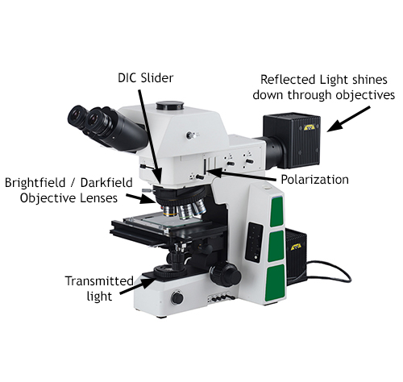

**Metallurgical Microscopes**

Metallurgical microscopes provide high magnification and resolution for samples that do not allow light to pass through them.

[Shop Metallurgical Microscopes](https://www.microscopeworld.com/c-448-metallurgical-microscopes.aspx)

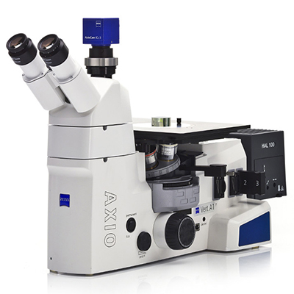

**Metallurgical microscopes** are sometimes referred to as materials microscopes and are available as an [upright metallurgical microscope](https://www.microscopeworld.com/c-449-upright-metallurgical-microscopes.aspx) (shown above), as an [inverted metallurgical microscope](https://www.microscopeworld.com/c-450-inverted-metallurgical-microscopes.aspx) (image at right), or on a [boom stand](https://www.microscopeworld.com/c-451-boom-stand-metallurgical-microscopes.aspx) for viewing extra large samples. Upright metallurgical microscopes are used to view samples that will fit on the microscope stage. An inverted metallurgical microscope would be used to view larger parts, as the objective lenses are located beneath the stage and allow for placing heavy mechanical parts directly on the stage above the objectives. A boom stand metallurgical microscope is used with a bit more working distance is required than what an upright metallurgical microscope provides.

Metallurgical microscopes may look similar to [compound biological microscopes](https://www.microscopeworld.com/c-455-lab-biological-microscopes.aspx), but they differ in a number of ways. Using a **metallurgical microscope** allows the user to view samples at high magnification (up to 500x and 1000x), without any light passing through the sample the way a biological sample is viewed. [Stereo microscopes](https://www.microscopeworld.com/c-429-stereo-microscopes.aspx) are another option when reflected illumination is required, however metallurgical microscopes provide a much higher resolution (and magnification) than a stereo microscope would provide.

**What are some Features of a Metallurgical Microscope?**

Metallurgical microscopes have several unique features that are not always found on a biological or stereo microscope:

* Polarization
* Differential Interference Contrast (DIC)
* High power magnification and high resolution with reflected light illumination
* Brightfield and Darkfield options
* Reflected (and sometimes also transmitted) illumination

Some of the types of samples you might look at with a metallurgical microscope include metal parts, fiberglass, industrial manufacturing failures in materials, carbon fiber, plastics and concrete.

Types of Metallurgical Microscopes

You will run into several types of metallurgical microscopes. The first variation will be with illumination - does the metallurgical microscope have reflected illumination only, or does it also have reflected and transmitted illumination? Will you need to view particles that do allow light to pass through them? If so you will probably want both reflected and transmitted illumination. The next variation will be in the types of objective lenses. Some metallurgical microscopes are created only for brightfield microscopy, while others also allow for darkfield microscopy. Think also about the types of samples you need to place on the microscope. Are they rather small in size and fit in the palm of your hand? If so, then an upright metallurigcal microscope will fit your needs. If you need to look at large car parts or another type of large sample, an inverted metallurgical microscope will work better for you. [Contact Microscope World with any questions](https://www.microscopeworld.com/contactus.aspx) regarding what type of **metallurgical microscope** is best for your application.

* [Microscope World on Facebook](http://www.facebook.com/MicroscopeWorld)

* [Microscope World on Twitter](http://twitter.com/microscopeworld)

* [Microscope World on Tumblr](http://microscope-world.tumblr.com/)

* [Microscope World on YouTube](http://www.youtube.com/channel/UCkE4ZEORGK02D-CIcgF15Wg?feature=watch)

* [Microscope World on Instagram](http://instagram.com/MicroscopeWorld)

* [Microscope World on Pinterest](https://www.pinterest.com/microscopeworld/)

* [Microscope World Blog](https://www.microscopeworld.com/s-516-blog.aspx)

[800.942.0528 (US Toll Free)](tel:8009420528) [1.760.438.0528 (International)](tel:17604380528)

[Microscope World](https://www.microscopeworld.com/)

[About Us](https://www.microscopeworld.com/t-about.aspx)

[Contracts & Certifications](https://www.microscopeworld.com/t-contracts_certifications.aspx)

[Contact Us](https://www.microscopeworld.com/contactus)

[Swift Microscope World](https://www.swift-microscopeworld.com/)

[Motic Microscope World](https://www.motic-microscope.com/)

Services

[Microscope Service](https://www.microscopeworld.com/t-Microscope_Service.aspx)

[Request a Quote](https://www.microscopeworld.com/t-requestquote.aspx)

[Microscope Digital Upgrade](https://www.microscopeworld.com/t-upgrade-to-digital.aspx)

Support

[My Account](https://www.microscopeworld.com/account.aspx)

[Resource Library](https://www.microscopeworld.com/t-resource-library.aspx)

[Shipping Information](https://www.microscopeworld.com/t-shipping.aspx)

[Return Policy](https://www.microscopeworld.com/t-returns.aspx)

[Privacy Policy](https://www.microscopeworld.com/t-privacy.aspx)

[](https://www.microscopeworld.com/t-green-business-network.aspx)

Copyright ©2022 Microscope World. All Rights Reserved. | 6122 Innovation Way, Carlsbad, CA 92009

[Need Asssistance? 800-942-0528](tel:%2018009420528)

[Microscope Blog](https://www.microscopeworld.com/s-516-blog.aspx)

[Resource Library](https://www.microscopeworld.com/t-resource-library.aspx)

* [Login](https://www.microscopeworld.com/signin.aspx?returnurl=%2Fc-448-metallurgical-microscopes.aspx)

[Request Quote](https://www.microscopeworld.com/t-requestquote.aspx)

[](https://www.microscopeworld.com/)

Top of Form

Bottom of Form

[0](https://www.microscopeworld.com/c-448-metallurgical-microscopes.aspx)

* [INDUSTRIAL](javascript:void(0);)
* [CLINICAL](javascript:void(0);)
* [PROFESSIONAL](javascript:void(0);)
* [STUDENT / HOBBYIST](javascript:void(0);)
* [RESEARCH](javascript:void(0);)
* [DIGITAL](javascript:void(0);)
* [ACCESSORIES](javascript:void(0);)
* [BRANDS](javascript:void(0);)

1. [Microscope World](https://www.microscopeworld.com/) /[Industrial](https://www.microscopeworld.com/c-290-industrial.aspx) / Metallurgical Microscopes

 Free Ground ShippingUS Continental Orders Over $200. Ground Shipping Only

Metallurgical Microscopes

4 Categories In List

[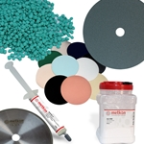](https://www.microscopeworld.com/c-637-metallurgical-sample-preparation.aspx)

[Metallurgical Sample Preparation](https://www.microscopeworld.com/c-637-metallurgical-sample-preparation.aspx)

[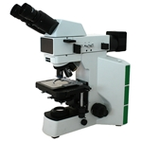](https://www.microscopeworld.com/c-449-upright-metallurgical-microscopes.aspx)

[Upright Metallurgical Microscopes](https://www.microscopeworld.com/c-449-upright-metallurgical-microscopes.aspx)

[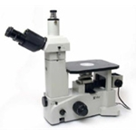](https://www.microscopeworld.com/c-450-inverted-metallurgical-microscopes.aspx)

[Inverted Metallurgical Microscopes](https://www.microscopeworld.com/c-450-inverted-metallurgical-microscopes.aspx)

[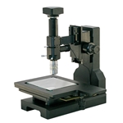](https://www.microscopeworld.com/c-451-long-working-distance-metallurgical-microscopes.aspx)

[Long Working Distance Metallurgical Microscopes](https://www.microscopeworld.com/c-451-long-working-distance-metallurgical-microscopes.aspx)

* [Microscope World on Facebook](http://www.facebook.com/MicroscopeWorld)

* [Microscope World on Twitter](http://twitter.com/microscopeworld)

* [Microscope World on Tumblr](http://microscope-world.tumblr.com/)

* [Microscope World on YouTube](http://www.youtube.com/channel/UCkE4ZEORGK02D-CIcgF15Wg?feature=watch)

* [Microscope World on Instagram](http://instagram.com/MicroscopeWorld)

* [Microscope World on Pinterest](https://www.pinterest.com/microscopeworld/)

* [Microscope World Blog](https://www.microscopeworld.com/s-516-blog.aspx)

[800.942.0528 (US Toll Free)](tel:8009420528) [1.760.438.0528 (International)](tel:17604380528)

[Microscope World](https://www.microscopeworld.com/)

[About Us](https://www.microscopeworld.com/t-about.aspx)

[Contracts & Certifications](https://www.microscopeworld.com/t-contracts_certifications.aspx)

[Contact Us](https://www.microscopeworld.com/contactus)

[Swift Microscope World](https://www.swift-microscopeworld.com/)

[Motic Microscope World](https://www.motic-microscope.com/)

Services

[Microscope Service](https://www.microscopeworld.com/t-Microscope_Service.aspx)

[Request a Quote](https://www.microscopeworld.com/t-requestquote.aspx)

[Microscope Digital Upgrade](https://www.microscopeworld.com/t-upgrade-to-digital.aspx)

Support

[My Account](https://www.microscopeworld.com/account.aspx)

[Resource Library](https://www.microscopeworld.com/t-resource-library.aspx)

[Shipping Information](https://www.microscopeworld.com/t-shipping.aspx)

[Return Policy](https://www.microscopeworld.com/t-returns.aspx)

[Privacy Policy](https://www.microscopeworld.com/t-privacy.aspx)

[](https://www.microscopeworld.com/t-green-business-network.aspx)

Copyright ©2022 Microscope World. All Rights Reserved. | 6122 Innovation Way, Carlsbad, CA 92009

[Need Asssistance? 800-942-0528](tel:%2018009420528)

[Microscope Blog](https://www.microscopeworld.com/s-516-blog.aspx)

[Resource Library](https://www.microscopeworld.com/t-resource-library.aspx)

* [Login](https://www.microscopeworld.com/signin.aspx?returnurl=%2Fc-451-long-working-distance-metallurgical-microscopes.aspx)

[Request Quote](https://www.microscopeworld.com/t-requestquote.aspx)

[](https://www.microscopeworld.com/)

Top of Form

Bottom of Form

[0](https://www.microscopeworld.com/c-451-long-working-distance-metallurgical-microscopes.aspx)

* [INDUSTRIAL](javascript:void(0);)
* [CLINICAL](javascript:void(0);)
* [PROFESSIONAL](javascript:void(0);)
* [STUDENT / HOBBYIST](javascript:void(0);)
* [RESEARCH](javascript:void(0);)
* [DIGITAL](javascript:void(0);)
* [ACCESSORIES](javascript:void(0);)
* [BRANDS](javascript:void(0);)

1. [Microscope World](https://www.microscopeworld.com/) /[Industrial](https://www.microscopeworld.com/c-290-industrial.aspx) / [Metallurgical Microscopes](https://www.microscopeworld.com/c-448-metallurgical-microscopes.aspx) / Long Working Distance Metallurgical Microscopes

 Free Ground ShippingUS Continental Orders Over $200. Ground Shipping Only

Long Working Distance Metallurgical Microscopes

Shop By

Clear refinements

[**CATEGORY**](https://www.microscopeworld.com/c-451-long-working-distance-metallurgical-microscopes.aspx#categories)

[**BRAND**](https://www.microscopeworld.com/c-451-long-working-distance-metallurgical-microscopes.aspx#brand)

[**PRICE RANGE**](https://www.microscopeworld.com/c-451-long-working-distance-metallurgical-microscopes.aspx#price)

[[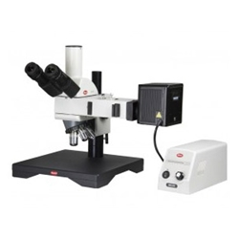](https://www.microscopeworld.com/p-1836-ba310met-h-metallurgical-reflected-light-large-work-surface-microscope.aspx)](https://www.microscopeworld.com/p-1836-ba310met-h-metallurgical-reflected-light-large-work-surface-microscope.aspx)

[BA310MET-H Metallurgical Reflected Light Large Work Surface Microscope](https://www.microscopeworld.com/p-1836-ba310met-h-metallurgical-reflected-light-large-work-surface-microscope.aspx)

**$4,650.00**

[[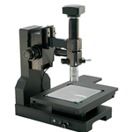](https://www.microscopeworld.com/p-4312-dhrm-metallurgical-microscope-system-1um-resolution-20-megapixels.aspx)](https://www.microscopeworld.com/p-4312-dhrm-metallurgical-microscope-system-1um-resolution-20-megapixels.aspx)

[DHRM Metallurgical Microscope System: 1um Resolution 20 Megapixels](https://www.microscopeworld.com/p-4312-dhrm-metallurgical-microscope-system-1um-resolution-20-megapixels.aspx)

**$10,408.00**

[[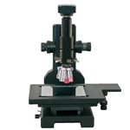](https://www.microscopeworld.com/p-4313-dhrm-metallurgical-microscope-system-sub-um-resolution-20-megapixels.aspx)](https://www.microscopeworld.com/p-4313-dhrm-metallurgical-microscope-system-sub-um-resolution-20-megapixels.aspx)

[DHRM Metallurgical Microscope System: sub um Resolution 20 Megapixels](https://www.microscopeworld.com/p-4313-dhrm-metallurgical-microscope-system-sub-um-resolution-20-megapixels.aspx)

**$15,885.00**

[[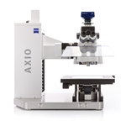](https://www.microscopeworld.com/p-3300-zeiss-axio-imager-vario-microscope.aspx)](https://www.microscopeworld.com/p-3300-zeiss-axio-imager-vario-microscope.aspx)

[ZEISS Axio Imager Vario Microscope](https://www.microscopeworld.com/p-3300-zeiss-axio-imager-vario-microscope.aspx)

[[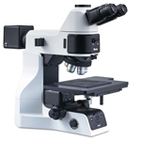](https://www.microscopeworld.com/p-1563-motic-pa53met-metallurgical-microscope-with-lwd-objectives.aspx)](https://www.microscopeworld.com/p-1563-motic-pa53met-metallurgical-microscope-with-lwd-objectives.aspx)

[Motic PA53MET Metallurgical Microscope with LWD Objectives](https://www.microscopeworld.com/p-1563-motic-pa53met-metallurgical-microscope-with-lwd-objectives.aspx)

**$19,509.00**

[[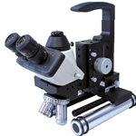](https://www.microscopeworld.com/p-942-mp20-portable-metallurgical-microscope.aspx)](https://www.microscopeworld.com/p-942-mp20-portable-metallurgical-microscope.aspx)

[MP20 Portable Metallurgical Microscope](https://www.microscopeworld.com/p-942-mp20-portable-metallurgical-microscope.aspx)

6 results found in 4ms

Results per page



 Same Day Response

**REQUEST A QUOTE**

[**Submit Request**](https://www.microscopeworld.com/t-requestquote.aspx)

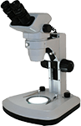

**HOLIDAY GIFT GUIDE**

[**Shop Now**](https://www.microscopeworld.com/t-gift_ideas.aspx)

* [Microscope World on Facebook](http://www.facebook.com/MicroscopeWorld)

* [Microscope World on Twitter](http://twitter.com/microscopeworld)

* [Microscope World on Tumblr](http://microscope-world.tumblr.com/)

* [Microscope World on YouTube](http://www.youtube.com/channel/UCkE4ZEORGK02D-CIcgF15Wg?feature=watch)

* [Microscope World on Instagram](http://instagram.com/MicroscopeWorld)

* [Microscope World on Pinterest](https://www.pinterest.com/microscopeworld/)

* [Microscope World Blog](https://www.microscopeworld.com/s-516-blog.aspx)

[800.942.0528 (US Toll Free)](tel:8009420528) [1.760.438.0528 (International)](tel:17604380528)

[Microscope World](https://www.microscopeworld.com/)

[About Us](https://www.microscopeworld.com/t-about.aspx)

[Contracts & Certifications](https://www.microscopeworld.com/t-contracts_certifications.aspx)

[Contact Us](https://www.microscopeworld.com/contactus)

[Swift Microscope World](https://www.swift-microscopeworld.com/)

[Motic Microscope World](https://www.motic-microscope.com/)

Services

[Microscope Service](https://www.microscopeworld.com/t-Microscope_Service.aspx)

[Request a Quote](https://www.microscopeworld.com/t-requestquote.aspx)

[Microscope Digital Upgrade](https://www.microscopeworld.com/t-upgrade-to-digital.aspx)

Support

[My Account](https://www.microscopeworld.com/account.aspx)

[Resource Library](https://www.microscopeworld.com/t-resource-library.aspx)

[Shipping Information](https://www.microscopeworld.com/t-shipping.aspx)

[Return Policy](https://www.microscopeworld.com/t-returns.aspx)

[Privacy Policy](https://www.microscopeworld.com/t-privacy.aspx)

[](https://www.microscopeworld.com/t-green-business-network.aspx)

Copyright ©2022 Microscope World. All Rights Reserved. | 6122 Innovation Way, Carlsbad, CA 92009

[Need Asssistance? 800-942-0528](tel:%2018009420528)

[Microscope Blog](https://www.microscopeworld.com/s-516-blog.aspx)

[Resource Library](https://www.microscopeworld.com/t-resource-library.aspx)

* [Login](https://www.microscopeworld.com/signin.aspx?returnurl=%2Fp-1563-motic-pa53met-metallurgical-microscope-with-lwd-objectives.aspx)

[Request Quote](https://www.microscopeworld.com/t-requestquote.aspx)

[](https://www.microscopeworld.com/)

Top of Form

Bottom of Form

[0](https://www.microscopeworld.com/p-1563-motic-pa53met-metallurgical-microscope-with-lwd-objectives.aspx)

* [INDUSTRIAL](javascript:void(0);)
* [CLINICAL](javascript:void(0);)
* [PROFESSIONAL](javascript:void(0);)
* [STUDENT / HOBBYIST](javascript:void(0);)
* [RESEARCH](javascript:void(0);)
* [DIGITAL](javascript:void(0);)
* [ACCESSORIES](javascript:void(0);)
* [BRANDS](javascript:void(0);)

1. [Microscope World](https://www.microscopeworld.com/) /[Industrial](https://www.microscopeworld.com/c-290-industrial.aspx) / [Metallurgical Microscopes](https://www.microscopeworld.com/c-448-metallurgical-microscopes.aspx) / [Upright Metallurgical Microscopes](https://www.microscopeworld.com/c-449-upright-metallurgical-microscopes.aspx) / Motic PA53MET Metallurgical Microscope with LWD Objectives

 Free Ground ShippingUS Continental Orders Over $200. Ground Shipping Only

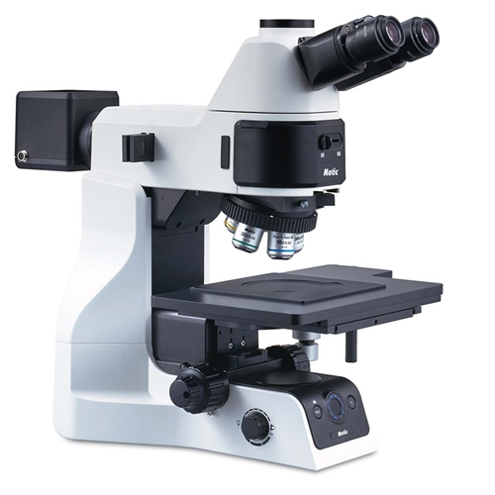

View Larger Image

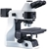

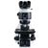



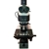

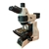

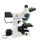

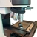

**Motic PA53MET Metallurgical Microscope with LWD Objectives**

SKU: 1100.1046.00881-LWD

Price: $19,509.00

Top of Form

 Add to Cart

Bottom of Form

[Request Quote](https://www.microscopeworld.com/t-requestquote.aspx)

Motic PA53MET Metallurgical Microscope with LWD Objectives

The Motic PA53 MET microscope is designed for metallurgical applications. This microscope has Mitutoyo M Plan Apo Long working distance (LWD) Objective lenses.  NOTE: Please [contact us](mailto:info@microscopeworld.com?subject=PA53MET%20Regional%20Availability%3F) for regional availability.

* **Objective Lenses:**  
  Scalable Infinity-Corrected Optical System (CCIS) brightfield metallurgical objectives:
  + Mitutoyo Plan M-APO 5x/0.14, WD = 34.0mm
  + Mitutoyo Plan M-APO 10x/0.28, WD = 34.0mm
  + Mitutoyo Plan M-APO 20x/0.42, WD = 20.0mm
  + Mitutoyo Plan M-APO 50x/0.55, WD = 13.0mm
  + Spacers (PA53MS50M), quantity 4, are included.
* **Viewing Head:**Erect type (F.N 25) Trinocular head 20º inclined, Light path to eyepieces/camera either 100:0 or 0:100
* **Eyepieces:** 10x eyepieces/ 25mm, accepts 25mm diameter [reticle](https://www.microscopeworld.com/c-243-reticles-and-stage-micrometers.aspx). Adjustable diopters.
* **Total Magnification:**50x, 100x, 200x, 500x.
* **Specimen Stage:** 4x4 inch stage, with 210 (W)x 170(D) mm specimen size, stroke 104(X) x 102(Y) mm, with a metal plate.
* **Focusing:**Manual coarse and fine focusing. Coarse: 17.7 mm/ revolution, Fine: 0.1 mm/revolution (1 µm scale)
* **Illumination:**Reflected: Koehler illumination system Brightfield / Darkfield, Normanski DIC, simple polarized. Light source: 12V, 100W Halogen bulb.
* **Stand Features:**Five-position nosepiece with DIC slot.
* **Size & Weight:** 9.7" W x 22.5" H x 20.2" D, 42 lb.
* **Warranty:**  5 years on microscope parts. 1 year warranty on electrical, electronic components, and digital cameras.

[View the Motic PA53MET Product Brochure.](https://www.microscopeworld.com/images/Brochures/Motic_PA53MET_Microscope_Brochure.pdf)

**Combine Your Purchase With**

6 Total Upsell Products

Combine Your Purchase With

[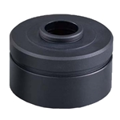](https://www.microscopeworld.com/p-1722-motic-pa53-c-mount-camera-adapter.aspx)

[Motic PA53 C-Mount Camera Adapter](https://www.microscopeworld.com/p-1722-motic-pa53-c-mount-camera-adapter.aspx)

$473.00

[Details](https://www.microscopeworld.com/p-1722-motic-pa53-c-mount-camera-adapter.aspx)

[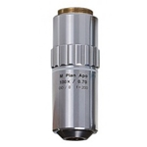](https://www.microscopeworld.com/p-2195-mitutoyo-m-plan-apo-100x-objective.aspx)

[Mitutoyo M Plan Apo 100x Objective](https://www.microscopeworld.com/p-2195-mitutoyo-m-plan-apo-100x-objective.aspx)

$3,850.00

Top of Form

Add to Cart

Bottom of Form

[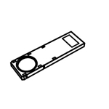](https://www.microscopeworld.com/p-1723-motic-pa53met-analyzer-filter.aspx)

[Motic PA53MET Analyzer Filter](https://www.microscopeworld.com/p-1723-motic-pa53met-analyzer-filter.aspx)

$814.00

Top of Form

Add to Cart

Bottom of Form

[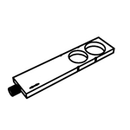](https://www.microscopeworld.com/p-1727-motic-pa53met-metallurgical-microscope-polarizer.aspx)

[Motic PA53MET Metallurgical Microscope Polarizer](https://www.microscopeworld.com/p-1727-motic-pa53met-metallurgical-microscope-polarizer.aspx)

$583.00

Top of Form

Add to Cart

Bottom of Form

[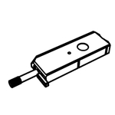](https://www.microscopeworld.com/p-1728-motic-pa53-metallurgical-microscope-dic-slider.aspx)

[Motic PA53 Metallurgical Microscope DIC Slider](https://www.microscopeworld.com/p-1728-motic-pa53-metallurgical-microscope-dic-slider.aspx)

$3,319.00

Top of Form

Add to Cart

Bottom of Form

[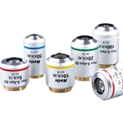](https://www.microscopeworld.com/p-1729-motic-plan-s-apo-bd-100x-microscope-objective-lens.aspx)

[Motic Plan S-APO BD 100x Microscope Objective Lens](https://www.microscopeworld.com/p-1729-motic-plan-s-apo-bd-100x-microscope-objective-lens.aspx)

$1,822.00

Top of Form

Add to Cart

Bottom of Form

* [Microscope World on Facebook](http://www.facebook.com/MicroscopeWorld)

* [Microscope World on Twitter](http://twitter.com/microscopeworld)

* [Microscope World on Tumblr](http://microscope-world.tumblr.com/)

* [Microscope World on YouTube](http://www.youtube.com/channel/UCkE4ZEORGK02D-CIcgF15Wg?feature=watch)

* [Microscope World on Instagram](http://instagram.com/MicroscopeWorld)

* [Microscope World on Pinterest](https://www.pinterest.com/microscopeworld/)

* [Microscope World Blog](https://www.microscopeworld.com/s-516-blog.aspx)

[800.942.0528 (US Toll Free)](tel:8009420528) [1.760.438.0528 (International)](tel:17604380528)

[Microscope World](https://www.microscopeworld.com/)

[About Us](https://www.microscopeworld.com/t-about.aspx)

[Contracts & Certifications](https://www.microscopeworld.com/t-contracts_certifications.aspx)

[Contact Us](https://www.microscopeworld.com/contactus)

[Swift Microscope World](https://www.swift-microscopeworld.com/)

[Motic Microscope World](https://www.motic-microscope.com/)

Services

[Microscope Service](https://www.microscopeworld.com/t-Microscope_Service.aspx)

[Request a Quote](https://www.microscopeworld.com/t-requestquote.aspx)

[Microscope Digital Upgrade](https://www.microscopeworld.com/t-upgrade-to-digital.aspx)

Support

[My Account](https://www.microscopeworld.com/account.aspx)

[Resource Library](https://www.microscopeworld.com/t-resource-library.aspx)

[Shipping Information](https://www.microscopeworld.com/t-shipping.aspx)

[Return Policy](https://www.microscopeworld.com/t-returns.aspx)

[Privacy Policy](https://www.microscopeworld.com/t-privacy.aspx)

[](https://www.microscopeworld.com/t-green-business-network.aspx)

Copyright ©2022 Microscope World. All Rights Reserved. | 6122 Innovation Way, Carlsbad, CA 92009

[Need Asssistance? 800-942-0528](tel:%2018009420528)

[Microscope Blog](https://www.microscopeworld.com/s-516-blog.aspx)

[Resource Library](https://www.microscopeworld.com/t-resource-library.aspx)

* [Login](https://www.microscopeworld.com/signin.aspx?returnurl=%2Fp-4313-dhrm-metallurgical-microscope-system-sub-um-resolution-20-megapixels.aspx)

[Request Quote](https://www.microscopeworld.com/t-requestquote.aspx)

[](https://www.microscopeworld.com/)

Top of Form

Bottom of Form

[0](https://www.microscopeworld.com/p-4313-dhrm-metallurgical-microscope-system-sub-um-resolution-20-megapixels.aspx)

* [INDUSTRIAL](javascript:void(0);)
* [CLINICAL](javascript:void(0);)
* [PROFESSIONAL](javascript:void(0);)
* [STUDENT / HOBBYIST](javascript:void(0);)
* [RESEARCH](javascript:void(0);)
* [DIGITAL](javascript:void(0);)
* [ACCESSORIES](javascript:void(0);)
* [BRANDS](javascript:void(0);)

1. [Microscope World](https://www.microscopeworld.com/) /[Industrial](https://www.microscopeworld.com/c-290-industrial.aspx) / [Metallurgical Microscopes](https://www.microscopeworld.com/c-448-metallurgical-microscopes.aspx) / [Long Working Distance Metallurgical Microscopes](https://www.microscopeworld.com/c-451-long-working-distance-metallurgical-microscopes.aspx) / DHRM Metallurgical Microscope System: sub um Resolution 20 Megapixels

 Free Ground ShippingUS Continental Orders Over $200. Ground Shipping Only

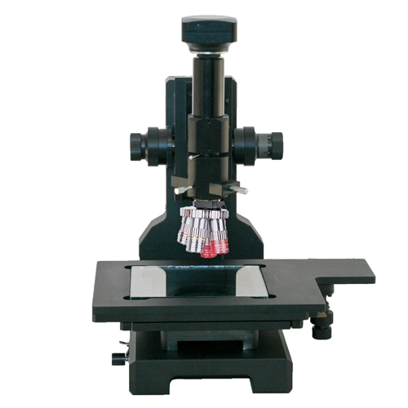

View Larger Image

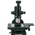

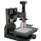

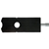

**DHRM Metallurgical Microscope System: sub um Resolution 20 Megapixels**

SKU: DHRM-MET-Sub

Price: $15,885.00

Top of Form



 Add to Cart

Bottom of Form

[Request Quote](https://www.microscopeworld.com/t-requestquote.aspx)

Digital High Resolution Metallurgical Microscope System: sub um, 20mp

The DHRM metallurgical microscope system offers longer working distance and provides sub 1µm resolution. It features a built in rotating polarizer and an insertable DIC slider for polarized and DIC observation methods.

* **Lens System:**Long working distance lens with built in 1x C-mount adapter.
* **Objective Lenses with quad turret:**
  + Plan Apo ELWD 5x objective, NA 0.14, WD 24mm, FOV 1.92mm x 2.56mm
  + Plan Apo ELWD 10x objective, NA 0.25, WD 33.5mm, FOV 0.96mm x 1.28mm
  + Plan Apo ELWD 20x objective, NA 0.64, WD 20mm, FOV 0.48mm x 0.64mm
  + Plan Apo ELWD 50x objective, NA 0.55, WD 13mm, FOV 0.19mm x 0.26mm
* **Camera Mount:**Includes c-mount adapter to mount camera directly to the optical tube.
* **Resolution:**
  + Plan Apo ELWD 5x objective = 2.0µm
  + Plan Apo ELWD 10x objective = 1.0µm
  + Plan Apo ELWD 20x objective = 0.7µm
  + Plan Apo ELWD 50x objective = 0.5µm
* **Magnification:**If using a 22" monitor,170x, 350x, 700x, 1,750x. Magnification will vary depending on monitor size.
* **Stage:** Double layer mechanical stage 220 x 260 mm with an inset glass stage measuring 170 x 150mm. Coaxial adjustment movement range of 150 (X)  x 75mm (Y).
* **Focusing:**Coaxial coarse and fine focus with rack and pinion. Coarse adjustment distance of 60mm, precision fine adjustment of 0.002mm with rack stop.
* **Illumination:**Reflected and transmitted high intensity LED light with intensity controls.
* **Polarizer:**Built in 100º rotatable polarizer for orthogonal observation.
* **DIC:**Included DIC slider inserts into the empty DIC slot on the body of the microscope.
* **Digital Camera:** Includes 20 megapixel back-illuminated Exmor sensor USB3 high sensitivity, low noise camera. Capture images up to 5440 x 3648.  System includes c-mount connection.
* **Software:** Includes software for image capture, documentation, measurement, and extended depth of focus. Windows 7, 8, 10.
* **Software Calibration:** If you plan to make measurements using the software you will need to calibrate the microscope and you will want to order the system with detent. Calibrating your software with the microscope requires use of a stage micrometer. When ordering please select this option if you do not already have a stage micrometer. The stage micrometer included is a dual ruler with 1" equally spaced and numbered 0-10 as well as 25mm equally spaced and numbered 0-25. If NIST certification is selected 10 points on each scale will be certified. Please note that NIST certification takes approximately 2 weeks.
* **Warranty:**3 year warranty on microscope, 1 year camera and software.
* [Microscope World on Facebook](http://www.facebook.com/MicroscopeWorld)

* [Microscope World on Twitter](http://twitter.com/microscopeworld)

* [Microscope World on Tumblr](http://microscope-world.tumblr.com/)

* [Microscope World on YouTube](http://www.youtube.com/channel/UCkE4ZEORGK02D-CIcgF15Wg?feature=watch)

* [Microscope World on Instagram](http://instagram.com/MicroscopeWorld)

* [Microscope World on Pinterest](https://www.pinterest.com/microscopeworld/)

* [Microscope World Blog](https://www.microscopeworld.com/s-516-blog.aspx)

[800.942.0528 (US Toll Free)](tel:8009420528) [1.760.438.0528 (International)](tel:17604380528)

[Microscope World](https://www.microscopeworld.com/)

[About Us](https://www.microscopeworld.com/t-about.aspx)

[Contracts & Certifications](https://www.microscopeworld.com/t-contracts_certifications.aspx)

[Contact Us](https://www.microscopeworld.com/contactus)

[Swift Microscope World](https://www.swift-microscopeworld.com/)

[Motic Microscope World](https://www.motic-microscope.com/)

Services

[Microscope Service](https://www.microscopeworld.com/t-Microscope_Service.aspx)

[Request a Quote](https://www.microscopeworld.com/t-requestquote.aspx)

[Microscope Digital Upgrade](https://www.microscopeworld.com/t-upgrade-to-digital.aspx)

Support

[My Account](https://www.microscopeworld.com/account.aspx)

[Resource Library](https://www.microscopeworld.com/t-resource-library.aspx)

[Shipping Information](https://www.microscopeworld.com/t-shipping.aspx)

[Return Policy](https://www.microscopeworld.com/t-returns.aspx)

[Privacy Policy](https://www.microscopeworld.com/t-privacy.aspx)

[](https://www.microscopeworld.com/t-green-business-network.aspx)

Copyright ©2022 Microscope World. All Rights Reserved. | 6122 Innovation Way, Carlsbad, CA 92009

[Need Asssistance? 800-942-0528](tel:%2018009420528)

[Microscope Blog](https://www.microscopeworld.com/s-516-blog.aspx)

[Resource Library](https://www.microscopeworld.com/t-resource-library.aspx)

* [Login](https://www.microscopeworld.com/signin.aspx?returnurl=%2Fp-4312-dhrm-metallurgical-microscope-system-1um-resolution-20-megapixels.aspx)

[Request Quote](https://www.microscopeworld.com/t-requestquote.aspx)

[](https://www.microscopeworld.com/)

Top of Form

Bottom of Form

[0](https://www.microscopeworld.com/p-4312-dhrm-metallurgical-microscope-system-1um-resolution-20-megapixels.aspx)

* [INDUSTRIAL](javascript:void(0);)
* [CLINICAL](javascript:void(0);)
* [PROFESSIONAL](javascript:void(0);)
* [STUDENT / HOBBYIST](javascript:void(0);)
* [RESEARCH](javascript:void(0);)
* [DIGITAL](javascript:void(0);)
* [ACCESSORIES](javascript:void(0);)
* [BRANDS](javascript:void(0);)

1. [Microscope World](https://www.microscopeworld.com/) /[Industrial](https://www.microscopeworld.com/c-290-industrial.aspx) / [Metallurgical Microscopes](https://www.microscopeworld.com/c-448-metallurgical-microscopes.aspx) / [Long Working Distance Metallurgical Microscopes](https://www.microscopeworld.com/c-451-long-working-distance-metallurgical-microscopes.aspx) / DHRM Metallurgical Microscope System: 1um Resolution 20 Megapixels

 Free Ground ShippingUS Continental Orders Over $200. Ground Shipping Only

**DHRM Metallurgical Microscope System: 1um Resolution 20 Megapixels**

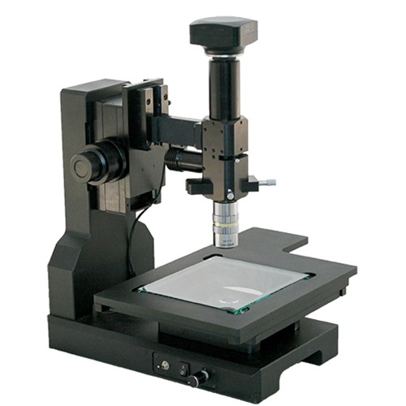

View Larger Image

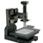

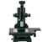

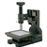

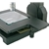

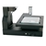



Options:   

SKU:  DHRM-MET-10x

Price: $10,408.00

Top of Form

 Add to Cart

Bottom of Form

[Request Quote](https://www.microscopeworld.com/t-requestquote.aspx)

The DHRM metallurgical microscope system offers longer working distance and provides resolution down to 1µm. It features a built in rotating polarizer and an insertable DIC slider for polarized and DIC observation methods.

* **Lens System:**Long working distance lens with built in 1x C-mount adapter.
* **Objective Lens:** Plan Apo 10x objective, NA 0.25, WD 33.5, resolution 1µm.
* **Camera Mount:**Includes c-mount adapter to mount camera directly to the optical tube.
* **Resolution:**1µm
* **Field of view:**0.96mm x 1.28mm
* **Magnification:**If using a 22" monitor, 350x. Magnification will vary depending on monitor size.
* **Stage:** Double layer mechanical stage 220 x 260 mm with an inset glass stage measuring 170 x 150mm. Coaxial adjustment movement range of 150 (X)  x 75mm (Y).
* **Focusing:**Coaxial coarse and fine focus with rack and pinion. Coarse adjustment distance of 60mm, precision fine adjustment of 0.002mm with rack stop.
* **Illumination:**Reflected and transmitted high intensity LED light with intensity controls.
* **Polarizer:**Built in 100º rotatable polarizer for orthogonal observation.
* **DIC:**Included DIC slider inserts into the empty DIC slot on the body of the microscope.
* **Working Distance:** 33.5mm
* **Digital Camera:** Includes 20 megapixel back-illuminated Exmor sensor USB3 high sensitivity, low noise camera. Capture images up to 5440 x 3648.  System includes c-mount connection.
* **Software:** Includes software for image capture, documentation, measurement, and extended depth of focus. Windows 7, 8, 10.
* **Software Calibration:** If you plan to make measurements using the software you will need to calibrate the microscope and you will want to order the system with detent. Calibrating your software with the microscope requires use of a stage micrometer. When ordering please select this option if you do not already have a stage micrometer. The stage micrometer included is a dual ruler with 1" equally spaced and numbered 0-10 as well as 25mm equally spaced and numbered 0-25. If NIST certification is selected 10 points on each scale will be certified. Please note that NIST certification takes approximately 2 weeks.
* **Warranty:**3 year warranty on microscope, 1 year on camera and software.
* [Microscope World on Facebook](http://www.facebook.com/MicroscopeWorld)

* [Microscope World on Twitter](http://twitter.com/microscopeworld)

* [Microscope World on Tumblr](http://microscope-world.tumblr.com/)

* [Microscope World on YouTube](http://www.youtube.com/channel/UCkE4ZEORGK02D-CIcgF15Wg?feature=watch)

* [Microscope World on Instagram](http://instagram.com/MicroscopeWorld)

* [Microscope World on Pinterest](https://www.pinterest.com/microscopeworld/)

* [Microscope World Blog](https://www.microscopeworld.com/s-516-blog.aspx)

[800.942.0528 (US Toll Free)](tel:8009420528) [1.760.438.0528 (International)](tel:17604380528)

[Microscope World](https://www.microscopeworld.com/)

[About Us](https://www.microscopeworld.com/t-about.aspx)

[Contracts & Certifications](https://www.microscopeworld.com/t-contracts_certifications.aspx)

[Contact Us](https://www.microscopeworld.com/contactus)

[Swift Microscope World](https://www.swift-microscopeworld.com/)

[Motic Microscope World](https://www.motic-microscope.com/)

Services

[Microscope Service](https://www.microscopeworld.com/t-Microscope_Service.aspx)

[Request a Quote](https://www.microscopeworld.com/t-requestquote.aspx)

[Microscope Digital Upgrade](https://www.microscopeworld.com/t-upgrade-to-digital.aspx)

Support

[My Account](https://www.microscopeworld.com/account.aspx)

[Resource Library](https://www.microscopeworld.com/t-resource-library.aspx)

[Shipping Information](https://www.microscopeworld.com/t-shipping.aspx)

[Return Policy](https://www.microscopeworld.com/t-returns.aspx)

[Privacy Policy](https://www.microscopeworld.com/t-privacy.aspx)

[](https://www.microscopeworld.com/t-green-business-network.aspx)

Copyright ©2022 Microscope World. All Rights Reserved. | 6122 Innovation Way, Carlsbad, CA 92009

EXHIBIT WITH US

USD - $

English

Top of Form



Bottom of Form

* [**PRODUCTS**](https://www.directindustry.com/)
* [**CATALOGS**](https://pdf.directindustry.com/)
* [**RFQ**](https://www.directindustry.com/rfq/form.html)
* [**NEWS & TRENDS**](https://trends.directindustry.com/)
* E-MAGAZINE





**YOUR REQUEST  
HAS BEEN SENT**



OPTICAL MICROSCOPE

DM750 M

LEICA MICROSYSTEMS

 Germany

★★★★★★(11 ratings)

The seller will reply to **samagbob@gmail.com**.  
Go to [My account](javascript:void(0);).

Back to start

Need help? Take a look at our [FAQ](https://virtual-expo.force.com/Visitors/s/?language=en_US).

Top of Form

**Do you need to compare quotes quickly?**

**New: Get Up to 4 Personalized Quotes**

**Click on a product to add it to your selection**

[[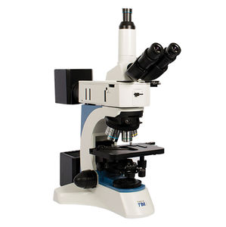](https://www.directindustry.com/prod/vision-engineering-ltd/product-5580-1575111.html)](https://www.directindustry.com/prod/vision-engineering-ltd/product-5580-1575111.html)

[](https://www.directindustry.com/prod/vision-engineering-ltd/product-5580-1575111.html)

[METALLURGICAL MICROSCOPETIM5](https://www.directindustry.com/prod/vision-engineering-ltd/product-5580-1575111.html)

[opticalinspectionfor materials inspection](https://www.directindustry.com/prod/vision-engineering-ltd/product-5580-1575111.html)

**[Sold by:](https://www.directindustry.com/prod/vision-engineering-ltd/product-5580-1575111.html)**

[Vision Engineering Ltd.](https://www.directindustry.com/prod/vision-engineering-ltd/product-5580-1575111.html)

[United Kingdom](https://www.directindustry.com/prod/vision-engineering-ltd/product-5580-1575111.html)

[★★★★★(2 ratings)](https://www.directindustry.com/prod/vision-engineering-ltd/product-5580-1575111.html)

**[4 days](https://www.directindustry.com/prod/vision-engineering-ltd/product-5580-1575111.html)**

[See product](https://www.directindustry.com/prod/vision-engineering-ltd/product-5580-1575111.html)

[[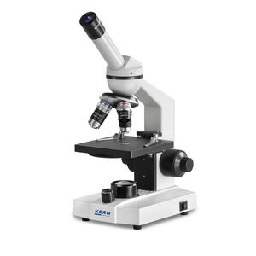](https://www.directindustry.com/prod/kern-sohn/product-16909-1899745.html)](https://www.directindustry.com/prod/kern-sohn/product-16909-1899745.html)

[](https://www.directindustry.com/prod/kern-sohn/product-16909-1899745.html)

[OPTICAL MICROSCOPEOBS-1](https://www.directindustry.com/prod/kern-sohn/product-16909-1899745.html)

[educationaluprightLED illumination](https://www.directindustry.com/prod/kern-sohn/product-16909-1899745.html)

**[Sold by:](https://www.directindustry.com/prod/kern-sohn/product-16909-1899745.html)**

[KERN & SOHN](https://www.directindustry.com/prod/kern-sohn/product-16909-1899745.html)

[Nigeria](https://www.directindustry.com/prod/kern-sohn/product-16909-1899745.html)

[See product](https://www.directindustry.com/prod/kern-sohn/product-16909-1899745.html)

[[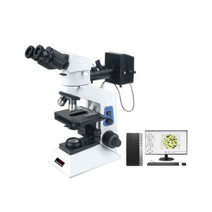](https://www.directindustry.com/prod/shanghai-hualong-test-instruments-corporation/product-38790-2521608.html)](https://www.directindustry.com/prod/shanghai-hualong-test-instruments-corporation/product-38790-2521608.html)

[](https://www.directindustry.com/prod/shanghai-hualong-test-instruments-corporation/product-38790-2521608.html)

[METALLOGRAPHIC MICROSCOPEHL401W](https://www.directindustry.com/prod/shanghai-hualong-test-instruments-corporation/product-38790-2521608.html)

[measuringinspectionlaboratory](https://www.directindustry.com/prod/shanghai-hualong-test-instruments-corporation/product-38790-2521608.html)

**[Sold by:](https://www.directindustry.com/prod/shanghai-hualong-test-instruments-corporation/product-38790-2521608.html)**

[Corfeam Beam Ventures,](https://www.directindustry.com/prod/shanghai-hualong-test-instruments-corporation/product-38790-2521608.html)

[Ibadan, Nigeria](https://www.directindustry.com/prod/shanghai-hualong-test-instruments-corporation/product-38790-2521608.html)

[See product](https://www.directindustry.com/prod/shanghai-hualong-test-instruments-corporation/product-38790-2521608.html)

[[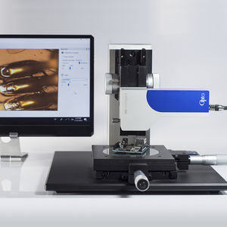](https://www.directindustry.com/prod/opto/product-69166-2099597.html)](https://www.directindustry.com/prod/opto/product-69166-2099597.html)

[](https://www.directindustry.com/prod/opto/product-69166-2099597.html)

[OPTO-DIGITAL MICROSCOPEMVM](https://www.directindustry.com/prod/opto/product-69166-2099597.html)

[for analysisinspectionmeasuring](https://www.directindustry.com/prod/opto/product-69166-2099597.html)

**[Sold by:](https://www.directindustry.com/prod/opto/product-69166-2099597.html)**

[OPTO](https://www.directindustry.com/prod/opto/product-69166-2099597.html)

[Germany](https://www.directindustry.com/prod/opto/product-69166-2099597.html)

[★★★★★(4 ratings)](https://www.directindustry.com/prod/opto/product-69166-2099597.html)

**[24 hrs](https://www.directindustry.com/prod/opto/product-69166-2099597.html)**

[See product](https://www.directindustry.com/prod/opto/product-69166-2099597.html)

Describe your project



Quantity



Budget





EUR - €

Decision deadline



Please select at least 1 product

Bottom of Form

HOW TO SOURCE PRODUCTS

EXHIBIT WITH US

FAQ

* [Brand list](https://www.directindustry.com/soc-A.html)
* Manufacturer account
* Buyer account
* Our services
* Newsletter subscription
* About VirtualExpo Group

© 2023  All rights reserved - Terms - Privacy policy - General Terms - Manage cookies - [Distributor list -](https://dealers.directindustry.com/A.html) 鄂ICP备16017613号-2



X-ray Crystallography equipment

Skip to main content[Accessibility help](https://support.google.com/websearch/answer/181196?hl=en)

Top of Form



Bottom of Form

[](https://accounts.google.com/SignOutOptions?hl=en&continue=https://www.google.com/search%3Fq%3Dcussons%2BX-ray%2BCrystallography%2Bequipment%26tbm%3Disch%26chips%3Dq:cussons%2Bx%2Bray%2Bcrystallography%2Bequipment,online_chips:engineering:R8aXRyWS8ao%253D%26rlz%3D1C1CHBF_enNG955NG955%26hl%3Den%26sa%3DX%26ved%3D2ahUKEwjfyNnc7cH8AhVlUqQEHT1OAxAQ4lYoA3oECAEQKw%26biw%3D1098%26bih%3D591%26sfr%3Dvfe)

**Search Modes**

[All](https://www.google.com/search?q=cussons+X-ray+Crystallography+equipment&source=lmns&bih=591&biw=1098&rlz=1C1CHBF_enNG955NG955&hl=en&sa=X&ved=2ahUKEwj0vNLl7cH8AhXVWaQEHTPNDAwQ_AUoAHoECAEQAA)Images[Videos](https://www.google.com/search?q=cussons+X-ray+Crystallography+equipment&source=lmns&tbm=vid&bih=591&biw=1098&rlz=1C1CHBF_enNG955NG955&hl=en&sa=X&ved=2ahUKEwj0vNLl7cH8AhXVWaQEHTPNDAwQ_AUoAnoECAEQAg)[News](https://www.google.com/search?q=cussons+X-ray+Crystallography+equipment&source=lmns&tbm=nws&bih=591&biw=1098&rlz=1C1CHBF_enNG955NG955&hl=en&sa=X&ved=2ahUKEwj0vNLl7cH8AhXVWaQEHTPNDAwQ_AUoA3oECAEQAw)[Books](https://www.google.com/search?q=cussons+X-ray+Crystallography+equipment&source=lmns&tbm=bks&bih=591&biw=1098&rlz=1C1CHBF_enNG955NG955&hl=en&sa=X&ved=2ahUKEwj0vNLl7cH8AhXVWaQEHTPNDAwQ_AUoBHoECAEQBA)

More

Tools

[Collections](https://www.google.com/save?&bih=591&biw=1098&rlz=1C1CHBF_enNG955NG955&hl=en&sa=X&ved=2ahUKEwj0vNLl7cH8AhXVWaQEHTPNDAwQ7XV6BAgBEBw)

[SafeSearch](https://www.google.com/preferences)

**Refinements**

[engineering](https://www.google.com/search?q=cussons+X-ray+Crystallography+equipment&tbm=isch&hl=en&bih=591&biw=1098&rlz=1C1CHBF_enNG955NG955&sa=X&ved=2ahUKEwj0vNLl7cH8AhXVWaQEHTPNDAwQ3VYoAHoECAEQJQ)

[xrd](https://www.google.com/search?q=cussons+X-ray+Crystallography+equipment&tbm=isch&hl=en&chips=q:cussons+x+ray+crystallography+equipment,online_chips:engineering:R8aXRyWS8ao%3D,online_chips:xrd:KalHePqfDSA%3D&bih=591&biw=1098&rlz=1C1CHBF_enNG955NG955&sa=X&ved=2ahUKEwj0vNLl7cH8AhXVWaQEHTPNDAwQ4lYoAHoECAEQKA)

[powder xrd](https://www.google.com/search?q=cussons+X-ray+Crystallography+equipment&tbm=isch&hl=en&chips=q:cussons+x+ray+crystallography+equipment,online_chips:engineering:R8aXRyWS8ao%3D,online_chips:powder+xrd:3WkVA7a1APo%3D&bih=591&biw=1098&rlz=1C1CHBF_enNG955NG955&sa=X&ved=2ahUKEwj0vNLl7cH8AhXVWaQEHTPNDAwQ4lYoAXoECAEQKg)

[chemical](https://www.google.com/search?q=cussons+X-ray+Crystallography+equipment&tbm=isch&hl=en&chips=q:cussons+x+ray+crystallography+equipment,online_chips:engineering:R8aXRyWS8ao%3D,online_chips:chemical:_0Ytaqn3YEY%3D&bih=591&biw=1098&rlz=1C1CHBF_enNG955NG955&sa=X&ved=2ahUKEwj0vNLl7cH8AhXVWaQEHTPNDAwQ4lYoAnoECAEQLA)

[tecquipment](https://www.google.com/search?q=cussons+X-ray+Crystallography+equipment&tbm=isch&hl=en&chips=q:cussons+x+ray+crystallography+equipment,online_chips:engineering:R8aXRyWS8ao%3D,online_chips:tecquipment:R8aXRyWS8ao%3D&bih=591&biw=1098&rlz=1C1CHBF_enNG955NG955&sa=X&ved=2ahUKEwj0vNLl7cH8AhXVWaQEHTPNDAwQ4lYoA3oECAEQLg)

[chemical analysis](https://www.google.com/search?q=cussons+X-ray+Crystallography+equipment&tbm=isch&hl=en&chips=q:cussons+x+ray+crystallography+equipment,online_chips:engineering:R8aXRyWS8ao%3D,online_chips:chemical+analysis&bih=591&biw=1098&rlz=1C1CHBF_enNG955NG955&sa=X&ved=2ahUKEwj0vNLl7cH8AhXVWaQEHTPNDAwQ4lYoBHoECAEQMA)

[ray diffractometer](https://www.google.com/search?q=cussons+X-ray+Crystallography+equipment&tbm=isch&hl=en&chips=q:cussons+x+ray+crystallography+equipment,online_chips:engineering:R8aXRyWS8ao%3D,online_chips:ray+diffractometer:7dQUEVcsAUs%3D&bih=591&biw=1098&rlz=1C1CHBF_enNG955NG955&sa=X&ved=2ahUKEwj0vNLl7cH8AhXVWaQEHTPNDAwQ4lYoBXoECAEQMQ)

[fluid mechanics](https://www.google.com/search?q=cussons+X-ray+Crystallography+equipment&tbm=isch&hl=en&chips=q:cussons+x+ray+crystallography+equipment,online_chips:engineering:R8aXRyWS8ao%3D,online_chips:fluid+mechanics:4uPu1zRpsHo%3D&bih=591&biw=1098&rlz=1C1CHBF_enNG955NG955&sa=X&ved=2ahUKEwj0vNLl7cH8AhXVWaQEHTPNDAwQ4lYoBnoECAEQMw)

[instrument](https://www.google.com/search?q=cussons+X-ray+Crystallography+equipment&tbm=isch&hl=en&chips=q:cussons+x+ray+crystallography+equipment,online_chips:engineering:R8aXRyWS8ao%3D,online_chips:instrument:LphZU3wONo8%3D&bih=591&biw=1098&rlz=1C1CHBF_enNG955NG955&sa=X&ved=2ahUKEwj0vNLl7cH8AhXVWaQEHTPNDAwQ4lYoB3oECAEQNQ)

[apparatus](https://www.google.com/search?q=cussons+X-ray+Crystallography+equipment&tbm=isch&hl=en&chips=q:cussons+x+ray+crystallography+equipment,online_chips:engineering:R8aXRyWS8ao%3D,online_chips:apparatus:BDHqbNEXH1I%3D&bih=591&biw=1098&rlz=1C1CHBF_enNG955NG955&sa=X&ved=2ahUKEwj0vNLl7cH8AhXVWaQEHTPNDAwQ4lYoCHoECAEQNw)

[xrd analysis](https://www.google.com/search?q=cussons+X-ray+Crystallography+equipment&tbm=isch&hl=en&chips=q:cussons+x+ray+crystallography+equipment,online_chips:engineering:R8aXRyWS8ao%3D,online_chips:xrd+analysis:uuW4glVDp8A%3D&bih=591&biw=1098&rlz=1C1CHBF_enNG955NG955&sa=X&ved=2ahUKEwj0vNLl7cH8AhXVWaQEHTPNDAwQ4lYoCXoECAEQOQ)

[experiment](https://www.google.com/search?q=cussons+X-ray+Crystallography+equipment&tbm=isch&hl=en&chips=q:cussons+x+ray+crystallography+equipment,online_chips:engineering:R8aXRyWS8ao%3D,online_chips:experiment:HqyyCKVxa3A%3D&bih=591&biw=1098&rlz=1C1CHBF_enNG955NG955&sa=X&ved=2ahUKEwj0vNLl7cH8AhXVWaQEHTPNDAwQ4lYoCnoECAEQOw)

[kentucky](https://www.google.com/search?q=cussons+X-ray+Crystallography+equipment&tbm=isch&hl=en&chips=q:cussons+x+ray+crystallography+equipment,online_chips:engineering:R8aXRyWS8ao%3D,online_chips:kentucky:eMSqEJOPjgg%3D&bih=591&biw=1098&rlz=1C1CHBF_enNG955NG955&sa=X&ved=2ahUKEwj0vNLl7cH8AhXVWaQEHTPNDAwQ4lYoC3oECAEQPQ)

[[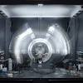](https://www.google.com/search?q=cussons+X-ray+Crystallography+equipment&tbm=isch&hl=en&chips=q:cussons+x+ray+crystallography+equipment,online_chips:engineering:R8aXRyWS8ao%3D,online_chips:powder+diffraction:k8w-aH5Skk0%3D&bih=591&biw=1098&rlz=1C1CHBF_enNG955NG955&sa=X&ved=2ahUKEwj0vNLl7cH8AhXVWaQEHTPNDAwQ4lYoDHoECAEQPw)powder diffraction](https://www.google.com/search?q=cussons+X-ray+Crystallography+equipment&tbm=isch&hl=en&chips=q:cussons+x+ray+crystallography+equipment,online_chips:engineering:R8aXRyWS8ao%3D,online_chips:powder+diffraction:k8w-aH5Skk0%3D&bih=591&biw=1098&rlz=1C1CHBF_enNG955NG955&sa=X&ved=2ahUKEwj0vNLl7cH8AhXVWaQEHTPNDAwQ4lYoDHoECAEQPw)

[[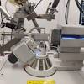](https://www.google.com/search?q=cussons+X-ray+Crystallography+equipment&tbm=isch&hl=en&chips=q:cussons+x+ray+crystallography+equipment,online_chips:engineering:R8aXRyWS8ao%3D,online_chips:crystal:xgqCJYOyKqU%3D&bih=591&biw=1098&rlz=1C1CHBF_enNG955NG955&sa=X&ved=2ahUKEwj0vNLl7cH8AhXVWaQEHTPNDAwQ4lYoDXoECAEQQQ)crystal](https://www.google.com/search?q=cussons+X-ray+Crystallography+equipment&tbm=isch&hl=en&chips=q:cussons+x+ray+crystallography+equipment,online_chips:engineering:R8aXRyWS8ao%3D,online_chips:crystal:xgqCJYOyKqU%3D&bih=591&biw=1098&rlz=1C1CHBF_enNG955NG955&sa=X&ved=2ahUKEwj0vNLl7cH8AhXVWaQEHTPNDAwQ4lYoDXoECAEQQQ)

[[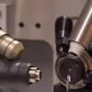](https://www.google.com/search?q=cussons+X-ray+Crystallography+equipment&tbm=isch&hl=en&chips=q:cussons+x+ray+crystallography+equipment,online_chips:engineering:R8aXRyWS8ao%3D,online_chips:protein+structure:Zy4omc9FwTo%3D&bih=591&biw=1098&rlz=1C1CHBF_enNG955NG955&sa=X&ved=2ahUKEwj0vNLl7cH8AhXVWaQEHTPNDAwQ4lYoDnoECAEQQw)protein structure](https://www.google.com/search?q=cussons+X-ray+Crystallography+equipment&tbm=isch&hl=en&chips=q:cussons+x+ray+crystallography+equipment,online_chips:engineering:R8aXRyWS8ao%3D,online_chips:protein+structure:Zy4omc9FwTo%3D&bih=591&biw=1098&rlz=1C1CHBF_enNG955NG955&sa=X&ved=2ahUKEwj0vNLl7cH8AhXVWaQEHTPNDAwQ4lYoDnoECAEQQw)

**Search Results**

**Image Results**

**X-ray crystallography instrumentation – Turku Bioscience**

[Turku Bioscience Centre](https://bioscience.fi/services/protein-structure-and-chemistry/instruments-and-software/x-ray-crystallography/" \o "X-ray crystallography instrumentation – Turku Bioscience" \t "_blank)

[X-ray crystallography instrumentation ...](https://bioscience.fi/services/protein-structure-and-chemistry/instruments-and-software/x-ray-crystallography/" \o "X-ray crystallography instrumentation – Turku Bioscience" \t "_blank)

**X-ray crystallography machine - Stock Image - C009/7602 - Science Photo Library**

[Science Photo Library](https://www.sciencephoto.com/media/395188/view/x-ray-crystallography-machine" \o "X-ray crystallography machine - Stock Image - C009/7602 - Science Photo  Library" \t "_blank)

[X-ray crystallography machine - Stock ...](https://www.sciencephoto.com/media/395188/view/x-ray-crystallography-machine" \o "X-ray crystallography machine - Stock Image - C009/7602 - Science Photo  Library" \t "_blank)

**X-Ray Crystallography | University of Strathclyde**

[University of Strathclyde](https://www.strath.ac.uk/science/chemistry/workwithus/ourfacilities/x-raycrystallography/" \o "X-Ray Crystallography | University of Strathclyde" \t "_blank)

[X-Ray Crystallography | University of ...](https://www.strath.ac.uk/science/chemistry/workwithus/ourfacilities/x-raycrystallography/" \o "X-Ray Crystallography | University of Strathclyde" \t "_blank)

**X-ray crystallography instrumentation – Turku Bioscience**

[Turku Bioscience Centre](https://bioscience.fi/services/protein-structure-and-chemistry/instruments-and-software/x-ray-crystallography/" \o "X-ray crystallography instrumentation – Turku Bioscience" \t "_blank)

[X-ray crystallography instrumentation ...](https://bioscience.fi/services/protein-structure-and-chemistry/instruments-and-software/x-ray-crystallography/" \o "X-ray crystallography instrumentation – Turku Bioscience" \t "_blank)

**X-ray crystallography - Department of Chemistry - The University of Manchester**

[University of Manchester Chemistry](https://www.chemistry.manchester.ac.uk/research/facilities/x-ray-crystallography/" \o "X-ray crystallography - Department of Chemistry - The University of  Manchester" \t "_blank)

[X-ray crystallography - Department of ...](https://www.chemistry.manchester.ac.uk/research/facilities/x-ray-crystallography/" \o "X-ray crystallography - Department of Chemistry - The University of  Manchester" \t "_blank)

**X-ray crystallography - Wikipedia**

[Wikipedia](https://en.wikipedia.org/wiki/X-ray_crystallography" \o "X-ray crystallography - Wikipedia" \t "_blank)

[X-ray crystallography - Wikipedia](https://en.wikipedia.org/wiki/X-ray_crystallography" \o "X-ray crystallography - Wikipedia" \t "_blank)

**X-ray Crystallography Laboratory | Department of Chemistry and Biochemistry**

[OSU Chemistry - The Ohio State University](https://chemistry.osu.edu/x-ray-crystallography-laboratory" \o "X-ray Crystallography Laboratory | Department of Chemistry and Biochemistry" \t "_blank)

[X-ray Crystallography Laboratory ...](https://chemistry.osu.edu/x-ray-crystallography-laboratory" \o "X-ray Crystallography Laboratory | Department of Chemistry and Biochemistry" \t "_blank)

**X-ray crystallography system - All industrial manufacturers**

[DirectIndustry](https://www.directindustry.com/industrial-manufacturer/x-ray-crystallography-system-197475.html" \o "X-ray crystallography system - All industrial manufacturers" \t "_blank)

[X-ray crystallography system - All ...](https://www.directindustry.com/industrial-manufacturer/x-ray-crystallography-system-197475.html" \o "X-ray crystallography system - All industrial manufacturers" \t "_blank)

**X-Ray Diffraction Equipment | PROTO XRD**

[Pentagram](https://pentagramuae.com/products/laboratory-equipments/proto-xrd/" \o "X-Ray Diffraction Equipment | PROTO XRD" \t "_blank)

[X-Ray Diffraction Equipment | PROTO XRD](https://pentagramuae.com/products/laboratory-equipments/proto-xrd/" \o "X-Ray Diffraction Equipment | PROTO XRD" \t "_blank)

**Xray Crystallography | Structural Biology and Biochemistry**

[CU Anschutz](https://www.cuanschutz.edu/graduate-programs/structural-biology-and-biochemistry/facilities/xray-crystallography-structural-biology-shared-resource" \o "Xray Crystallography | Structural Biology and Biochemistry" \t "_blank)

[Xray Crystallography | Structural ...](https://www.cuanschutz.edu/graduate-programs/structural-biology-and-biochemistry/facilities/xray-crystallography-structural-biology-shared-resource" \o "Xray Crystallography | Structural Biology and Biochemistry" \t "_blank)

**X-Ray Diffraction Equipment | PROTO XRD**

[Pentagram](https://pentagramuae.com/products/laboratory-equipments/proto-xrd/" \o "X-Ray Diffraction Equipment | PROTO XRD" \t "_blank)

[X-Ray Diffraction Equipment | PROTO XRD](https://pentagramuae.com/products/laboratory-equipments/proto-xrd/" \o "X-Ray Diffraction Equipment | PROTO XRD" \t "_blank)

**X-Ray Crystallography - X-Ray Crystallography - Platforms - Queen's University**

[Queen's Research Discovery Network - Queen's University](https://uniweb.time.queensu.ca/equipment/60/profile" \o "X-Ray Crystallography - X-Ray Crystallography - Platforms - Queen's  University" \t "_blank)

[X-Ray Crystallography - X-Ray ...](https://uniweb.time.queensu.ca/equipment/60/profile" \o "X-Ray Crystallography - X-Ray Crystallography - Platforms - Queen's  University" \t "_blank)

**Xray Crystallography/Equipment - Wikibooks, open books for an open world**

[Wikibooks](https://en.wikibooks.org/wiki/Xray_Crystallography/Equipment" \o "Xray Crystallography/Equipment - Wikibooks, open books for an open world" \t "_blank)

[Xray Crystallography/Equipment ...](https://en.wikibooks.org/wiki/Xray_Crystallography/Equipment" \o "Xray Crystallography/Equipment - Wikibooks, open books for an open world" \t "_blank)

**X-Ray Crystallography Lab | School of Science & Engineering**

[Tulane School of Science and Engineering](https://sse.tulane.edu/chem/xray-crystallography-lab" \o "X-Ray Crystallography Lab | School of Science & Engineering" \t "_blank)

[X-Ray Crystallography Lab | School of ...](https://sse.tulane.edu/chem/xray-crystallography-lab" \o "X-Ray Crystallography Lab | School of Science & Engineering" \t "_blank)

**X-Ray Diffractometer (XRD Instruments) | Labcompare.com**

[Labcompare](https://www.labcompare.com/Spectroscopy/178-X-Ray-Diffractometer-XRD-Instruments/" \o "X-Ray Diffractometer (XRD Instruments) | Labcompare.com" \t "_blank)

[X-Ray Diffractometer (XRD Instruments ...](https://www.labcompare.com/Spectroscopy/178-X-Ray-Diffractometer-XRD-Instruments/" \o "X-Ray Diffractometer (XRD Instruments) | Labcompare.com" \t "_blank)

**X-Ray Crystallography Shared Service | University of Maryland School of Medicine**

[University of Maryland School of Medicine](https://www.medschool.umaryland.edu/CIBR/CORE/X-Ray-Crystallography/" \o "X-Ray Crystallography Shared Service | University of Maryland School of  Medicine" \t "_blank)

[X-Ray Crystallography Shared Service ...](https://www.medschool.umaryland.edu/CIBR/CORE/X-Ray-Crystallography/" \o "X-Ray Crystallography Shared Service | University of Maryland School of  Medicine" \t "_blank)

**Heritage Equipment**

[Heritage Equipment](https://heritageequipment.com/product-listing/x-ray-diffraction-crystallography/" \o "Heritage Equipment" \t "_blank)

[Heritage Equipment](https://heritageequipment.com/product-listing/x-ray-diffraction-crystallography/" \o "Heritage Equipment" \t "_blank)

**X-ray crystallography instrumentation – Turku Bioscience**

[Turku Bioscience Centre](https://bioscience.fi/services/protein-structure-and-chemistry/instruments-and-software/x-ray-crystallography/" \o "X-ray crystallography instrumentation – Turku Bioscience" \t "_blank)

[X-ray crystallography instrumentation ...](https://bioscience.fi/services/protein-structure-and-chemistry/instruments-and-software/x-ray-crystallography/" \o "X-ray crystallography instrumentation – Turku Bioscience" \t "_blank)

**X-Ray Crystallography — Department of Chemistry**

[University of Louisville](https://louisville.edu/chemistry/facilities/xrc" \o "X-Ray Crystallography — Department of Chemistry" \t "_blank)

[X-Ray Crystallography — Department of ...](https://louisville.edu/chemistry/facilities/xrc" \o "X-Ray Crystallography — Department of Chemistry" \t "_blank)

**X-Ray Apparatus**

[Indosaw](http://www.indosawedu.com/x-ray-apparatus.php" \o "X-Ray Apparatus" \t "_blank)

[X-Ray Apparatus](http://www.indosawedu.com/x-ray-apparatus.php" \o "X-Ray Apparatus" \t "_blank)

**X-Ray Diffraction Equipment | PROTO XRD**

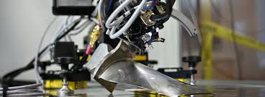

[[](https://pentagramuae.com/products/laboratory-equipments/proto-xrd/)](https://pentagramuae.com/products/laboratory-equipments/proto-xrd/" \o "X-Ray Diffraction Equipment | PROTO XRD" \t "_blank)

[Pentagram](https://pentagramuae.com/products/laboratory-equipments/proto-xrd/" \o "X-Ray Diffraction Equipment | PROTO XRD" \t "_blank)

[X-Ray Diffraction Equipment | PROTO XRD](https://pentagramuae.com/products/laboratory-equipments/proto-xrd/" \o "X-Ray Diffraction Equipment | PROTO XRD" \t "_blank)

**University of Kentucky X-Ray Crystallography Facility - Main**

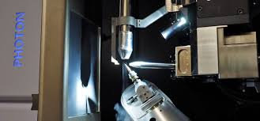

[[](https://xray.uky.edu/)](https://xray.uky.edu/" \o "University of Kentucky X-Ray Crystallography Facility - Main" \t "_blank)

[University of Kentucky](https://xray.uky.edu/" \o "University of Kentucky X-Ray Crystallography Facility - Main" \t "_blank)

[Kentucky X-Ray Crystallography Facility ...](https://xray.uky.edu/" \o "University of Kentucky X-Ray Crystallography Facility - Main" \t "_blank)

**X-Ray Diffractometer (XRD Instruments) | Labcompare.com**

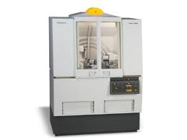

[[](https://www.labcompare.com/Spectroscopy/178-X-Ray-Diffractometer-XRD-Instruments/)](https://www.labcompare.com/Spectroscopy/178-X-Ray-Diffractometer-XRD-Instruments/" \o "X-Ray Diffractometer (XRD Instruments) | Labcompare.com" \t "_blank)

[Labcompare](https://www.labcompare.com/Spectroscopy/178-X-Ray-Diffractometer-XRD-Instruments/" \o "X-Ray Diffractometer (XRD Instruments) | Labcompare.com" \t "_blank)

[X-Ray Diffractometer (XRD Instruments ...](https://www.labcompare.com/Spectroscopy/178-X-Ray-Diffractometer-XRD-Instruments/" \o "X-Ray Diffractometer (XRD Instruments) | Labcompare.com" \t "_blank)

**X-ray crystallography system - All industrial manufacturers**

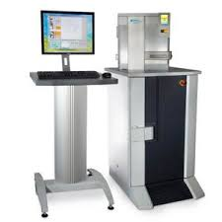

[[](https://www.directindustry.com/industrial-manufacturer/x-ray-crystallography-system-197475.html)](https://www.directindustry.com/industrial-manufacturer/x-ray-crystallography-system-197475.html" \o "X-ray crystallography system - All industrial manufacturers" \t "_blank)

[DirectIndustry](https://www.directindustry.com/industrial-manufacturer/x-ray-crystallography-system-197475.html" \o "X-ray crystallography system - All industrial manufacturers" \t "_blank)

[X-ray crystallography system - All ...](https://www.directindustry.com/industrial-manufacturer/x-ray-crystallography-system-197475.html" \o "X-ray crystallography system - All industrial manufacturers" \t "_blank)

Related searches

[[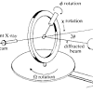](https://www.google.com/search?q=x-ray+crystallography+diagram&tbm=isch&hl=en&bih=591&biw=1098&rlz=1C1CHBF_enNG955NG955&sa=X&ved=2ahUKEwj0vNLl7cH8AhXVWaQEHTPNDAwQrNwCKAB6BAgBEHs)](https://www.google.com/search?q=x-ray+crystallography+diagram&tbm=isch&hl=en&bih=591&biw=1098&rlz=1C1CHBF_enNG955NG955&sa=X&ved=2ahUKEwj0vNLl7cH8AhXVWaQEHTPNDAwQrNwCKAB6BAgBEHs)

**[x-ray](https://www.google.com/search?q=x-ray+crystallography+diagram&tbm=isch&hl=en&bih=591&biw=1098&rlz=1C1CHBF_enNG955NG955&sa=X&ved=2ahUKEwj0vNLl7cH8AhXVWaQEHTPNDAwQrNwCKAB6BAgBEHs)**[crystallography](https://www.google.com/search?q=x-ray+crystallography+diagram&tbm=isch&hl=en&bih=591&biw=1098&rlz=1C1CHBF_enNG955NG955&sa=X&ved=2ahUKEwj0vNLl7cH8AhXVWaQEHTPNDAwQrNwCKAB6BAgBEHs)**[diagram](https://www.google.com/search?q=x-ray+crystallography+diagram&tbm=isch&hl=en&bih=591&biw=1098&rlz=1C1CHBF_enNG955NG955&sa=X&ved=2ahUKEwj0vNLl7cH8AhXVWaQEHTPNDAwQrNwCKAB6BAgBEHs)**

[[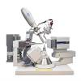](https://www.google.com/search?q=x+ray+crystallography+machine&tbm=isch&hl=en&bih=591&biw=1098&rlz=1C1CHBF_enNG955NG955&sa=X&ved=2ahUKEwj0vNLl7cH8AhXVWaQEHTPNDAwQrNwCKAB6BAgBEH0)](https://www.google.com/search?q=x+ray+crystallography+machine&tbm=isch&hl=en&bih=591&biw=1098&rlz=1C1CHBF_enNG955NG955&sa=X&ved=2ahUKEwj0vNLl7cH8AhXVWaQEHTPNDAwQrNwCKAB6BAgBEH0)

[x ray crystallography](https://www.google.com/search?q=x+ray+crystallography+machine&tbm=isch&hl=en&bih=591&biw=1098&rlz=1C1CHBF_enNG955NG955&sa=X&ved=2ahUKEwj0vNLl7cH8AhXVWaQEHTPNDAwQrNwCKAB6BAgBEH0)**[machine](https://www.google.com/search?q=x+ray+crystallography+machine&tbm=isch&hl=en&bih=591&biw=1098&rlz=1C1CHBF_enNG955NG955&sa=X&ved=2ahUKEwj0vNLl7cH8AhXVWaQEHTPNDAwQrNwCKAB6BAgBEH0)**

[[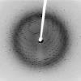](https://www.google.com/search?q=x-ray+crystallography+images&tbm=isch&hl=en&bih=591&biw=1098&rlz=1C1CHBF_enNG955NG955&sa=X&ved=2ahUKEwj0vNLl7cH8AhXVWaQEHTPNDAwQrNwCKAB6BAgBEH8)](https://www.google.com/search?q=x-ray+crystallography+images&tbm=isch&hl=en&bih=591&biw=1098&rlz=1C1CHBF_enNG955NG955&sa=X&ved=2ahUKEwj0vNLl7cH8AhXVWaQEHTPNDAwQrNwCKAB6BAgBEH8)

**[x-ray](https://www.google.com/search?q=x-ray+crystallography+images&tbm=isch&hl=en&bih=591&biw=1098&rlz=1C1CHBF_enNG955NG955&sa=X&ved=2ahUKEwj0vNLl7cH8AhXVWaQEHTPNDAwQrNwCKAB6BAgBEH8)**[crystallography](https://www.google.com/search?q=x-ray+crystallography+images&tbm=isch&hl=en&bih=591&biw=1098&rlz=1C1CHBF_enNG955NG955&sa=X&ved=2ahUKEwj0vNLl7cH8AhXVWaQEHTPNDAwQrNwCKAB6BAgBEH8)**[images](https://www.google.com/search?q=x-ray+crystallography+images&tbm=isch&hl=en&bih=591&biw=1098&rlz=1C1CHBF_enNG955NG955&sa=X&ved=2ahUKEwj0vNLl7cH8AhXVWaQEHTPNDAwQrNwCKAB6BAgBEH8)**

**Image Results**

**Engineering – AYVA Educational Solutions**

[[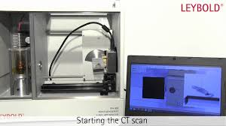](https://www.google.com/imgres?imgurl=https%3A%2F%2Fi.ytimg.com%2Fvi%2F_lvUCqfszJA%2Fmaxresdefault.jpg&imgrefurl=https%3A%2F%2Fwww.ayva.ca%2Feng%2Fcategory%2Feng%2F&tbnid=Uh8X0WzqMQQZIM&vet=12ahUKEwj0vNLl7cH8AhXVWaQEHTPNDAwQMygZegUIARCBAQ..i&docid=qQ671YfE8C9kMM&w=1280&h=720&itg=1&q=cussons%20X-ray%20Crystallography%20equipment&hl=en&ved=2ahUKEwj0vNLl7cH8AhXVWaQEHTPNDAwQMygZegUIARCBAQ)](https://www.google.com/imgres?imgurl=https%3A%2F%2Fi.ytimg.com%2Fvi%2F_lvUCqfszJA%2Fmaxresdefault.jpg&imgrefurl=https%3A%2F%2Fwww.ayva.ca%2Feng%2Fcategory%2Feng%2F&tbnid=Uh8X0WzqMQQZIM&vet=12ahUKEwj0vNLl7cH8AhXVWaQEHTPNDAwQMygZegUIARCBAQ..i&docid=qQ671YfE8C9kMM&w=1280&h=720&itg=1&q=cussons%20X-ray%20Crystallography%20equipment&hl=en&ved=2ahUKEwj0vNLl7cH8AhXVWaQEHTPNDAwQMygZegUIARCBAQ)

[[](https://www.ayva.ca/eng/category/eng/)](https://www.ayva.ca/eng/category/eng/" \o "Engineering – AYVA Educational Solutions" \t "_blank)

[AYVA Educational Solutions](https://www.ayva.ca/eng/category/eng/" \o "Engineering – AYVA Educational Solutions" \t "_blank)

[Engineering – AYVA Educational Solutions](https://www.ayva.ca/eng/category/eng/" \o "Engineering – AYVA Educational Solutions" \t "_blank)

**University of Kentucky X-Ray Crystallography Facility - Main**

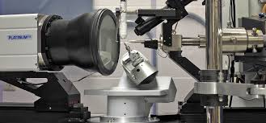

[[](https://xray.uky.edu/)](https://xray.uky.edu/" \o "University of Kentucky X-Ray Crystallography Facility - Main" \t "_blank)

[University of Kentucky](https://xray.uky.edu/" \o "University of Kentucky X-Ray Crystallography Facility - Main" \t "_blank)

[Kentucky X-Ray Crystallography Facility ...](https://xray.uky.edu/" \o "University of Kentucky X-Ray Crystallography Facility - Main" \t "_blank)

**X-Ray Diffractometer (XRD Instruments) | Labcompare.com**

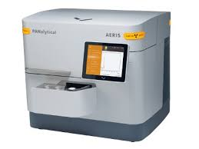

[[](https://www.labcompare.com/Spectroscopy/178-X-Ray-Diffractometer-XRD-Instruments/)](https://www.labcompare.com/Spectroscopy/178-X-Ray-Diffractometer-XRD-Instruments/" \o "X-Ray Diffractometer (XRD Instruments) | Labcompare.com" \t "_blank)

[Labcompare](https://www.labcompare.com/Spectroscopy/178-X-Ray-Diffractometer-XRD-Instruments/" \o "X-Ray Diffractometer (XRD Instruments) | Labcompare.com" \t "_blank)

[X-Ray Diffractometer (XRD Instruments ...](https://www.labcompare.com/Spectroscopy/178-X-Ray-Diffractometer-XRD-Instruments/" \o "X-Ray Diffractometer (XRD Instruments) | Labcompare.com" \t "_blank)

**X-ray diffractometer, XRD diffractometer - All industrial manufacturers**

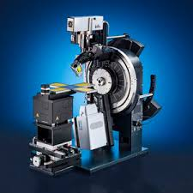

[[](https://www.directindustry.com/industrial-manufacturer/x-ray-diffractometer-80802.html)](https://www.directindustry.com/industrial-manufacturer/x-ray-diffractometer-80802.html" \o "X-ray diffractometer, XRD diffractometer - All industrial manufacturers" \t "_blank)

[DirectIndustry](https://www.directindustry.com/industrial-manufacturer/x-ray-diffractometer-80802.html" \o "X-ray diffractometer, XRD diffractometer - All industrial manufacturers" \t "_blank)

[X-ray diffractometer, XRD ...](https://www.directindustry.com/industrial-manufacturer/x-ray-diffractometer-80802.html" \o "X-ray diffractometer, XRD diffractometer - All industrial manufacturers" \t "_blank)

**X-ray crystallography instrumentation – Turku Bioscience**

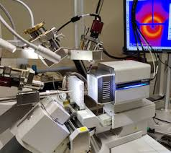

[[](https://bioscience.fi/services/protein-structure-and-chemistry/instruments-and-software/x-ray-crystallography/)](https://bioscience.fi/services/protein-structure-and-chemistry/instruments-and-software/x-ray-crystallography/" \o "X-ray crystallography instrumentation – Turku Bioscience" \t "_blank)

[Turku Bioscience Centre](https://bioscience.fi/services/protein-structure-and-chemistry/instruments-and-software/x-ray-crystallography/" \o "X-ray crystallography instrumentation – Turku Bioscience" \t "_blank)

[X-ray crystallography instrumentation ...](https://bioscience.fi/services/protein-structure-and-chemistry/instruments-and-software/x-ray-crystallography/" \o "X-ray crystallography instrumentation – Turku Bioscience" \t "_blank)

**In-situ X-ray Diffraction Instruments & Applications**

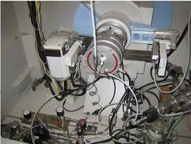

[www.if.tugraz.at](https://www.if.tugraz.at/workshops/presentation.php?944" \o "In-situ X-ray Diffraction Instruments & Applications" \t "_blank)

[In-situ X-ray Diffraction Instruments ...](https://www.if.tugraz.at/workshops/presentation.php?944" \o "In-situ X-ray Diffraction Instruments & Applications" \t "_blank)

**Advancing Protein Research with Ultra-High-Speed X-Ray Crystallography**

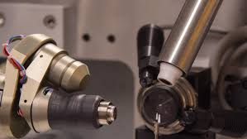

[[](https://www.azom.com/article.aspx?ArticleID=20452)](https://www.azom.com/article.aspx?ArticleID=20452" \o "Advancing Protein Research with Ultra-High-Speed X-Ray Crystallography" \t "_blank)

[AZoM](https://www.azom.com/article.aspx?ArticleID=20452" \o "Advancing Protein Research with Ultra-High-Speed X-Ray Crystallography" \t "_blank)

[X-Ray Crystallography](https://www.azom.com/article.aspx?ArticleID=20452" \o "Advancing Protein Research with Ultra-High-Speed X-Ray Crystallography" \t "_blank)

**Engineering – AYVA Educational Solutions**

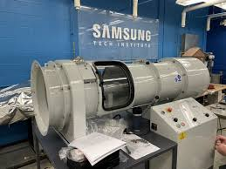

[[](https://www.ayva.ca/eng/category/eng/)](https://www.ayva.ca/eng/category/eng/" \o "Engineering – AYVA Educational Solutions" \t "_blank)

[AYVA Educational Solutions](https://www.ayva.ca/eng/category/eng/" \o "Engineering – AYVA Educational Solutions" \t "_blank)

[Engineering – AYVA Educational Solutions](https://www.ayva.ca/eng/category/eng/" \o "Engineering – AYVA Educational Solutions" \t "_blank)

**Low Temperature Service | Max Planck Institute for Solid State Research**

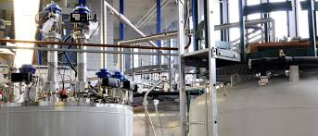

[[](https://www.fkf.mpg.de/449653/70_Low_Temperature)](https://www.fkf.mpg.de/449653/70_Low_Temperature" \o "Low Temperature Service | Max Planck Institute for Solid State Research" \t "_blank)

[Max-Planck-Institut für Festkörperforschung - Max-Planck-Gesellschaft](https://www.fkf.mpg.de/449653/70_Low_Temperature" \o "Low Temperature Service | Max Planck Institute for Solid State Research" \t "_blank)

[Max Planck Institute for Solid State ...](https://www.fkf.mpg.de/449653/70_Low_Temperature" \o "Low Temperature Service | Max Planck Institute for Solid State Research" \t "_blank)

**In-situ X-ray Diffraction Instruments & Applications**

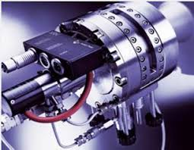

[www.if.tugraz.at](https://www.if.tugraz.at/workshops/presentation.php?944" \o "In-situ X-ray Diffraction Instruments & Applications" \t "_blank)

[In-situ X-ray Diffraction Instruments ...](https://www.if.tugraz.at/workshops/presentation.php?944" \o "In-situ X-ray Diffraction Instruments & Applications" \t "_blank)

**MIT CMSE X-ray Diffraction Facility: Instrumentation**

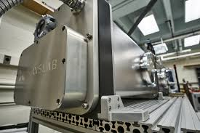

[prism.mit.edu](http://prism.mit.edu/xray/instruments/index.html" \o "MIT CMSE X-ray Diffraction Facility: Instrumentation" \t "_blank)

[MIT CMSE X-ray Diffraction Facility ...](http://prism.mit.edu/xray/instruments/index.html" \o "MIT CMSE X-ray Diffraction Facility: Instrumentation" \t "_blank)

**X-ray crystallography system - All industrial manufacturers**

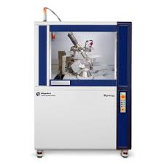

[[](https://www.directindustry.com/industrial-manufacturer/x-ray-crystallography-system-197475.html)](https://www.directindustry.com/industrial-manufacturer/x-ray-crystallography-system-197475.html" \o "X-ray crystallography system - All industrial manufacturers" \t "_blank)

[DirectIndustry](https://www.directindustry.com/industrial-manufacturer/x-ray-crystallography-system-197475.html" \o "X-ray crystallography system - All industrial manufacturers" \t "_blank)

[X-ray crystallography system - All ...](https://www.directindustry.com/industrial-manufacturer/x-ray-crystallography-system-197475.html" \o "X-ray crystallography system - All industrial manufacturers" \t "_blank)

**Sustainability | Free Full-Text | Microstructure and Strength Properties of Sustainable Concrete Using Effective Microorganisms as a Self-Curing Agent**

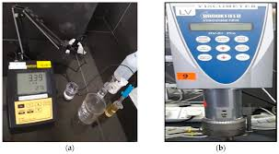

[[](https://www.mdpi.com/2071-1050/14/16/10443)](https://www.mdpi.com/2071-1050/14/16/10443" \o "Sustainability | Free Full-Text | Microstructure and Strength Properties of  Sustainable Concrete Using Effective Microorganisms as a Self-Curing Agent" \t "_blank)

[MDPI](https://www.mdpi.com/2071-1050/14/16/10443" \o "Sustainability | Free Full-Text | Microstructure and Strength Properties of  Sustainable Concrete Using Effective Microorganisms as a Self-Curing Agent" \t "_blank)

[Microstructure and Strength Properties ...](https://www.mdpi.com/2071-1050/14/16/10443" \o "Sustainability | Free Full-Text | Microstructure and Strength Properties of  Sustainable Concrete Using Effective Microorganisms as a Self-Curing Agent" \t "_blank)

**X-Ray Diffractometer (XRD Instruments) | Labcompare.com**

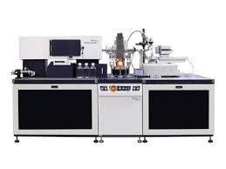

[[](https://www.labcompare.com/Spectroscopy/178-X-Ray-Diffractometer-XRD-Instruments/)](https://www.labcompare.com/Spectroscopy/178-X-Ray-Diffractometer-XRD-Instruments/" \o "X-Ray Diffractometer (XRD Instruments) | Labcompare.com" \t "_blank)

[Labcompare](https://www.labcompare.com/Spectroscopy/178-X-Ray-Diffractometer-XRD-Instruments/" \o "X-Ray Diffractometer (XRD Instruments) | Labcompare.com" \t "_blank)

[X-Ray Diffractometer (XRD Instruments ...](https://www.labcompare.com/Spectroscopy/178-X-Ray-Diffractometer-XRD-Instruments/" \o "X-Ray Diffractometer (XRD Instruments) | Labcompare.com" \t "_blank)

**X-ray crystallography - Wikipedia**

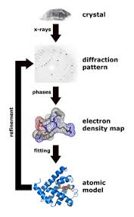

[[](https://en.wikipedia.org/wiki/X-ray_crystallography)](https://en.wikipedia.org/wiki/X-ray_crystallography" \o "X-ray crystallography - Wikipedia" \t "_blank)

[Wikipedia](https://en.wikipedia.org/wiki/X-ray_crystallography" \o "X-ray crystallography - Wikipedia" \t "_blank)

[X-ray crystallography - Wikipedia](https://en.wikipedia.org/wiki/X-ray_crystallography" \o "X-ray crystallography - Wikipedia" \t "_blank)

**Engineering – AYVA Educational Solutions**

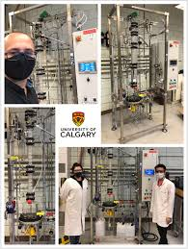

[[](https://www.ayva.ca/eng/category/eng/)](https://www.ayva.ca/eng/category/eng/" \o "Engineering – AYVA Educational Solutions" \t "_blank)

[AYVA Educational Solutions](https://www.ayva.ca/eng/category/eng/" \o "Engineering – AYVA Educational Solutions" \t "_blank)

[Engineering – AYVA Educational Solutions](https://www.ayva.ca/eng/category/eng/" \o "Engineering – AYVA Educational Solutions" \t "_blank)

**X-Ray Diffractometer (XRD Instruments) | Labcompare.com**

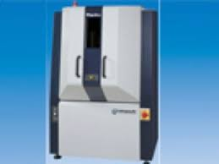

[[](https://www.labcompare.com/Spectroscopy/178-X-Ray-Diffractometer-XRD-Instruments/)](https://www.labcompare.com/Spectroscopy/178-X-Ray-Diffractometer-XRD-Instruments/" \o "X-Ray Diffractometer (XRD Instruments) | Labcompare.com" \t "_blank)

[Labcompare](https://www.labcompare.com/Spectroscopy/178-X-Ray-Diffractometer-XRD-Instruments/" \o "X-Ray Diffractometer (XRD Instruments) | Labcompare.com" \t "_blank)

[X-Ray Diffractometer (XRD Instruments ...](https://www.labcompare.com/Spectroscopy/178-X-Ray-Diffractometer-XRD-Instruments/" \o "X-Ray Diffractometer (XRD Instruments) | Labcompare.com" \t "_blank)

**The single-axis acoustic levitator present at ILL. | Download Scientific Diagram**

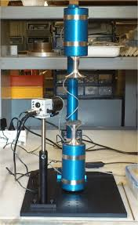

[[](https://www.researchgate.net/figure/The-single-axis-acoustic-levitator-present-at-ILL_fig3_285291715)](https://www.researchgate.net/figure/The-single-axis-acoustic-levitator-present-at-ILL_fig3_285291715" \o "The single-axis acoustic levitator present at ILL. | Download Scientific  Diagram" \t "_blank)

[ResearchGate](https://www.researchgate.net/figure/The-single-axis-acoustic-levitator-present-at-ILL_fig3_285291715" \o "The single-axis acoustic levitator present at ILL. | Download Scientific  Diagram" \t "_blank)

[The single-axis acoustic levitator ...](https://www.researchgate.net/figure/The-single-axis-acoustic-levitator-present-at-ILL_fig3_285291715" \o "The single-axis acoustic levitator present at ILL. | Download Scientific  Diagram" \t "_blank)

**Mechanical properties of ambient cured high-strength plain and hybrid fiber reinforced geopolymer composites from triaxial compressive tests - ScienceDirect**

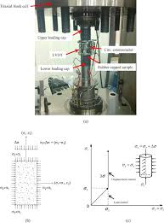

[[](https://www.sciencedirect.com/science/article/pii/S0950061818317641)](https://www.sciencedirect.com/science/article/pii/S0950061818317641" \o "Mechanical properties of ambient cured high-strength plain and hybrid fiber  reinforced geopolymer composites from triaxial compressive tests -  ScienceDirect" \t "_blank)

[ScienceDirect.com](https://www.sciencedirect.com/science/article/pii/S0950061818317641" \o "Mechanical properties of ambient cured high-strength plain and hybrid fiber  reinforced geopolymer composites from triaxial compressive tests -  ScienceDirect" \t "_blank)

[Mechanical properties of ambient cured ...](https://www.sciencedirect.com/science/article/pii/S0950061818317641" \o "Mechanical properties of ambient cured high-strength plain and hybrid fiber  reinforced geopolymer composites from triaxial compressive tests -  ScienceDirect" \t "_blank)

**X-ray physics - Atomic and nuclear physics - Physics Experiments - Physics**

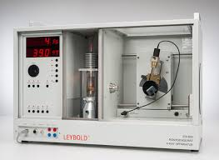

[[](https://www.leybold-shop.com/physics/physics-experiments/atomic-and-nuclear-physics/x-ray-physics.html)](https://www.leybold-shop.com/physics/physics-experiments/atomic-and-nuclear-physics/x-ray-physics.html" \o "X-ray physics - Atomic and nuclear physics - Physics Experiments - Physics" \t "_blank)

[Leybold Shop](https://www.leybold-shop.com/physics/physics-experiments/atomic-and-nuclear-physics/x-ray-physics.html" \o "X-ray physics - Atomic and nuclear physics - Physics Experiments - Physics" \t "_blank)

[X-ray physics - Atomic and nuclear ...](https://www.leybold-shop.com/physics/physics-experiments/atomic-and-nuclear-physics/x-ray-physics.html" \o "X-ray physics - Atomic and nuclear physics - Physics Experiments - Physics" \t "_blank)

**Engineering – AYVA Educational Solutions**

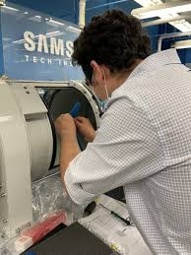

[[](https://www.ayva.ca/eng/category/eng/)](https://www.ayva.ca/eng/category/eng/" \o "Engineering – AYVA Educational Solutions" \t "_blank)

[AYVA Educational Solutions](https://www.ayva.ca/eng/category/eng/" \o "Engineering – AYVA Educational Solutions" \t "_blank)

[Engineering – AYVA Educational Solutions](https://www.ayva.ca/eng/category/eng/" \o "Engineering – AYVA Educational Solutions" \t "_blank)

**In-situ X-ray Diffraction Instruments & Applications**

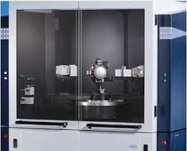

[www.if.tugraz.at](https://www.if.tugraz.at/workshops/presentation.php?944" \o "In-situ X-ray Diffraction Instruments & Applications" \t "_blank)

[In-situ X-ray Diffraction Instruments ...](https://www.if.tugraz.at/workshops/presentation.php?944" \o "In-situ X-ray Diffraction Instruments & Applications" \t "_blank)

The rest of the results might not be what you're looking for. See more anyway

**Lagos, Nigeria** - From your Internet address - [Learn more](https://support.google.com/websearch/answer/179386?source=g&hl=en)

[Help](https://support.google.com/websearch/?hl=en&sa=X&ved=2ahUKEwj0vNLl7cH8AhXVWaQEHTPNDAwQ8KwCegQIAhAB#topic=3378866)Send feedback[Privacy](https://policies.google.com/privacy?hl=en&gl=NG&sa=X&ved=2ahUKEwj0vNLl7cH8AhXVWaQEHTPNDAwQ8awCegQIAhAD)[Terms](https://policies.google.com/terms?hl=en&gl=NG&sa=X&ved=2ahUKEwj0vNLl7cH8AhXVWaQEHTPNDAwQ8qwCegQIAhAE)

[**Contact AYVA**](https://www.ayva.ca/eng/2021/12/15/contact-ayva/)          [SCIENCE](https://www.ayva.ca/sci/)  |  [ENGINEERING](https://www.ayva.ca/eng/)         ENGLISH | FRANCAIS

## ****1-877-967-2726****

Top of Form



Bottom of Form

* [HOME](https://www.ayva.ca/eng/)
* [E-LEARNING](https://www.ayva.ca/eng/remote-hybrid-learning/)
* [PRODUCTS](https://www.ayva.ca/eng/product/)
* [INDUSTRIES](https://www.ayva.ca/eng/industries/)
* [RESEARCH](https://www.ayva.ca/eng/product-tag/research/)
* [PARTNERS](https://www.ayva.ca/eng/partners/)
* [ABOUT](https://www.ayva.ca/eng/about/)
* [WISHLIST](https://www.ayva.ca/eng/request-quote/)
* [**CONTACT AYVA!**](https://www.ayva.ca/eng/2020/12/15/contact-ayva/)

# TecQuipment (TQ) Equipment That Can Be Delivered in 4-6 Weeks!

Written by AYVA on March 22, 2022. Posted in [Engineering](https://www.ayva.ca/eng/category/eng/). [Leave a Comment](https://www.ayva.ca/eng/2022/03/22/tq-in-stock-list-2020/#respond)

#### All TQ products are made to order and can sometimes take up to 20 weeks to be delivered. TQ currently has some great products in-stock that can be delivered within 4-6 weeks!

#### 

#### AYVA has partnered with TecQuipment (TQ) to provide a wide range of engineering training equipment for colleges and universities across Canada. TQ products are robust and designed to withstand long term, heavy laboratory & classroom use and come with a 5 year warranty. This ensures reliable operation over many years & a high standard of teaching & learning.

|  |  |  |
| --- | --- | --- |
| Part # | Product | QTY Available |
| AF1600H | AIRCRAFT MODEL HIGH WING | 1 |
| AF1600J | THREE DIMENSIONAL DRAG MODELS | 1 |
| AFA10 | SMOKE GENERATOR | 1 |
| CE123 | PLC TRAINER | 2 |
| CE150 | HELICOPTER MODEL | 1 |
| CE1B | COMPRESSOR | 1 |
| FC300K2 | FC300K2 ROUGHENED BED – SAND | 1 |
| H12L | SYPHON SPILLWAY | 2 |
| H13 | VORTEX APPARATUS | 1 |
| H1D/A | SET OF WEIRS FOR H1D | 8 |
| H1D/B | ADVANCED SET OF WEIRS FOR H1D | 4 |
| H1X | HYDRAULIC BENCH CONVERSION KIT | 2 |
| H314A | SURFACE TENSION BALANCE | 2 |
| SM1000A | SUPPORTING TABLE AND CUPBOARD | 1 |
| SM1000B | HAND OPERATED PUMP | 5 |
| SM1000D | EXTENSOMETER FOR SM1000 | 1 |
| SM1000H | CUPPING TEST | 1 |
| SM1000J | DOUBLE SHEAR TEST | 1 |
| SM1000K | DISC SPRING | 1 |
| SM1005A | SET OF ADDITIONAL STRUTS | 1 |
| SM110 | HOOKE’S LAW AND SPRING RATE | 2 |
| STR10 | TWO PINNED ARCH | 1 |
| STR11 | FIXED ARCH | 1 |
| STR14 | CURVED BARS AND DAVITS | 1 |
| STR15A | SPECIMEN BEAMS FOR STR15 | 1 |
| STR16 | PLASTIC BENDING OF PORTALS | 1 |
| STR16A | SPECIMEN PORTALS FOR STR16 | 1 |
| STR17 | REDUNDANT TRUSS | 1 |
| STR19 | SIMPLE SUSPENSION BRIDGE | 2 |
| STR20 | BENDING MOMENTS IN A PORTAL FRAME | 5 |
| STR3 | SHEAR FORCE IN A BEAM | 2 |
| STR6 | TORSION OF CIRCULAR SECTIONS | 3 |
| STRN10 | 10 SEAT STRUCTURES SOFTWARE | 2 |
| STRS | STRUCTURES SOFTWARE | 33 |
| STS14 | CURVED BARS AND DAVITS | 1 |
| SW1 | STOPWATCH | 1 |
| TM1005 | CENTRIFUGAL FORCE | 1 |
| TM1018B | TOOTHED BELT DRIVE UNIT | 1 |
| VDASe-lab1 | VDAS ELECTRONIC LABORATORY | 11 |
| VDASe-lab5 | VDAS ELECTRONIC LABORATORY | 8 |
| VDASe-labU | VDAS ELECTRONIC LABORATORY | 5 |
| WT | WEIGHT HANGER  AND 10g WEIGHTS | 18 |
| WTL | SET OF 1g WEIGHTS | 8 |

Tags: [engineering](https://www.ayva.ca/eng/tag/engineering/)

* [PREVIOUS](https://www.ayva.ca/eng/2022/02/09/2022-matrix-catalogue-request/)
* [NEXT](https://www.ayva.ca/eng/2022/06/28/working-with-tecquipments-wind-turbine-dynamics-apparatus/)

Top of Form



Bottom of Form

"We appreciate Pignat's willingness to partner with the university to customize a pilot training system that fits both our needs - and our budget. I want to thank AYVA for arranging a visit to Pignat's factory in France so I could meet the design engineers and see first-hand the attention to detail at every step of the manufacturing process. I especially want to thank my hosts at Pignat for their hospitality during my stay in Lyon. I really had a good time testing our CO2 absorption/stripping unit and seeing all the nice equipment in the plant."

**Dr. John Zhang**  
**University of Waterloo**

AYVA Educational Solutions | 7-233 Speers Road, Oakville ON L6K 0J5 | Toll Free: 1-877-967-2726 | Phone: 905-337-8486